DEPARTMENT OF ECONOMICS AND MANAGEMENT

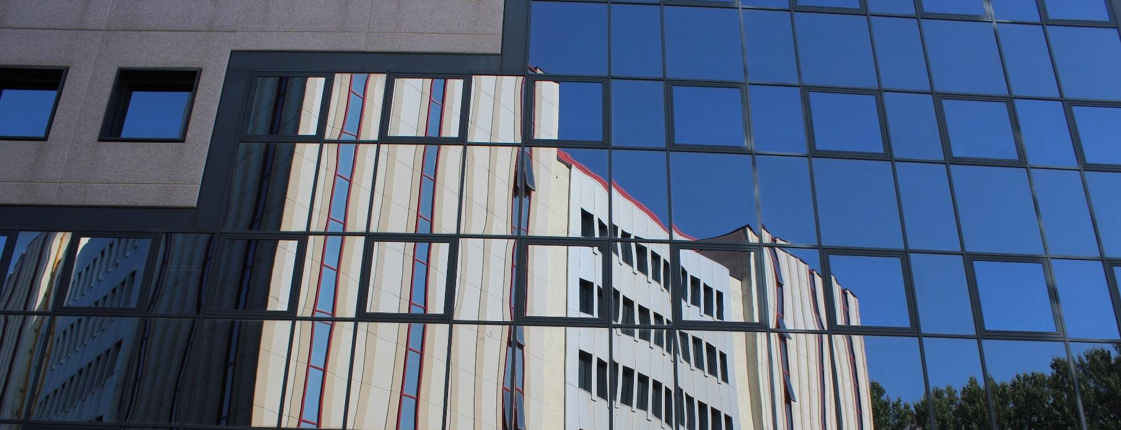

In the Academic Year 2025/26, the Department of Economics and Management offers the following degree programmes:

- One Bachelor’s degree programme in Economia (Economics) (EP2093):

  - The first and second years offer courses taught in Italian and organised in semesters (semesters 1 and 2). In the Academic Year 2025/26 classes start from 22nd September.
  - The third year offers courses taught in English and is organised in trimesters (Trimester 1, 2 and 3). In the Academic Year 2025/26 first trimester, classes start on 29th September.
- Three Master’s degree programmes in Accounting, Finance and Business Consulting (EP2731), Applied Economics (EP2733), Management for Sustainable Firms (EP2732). They are entirely taught in English (apart from a curriculum of the Accounting, Finance and Business Consulting programme).
The first year of each one is organised in semesters (semester 1 and 2), the second one in trimesters. In the Academic Year 2025/26 classes start on 29th September.

General rules for course selection:

- Not all the offered courses are available for exchange students, so you are warmly invited to carefully check this piece of information in each course unit info page for the relevant Academic Year, in the section “Information on the course unit” - “Course unit for Erasmus students”. Generally 3 credits course units are NOT open to Exchange students. Neither the “Italian as a foreign language” courses offered within the Master’s degree programmes are available.
- Incoming students can take courses from other Schools and Departments too, as long as they respect the restrictions established for each one of them (please see the other sections of this guide).
- They can also mix courses held in Italian (at least a B1 level is needed) and English, and mix courses organised in semesters and trimesters.
- Incoming students at Bachelor’s level are free to take courses at Master’s level (if their Home University allows them to do so), but they need to check the prerequisites in the course unit info page in the course catalogue.

TRIMESTERS AND SEMESTERS
You are invited to check the period of each course unit in its info page for the relevant Academic Year, in the section “Calendar”.

Pay attention to the academic dates, which are different for semesters and trimesters and might differ from the official Academic Calendar.

You can check the departmental Academic Calendar key dates here, in the “Exchange Students” section.

DEPARTMENTAL EXCHANGE STUDENT COURSE CATALOGUE
You can find a guide dedicated to incoming exchange students and presenting the list of available courses here, section: “Exchange students” -> “Learning Agreement”.

