CHANGE FORM LEARNING AGREEMENT - ACADEMIC YEAR 2023/2024
Student’s family name: First name:
Sending institution: Radboud University, Nijmegen, The Netherlands

DETAILS OF THE RECEIVING INSTITUTION
Na
m
e

r
ecei
v
i
n
g

i
ns
tit
u
ti
on
:

C
it
y

&

Coun
t
r
y
:

F
iel
d

o
f

s
t
ud
y

at

r
ecei
v
i
n
g

i
ns
tit
u
ti
on
:

CHANGES TO THE ORIGINAL PROPOSED STUDY PROGRAMME ABROAD
To be filled in only if applicable
Course code | Course title | Delete this course | Add this course | Number of ECTS credits
If necessary, continue this list on a separate sheet
CHANGES TO THE ORIGINAL PERIOD OF STUDY/TRAINEESHIP ABROAD
To be filled in only if applicable
Original period of study: | New period of study:
from: (day) / (month) / (year) | from: (day) / (month) / (year)
to: (day) / (month) / (year) | to: (day) / (month) / (year)
Student’s signature: | Date:
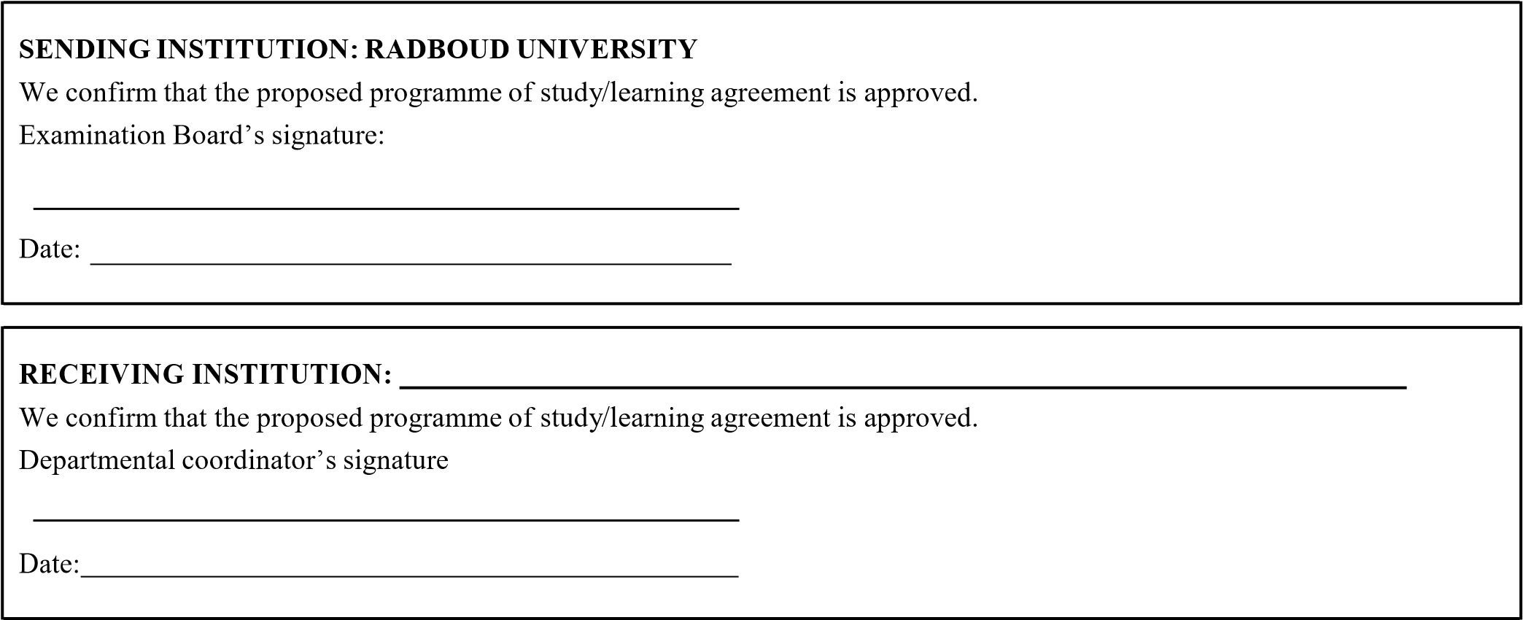

The Examination Board will confirm the conversion of foreign credits to ECTS credits only once the student submits the foreign Transcript of Records after the stay abroad

