Genetic and Pharmacological Animal Models of Schizophrenia

Focus on
Attention and Vigilance

Nathalie Buscher
Johnson and Johnson, Pharmaceutical Research and Development
Turnhoutseweg 30,B - 2340
Beerse, Belgium
and
Donders Institute for Brain, Cognition and Behaviour
Radboud University Nijmegen
(Host-university)
email: N.Buscher@gmx.de

Student number: 0547727
Master thesis Cognitive Neuroscience
Supervisors: Dr. Thomas Steckler, Dr. John Talpos and Dr. Indira Tendolkar
Johnson & Johnson Pharmaceutical Research and Development
and Radboud University, Nijmegen
20th of August 2010
Abstract
The continuous performance task is a powerful tool for studying schizophrenia, reliably detecting attentional deficits associated with the disorder. This test can be easily adapted for use in a variety of species, including the mouse. Pharmacological (PCP, amphetamine) and genetic (inducible DISC1 – transgene) models of schizophrenia were tested in the continuous performance task for the mouse. Scopolamine was assessed in this same assay to contrast the specific, schizophrenia – related, attention-disrupting effects of amphetamine and PCP. Testing has revealed distinct and dissociable profiles of these models. Amphetamine has resulted in effects on Go trials only, reflecting a possible role of the dopaminergic system in executive function, strategy formation and sustained attention. The profile of PCP was characterized by effects on NoGo trials only, reflecting the probable role of the glutaminergic system in response inhibition, cognitive flexibility and vigilance. Scopolamine resulted in a non-specific profile of full attentional disruption. These results suggest that there is a complex interaction between the contributions of dysfunctional dopaminergic and glutaminergic neurotransmitter systems to the development of the attentional deficits of schizophrenia. Targeting these two systems simultaneously will possibly constitute a new target pathway for drug development.

Keywords: mouse, operant task, attention, 5choice-continuous performance task, PCP, amphetamine, DISC1
Schizophrenia severely impacts the lives of patients and their families by inducing significant cognitive, social, emotional and occupational dysfunction (APA, 2000). It is a disorder with a substantial genetic component with several possible risk factors identified (for a review see Alaerts, & Del-Favero, 2009). However, its development has also been linked to certain environmental risk factors. Examples are illness of the mother during pregnancy, early life trauma, unstable family patterns, social isolation in childhood, stress or early drug abuse (Dick et al., 2010), suggesting that the origin of schizophrenia may lie in a complex genetic and environmental interaction.
The DSM-IV-TR (APA, 2000), the current reference instrument for clinical assessment by psychiatrists, lists several common core symptoms of schizophrenia as well as subtypes with more specified patterns of symptoms. To qualify for a diagnosis, symptoms of a 'positive' (delusions, hallucinations, disorganized speech, grossly disorganized or catatonic behavior) and 'negative' (affective flattening, alogia or avolition) nature as well as cognitive dysfunction (affecting attention, working memory, and executive functions) need to be present in a patient most of the time during at least a period of one month (DSM-IV-TR, APA, 2000). While some symptoms associated with schizophrenia might resemble features of other disorders (e.g. an overlap between schizophrenia and depression), the DSM seeks to uniquely identify key symptoms, the combination of which are classified as schizophrenia.
Available antipsychotic medication has variable efficiency in treating schizophrenic symptoms, owing to the fact that these treatments have specific actions on only some of the neurobiological substrates involved in the etiology of the disorder (McCreary, & Jones, 2010). Current schizophrenia treatments (typical or atypical antipsychotics, like haloperidol or risperidone, respectively) act on the dopaminergic and serotonergic neurotransmitter pathways, with the typical class primarily influencing dopamine receptors and diminishing positive symptoms (Salimi et al., 2009). However, these drugs have severe side effects (Leucht et al., 1999) and the so-called 'CATIE project' showed, that the newer atypical antipsychotics were only minimally more effective than the older, typical antipsychotics (Lieberman et al., 2005). Of much concern for psychiatrists and health care professionals is the inability to effectively treat negative symptoms and the cognitive deficits associated with schizophrenia (Murphy et al., 2006). The difficulty in treating these core symptoms has lead to a re-focused research effort in academia and industry alike.
Striving to support this research on the neurobiology of schizophrenia, the 'Measurement and Treatment Research to Improve Cognition in Schizophrenia' (MATRICS, Marder et al., 2004; Young et al., 2009b) initiative has been established. It is lead by the National Institute of Mental Health (NIMH) and incorporates interdisciplinary research that has been conducted by leading scientists in the field. This initiative attempts to identify the key domains that are of relevance to schizophrenia. In order to forward research on the field and pinpoint the crucial aspects in the neurobiology of the disorder, efforts were made to develop a rodent test battery that would help model and assess cognitive aspects of the disorder in animals. Allowing a concise overview over the whole field, the MATRICS initiative has proven to be of high utility for drug discovery and more basic neurobiological studies.
The research presented in this thesis has been conducted on several translational animal models that were also put forward within the framework of the MATRICS initiative. While in the MATRICS reports many aspects of cognition are considered (Fig. 1, Sellin et al., 2008), here, a focus on one core category of schizophrenia-related cognitive function was necessary. The translational animal models were tested on the cognitive ability of attention and vigilance.
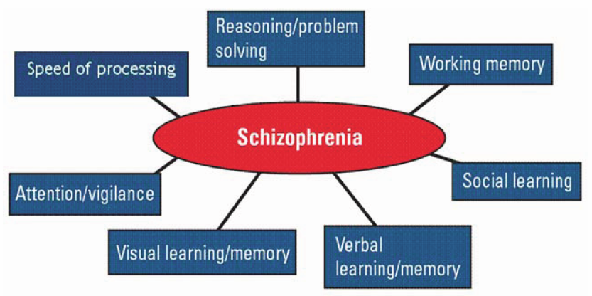
Fig. 1. The domains of dysfunctional cognitive function in schizophrenia, identified by the MATRICS initiative. Figure taken from (Sellin et al., 2008).

A popular and long established test, the continuous performance task (CPT), has been used for many years to study attentional dysfunction in schizophrenia (Rosvold et al. 1956; Mirsky, & Rosvold, 1960). Although many different versions exist, the CPT entails that a human subject has to attend to stimuli (i.e. letters) that are displayed upon a monitor. Some stimuli require an active response by a button-press (so-called go trials) while others require the subject to withhold the response (no-go trials). Schizophrenic patients are impaired on both trial types in that they have trouble to discriminate between a go – signal and a no-go signal (Nuechterlein, 1991).
Owing to the utility of the human task, attempts have been made to adapt it to the rodent. This would allow the manipulation and examination of the key components involved in performance. The result was the 5-choice serial reaction time task (5C-SRTT, Carli et al., 1983), requiring the animals to respond by nose pokes to signals at different locations, maintaining sustained – and divided - attention to the occurrence of these stimuli (Robbins, 2002). Although based upon the human version of the task, this rodent adaptation differed in several minor (e.g. number of trials to be completed, time spend on the task and number of locations to be constantly monitored) and one major aspect: the absence of "non-signal" stimuli trials (Amitai, & Markou, 2010). Despite this difference, the task has a long-standing reputation of assessing cognitive function in animal models of schizophrenia, examples being response dis-inhibition and impulsivity, cognitive flexibility and compulsivity as well as processing speed (Robbins, 2002). The 5C-SRTT has been used in a wide variety of studies, with examples being its use for measurement of effects of drug treatments (affecting the noradrenergic, dopaminergic, serotonergic and cholinergic systems), more central manipulations by neurochemical lesions, and within the framework of disorders like Alzheimer’s disease, schizophrenia and attention deficit / hyperactivity disorder (ADHD) (for a review see Robbins, 2002).
Recently, it was hypothesized that the task would be more powerful for the study of the underlying circuitry of attention and vigilance if its cross-species translatability was improved by adding the non-signal / NoGo condition (Young et al.,2009a). This effort resulted in the 5-choice continuous performance task (5C-CPT) that includes NoGo trials on 20% of total trials to be completed. With this new addition, the measurements that could be derived from training of animals in this task (accuracy, latency, omissions and perseverative responses) were extended by measurements in the framework of the broader, so-called signal detection theory (SDT, Tanner, et al., 1954 or more recently Steckler, 2001; and Young et al., 2009a). This was possible because the NoGo trials added ‘correct rejection’ (correctly inhibiting a response in a NoGo trial) and ‘false alarm’ (incorrectly responding to a NoGo trial) variables to the 'omission' (failure to respond to a Go trial), 'correct' (correctly responding to a Go trial by a nosepoke to the right location) and 'incorrect' (incorrectly responding to a Go trial by a nosepoke to another location) response variables measured.
The SDT was set up as a means to quantify the ability to discriminate between signal (here: Go trials) and noise (here: NoGo trials). Past experience, expectations of a situation, the current physiological state as well as several other factors can determine detection thresholds, placing the observing subject in a position of an active decision maker. Response biases as well as real sensitivity are disentangled by the measures used. An example is provided in the paper by Duncan, et al. (1971) and is re-discussed in the framework of the SDT in the paper by Steckler (2001). Duncan’s example entails the presentation of the possibility that two strains of mice differ in their response to stressful situations, such as being placed in the testing chamber. The response of one strain to this stress might be increased locomotor activity while the other may show freezing. When these two strains are tested on a cognitive test, these different stress-responses might look like strain differences in performance on the task. In his paper, Steckler shows that the SDT, however, is able to disentangle non-cognitive (anxiety or stress-related, biases) from cognition-related effects by assessing the difference between the current state of the animal, i.e. motivation, and the sensitivity of the neurobiological substrates that mediate cognition. The specific method and protocol for conducting the test will be presented in the methods section.

The newly revised 5C-CPT is a useful translational tool to assess attentional dysfunction associated with schizophrenia in rodents. However, schizophrenia does not naturally occur in these animals and needs to be modeled. This is done by a focus on the symptoms observed in schizophrenia and the finding that different neurotransmitter systems and genetic factors are involved in its etiology. The models aim on inducing similar behavioral changes, symptoms and disrupted genetic or neuronal substrates as observed in the human disorder, in animals (Pantelis, et al., 2003). For pharmacological and genetic manipulation resulting in these changes, several means are available and those used will be discussed in the following along with their theoretical background.
The dominant neurochemical theory of schizophrenia is the dopamine hypothesis (Carlsson, & Lindqvist, 1963; Bai et al., 2004). Dopamine as a neurotransmitter has a wide variety of roles in behavior and cognition - with the examples of attention, working memory and learning, as well as in associations of punishment and reward, mood and motivation, voluntary movement and sleep (for a review see Arias–Carrion, & Poeppel, 2007). The dopamine hypothesis of schizophrenia specifically attributes the positive symptoms observed in the disorder to an abnormal and hyperactive dopaminergic function in the mesolimbic pathway (projecting to the striatum, Stevens, 1979) while negative and cognitive symptoms are ascribed to a hypoactive mesocortical dopaminergic pathway (projecting to the frontal cortex) (Abi-Dargham, & Moore, 2003).
Some of the strongest support for the dopamine hypothesis of schizophrenia comes from the effects of amphetamine on normal people and schizophrenic patients. In previously diagnosed and medicated schizophrenics, ingestion of amphetamine has been shown to cause a relapse into psychosis (Ujike, 2002). Also, amphetamine is able to induce and potentiate psychotic symptoms in healthy control subjects or schizophrenic patients, respectively (Laruelle, et al., 1997; Kegeles, et al., 2000). By means of an imaging study it was shown that the drug triggers a greater amount of dopamine release in the striatum in non-medicated schizophrenics than in controls (Laruelle et al., 1997). Post – mortem analyses of human brain tissue have shown that the number of D1 receptors is up-regulated in the prefrontal cortex (PFC, Abi-Dargham, et al., 2002) while the activity of the transporter responsible for its reuptake is decreased there (Akil, et al., 1999), probably caused by a compensation to chronic low levels of dopamine.
Together, these findings suggest a role of dopamine dysfunction in the etiology of schizophrenia, with a very sensitive system in schizophrenics and neurobiological abnormalities even on the molecular level. Therefore, amphetamine has been included in the research presented here. While not the same as full blown schizophrenia, amphetamine use - with its influences on the dopaminergic system - may mimic (in mouse and man) some of the neurochemical conditions seen in humans that suffer from the disorder. Additionally, due to a population of patients that abuse amphetamine or use it as a recreational drug, findings based on its experimental use can be used to further validate rodent models.

After some doubt was cast on the idea that aberrant dopaminergic function was the sole origin of schizophrenic symptoms (Konradi, & Heckers, 2003), another very popular theory was formulated which deals with the glutaminergic neurotransmitter system. Glutamate is the major excitatory neurotransmitter in the central nervous system (CNS) and is considered to be the master 'switch' of the brain, owing to the fact that it can excite and turn on all types of CNS neurons (Mattson, 2008). It is involved in neurogenesis, neurite outgrowth and synaptogenesis and therefore plays a crucial role in neuronal plasticity. This plasticity, called long-term potentiation (LTP), is important for cognitive functions like learning and memory (McEntee, & Crook, 1993). The glutamate hypothesis of schizophrenia (Kim et al., 1980) specifically describes the finding of NMDA glutamate receptor hypofunction in patients. It seems that NMDA receptors in the cortico-brainstem glutamate pathway (projecting from cortical pyramidal neurons to the brain stem neurotransmitter systems of serotonin, dopamine and norepinephrine) are hypoactive in schizophrenia (Marek, 2010). This leads to a loss of tonic inhibition of the mesolimbic dopamine neurons (Pehrson, & Moghaddam, 2010), a finding that nicely fits with the dopamine hypothesis discussed previously. Support for this theory comes from several sources, among which findings based on the action of NMDA receptor antagonists such as phenylcyclidine (PCP) on the brains of schizophrenic and healthy subjects, findings from post mortem brain studies on dopamine receptor levels and genetic studies on the association between NMDA receptor genes and schizophrenia.
As with the dopamine hypothesis, the best support for the glutamate hypothesis comes from drugs blocking glutamate transmission (ketamine, PCP). If NMDA receptors are made hypofunctional by exposure to these drugs, a psychotic condition - including positive and negative symptoms as well as cognitive dysfunction - is induced in healthy control subjects, that is very similar to schizophrenic symptoms observed in patients (Lahti et al., 2001). Also, PCP and ketamine are able to exacerbate these symptoms in subjects previously diagnosed with the disorder (Coyle, 2007). Post mortem studies on the brains of schizophrenic subjects have revealed abnormally low levels of glutamate receptors (Coyle et al., 2003), giving more support to the glutamate hypofunction theory of schizophrenia. Furthermore, it has been shown that there is an association between individual NMDA receptor subunit allelic variants and schizophrenia (Tang et al., 2006).
Together, these findings suggest a role of glutamate hypofunction in the etiology of schizophrenia, with the dysfunctional glutamate system inducing abnormalities in several other neurotransmitter systems, including dopamine. Therefore, PCP has been included in the research presented here. It exerts its antagonistic effects by entering the ion channel from the outside of the neuron and binding, reversibly, to the channel pore (Flores et al., 2007). There, it blocks the flux of positive ions into the cell and inhibits depolarization of neurons.
The use of PCP does not result in a full-blown schizophrenic disorder. However, it induces symptoms that are very much alike those observed in patients and also impacts the same neuronal systems that are thought to be impaired in the disorder. Additionally, abnormal behavior with schizophrenia-like symptoms has previously been reported in animals exposed to the substance (for a review, see Bubeníková-Valesová et al., 2008). Last but not least, as with amphetamine, there is a pool of data on a patient population that abuse PCP available for back-comparison of the results to humans (Javitt, & Zukin, 1991). However, it is interesting to note failure of glutaminergic drugs to treat the positive symptoms od schizophrenia (Tuominen et al., 2005). Therefore, so-called circuit-based models (Lisman et al., 2008) try to integrate the dopaminergic and glutaminergic theories into one comprehensive framework.

While these two approaches model the roles of the two most influential hypotheses, their value can be appreciated more if they are contrasted with a model of a system thought not to be involved with schizophrenia but that still influences attention. The acetylcholine neurotransmitter system and its dysfunction is involved in Alzheimer’s disease (AD), where disruption of cholinergic projections is thought to be a main contributor to the cognitive deficits seen in the disorder (Cummings, & Kaufer, 1996). Evidence for this also comes from the fact that symptoms of AD are relieved by inhibiting the breakdown of cholinergic transmitters, prolonging its effect in the synaptic cleft. The drug donepezil (an acetylcholinesterase inhibitor, Birks, & Harvey, 2006) is therefore used as medication for AD.
Here, we use scopolamine, a competitive antagonist at the muscarinic type acetylcholine receptors (Mahmoodi et al., 2010) to mimic dysfunction of the cholinergic system . Inactivation of these receptors does result in attentional impairments while having minimal effects on learning (Klinkenberg, & Blokland, 2010). Scopolamine can be used as a negative control as it has anticholinergic and antimuscarinic actions (Levy-Cooperman et al., 2010), making it less relevant to schizophrenia. Again, the drug allows modeling symptoms and underlying neurobiological pathologies of a human disorder (this time AD) in animals while it does not represent the full blown disease. As with amphetamine and PCP, the drug has been used in humans and therefore, a comparison to its effect in humans is possible (Robbins, et al., 1997).
With pharmacological models covering the inducible, neurochemical component of the supposed development of schizophrenia, the genetic component has should not be neglected. The genetic models of schizophrenia attempt to represent the situation as found in a subset of human schizophrenic patients – i.e. disrupted brain circuitry due to aberrant neurodevelopmental processes and protein interactions based on mutated and dysfunctional genes (McCullumsmith et al., 2004). The genetic liability to schizophrenia is transmitted in a polygenic, non-Mendelian fashion (Risch, 2000). As such, multiple genetic models of schizophrenia exist. Of these, the Disrupted-in-Schizophrenia (DISC1) gene, is of great interest (e.g. Brandon et al., 2009). The gene was initially identified in a family study of a very large Scottish pedigree (St. Clair et al., 1990). It has been termed a 'susceptibility gene' because of its localization to the so-called breakpoint of a balanced chromosomal translocation t(1;11)(q42;q14.3) that co-segregates with major psychiatric disorders (LOD scores = 4–7) among which is schizophrenia. This translocation disrupts two genes later called DISC1 and DISC2 on chromosome 1 (Millar, et al., 2004).
The functional DISC1 gene product acts as a scaffold protein, mediating the binding to several other proteins, facilitating the formation of protein complexes. As a result, it exists in a protein interaction complex with NudE- like (NUDEL) protein and LIS1 which is implicated in neurite outgrowth, neuronal migration and the complexity of dendrite arbors (McCullumsmith et al., 2004). Additionally, it interacts with several other proteins, among which fasciculation and elongation protein zeta-1 (Fez1, Matsuzaki, & Tohyama, 2007). When the gene is mutated, i.e. by truncation (Pletnikov et al., 2008), the interactive complexes are not formed and deficits and abnormalities are detectable. These abnormalities do consist of the effects of lost protein interaction with NUDEL and LIS1 (neurite outgrowth, neuronal migration, complexity of dendrite arbors). Also, when the interaction with Fez1 is lost, more gross problems with circuit formation may result (Matsuzaki, & Tohyama, 2007).
Following this line of evidence, the transgenic model taken up in the research presented here is the DISC1 transgenic mouse. This model has been presented previously as a very promising genetic translational model (Pletnikov et al., 2008, who developed and inducible variant of it). The characteristic features of this model are similar to alterations and deficits that have been found in schizophrenic patients (e.g. Buchanan, & Carpenter Jr.1997; Harrison, 2004). DISC1 is expressed throughout the brain (Hennah et al., 2009). Its dysfunction in mice is associated with abnormalities in structures like the hippocampus and prefrontal cortex, lateral ventricle enlargement, attenuation of neurite complexity in primary cortical neurons, decreased dendritic arborization in cortex and hippocampus (Pletnikov et al., 2008), white matter reductions, disrupted cAMP signalling (Chubb et al., 2008), aberrant and accelerated neuronal progenitor cell migration (Mao et al., 2009), axon guidance and outgrowth (McCullumsmith et al., 2004), as well as dendritic development, leading to inappropriate positioning of new neurons (Mackie, S. et al., 2007). Based on these neurobiological findings (especially the abnormalities found in the hippocampal - prefrontal cortex circuitry), it was expected that DISC1 mutant animals would express similar behavioral deficits as seen in schizophrenic patients, i.e. deficient, spatial navigation, attention, executive functioning, working, short- and long-term memory, and speed of processing (Young, et al., 2009b). However, initial studies of the DISC1 transgenic animals used here show only moderate effects on hyperactivity in an open field, social interactions and spatial memory (in female mice only) (Pletnikov, et al, 2008). It was unclear what phenotype they would express in more demanding tests of cognition.

The use of the exciting new 5C-CPT protocol under the lead of the SDT will help us understand the neurobiological underpinnings of attentional disruption in the devastating disorder of schizophrenia. The distrupted dopaminergic and glutaminergic neurotransmitter systems that supposedly contribute to its development will be modeled in wild-type animals by amphetamine and PCP, respectively. Additionally, the genetic contribution to the etiology of the disorder will be modeled by the assessment of the DISC1 transgenic mouse model.

Results
The associated figures can be found in the attachment.
Pharmacological study

When the animals were fully trained and highly accurate on both go (around 80%) and NoGo trials (around 95%), the effects of different compounds on the go-NoGo performance in the 5C-CPT were assessed. A Latin square design was used for each compound and mice were first subjected to PCP, then scopolamine and finally amphetamine. For each drug, the parameters calculated and recorded will be presented separately. To facilitate more qualitative comparison and discussion later, however, the figures will present the results of all three drugs per parameter. Comparisons between groups in the text are expressed as mean ⁺ SEM.

Amphetamine
Amphetamine treatment (1 mg/kg) resulted in significant effects on the standard 5C-SRTT measure accuracy (t(6) = 0, p < 0.02, Fig.4a), with a decrease on only the go trial proportion of the test (0.68 ⁺0.05 for the amphetamine group vs. 0.79 ⁺ 0.05 for the vehicle group). The NoGo portion of the test was unaffected. Following this effect found on only the Go trials, the calculation of the proportions correct, incorrect and omissions for the Go trials showed that it was the correct responses (t(6) = 0, p < 0.02, Fig.5a) and omissions (t(6) = 0, p < 0.02, Fig.5a) that were affected, i.e. a decreased proportion of correct responses (0.48 ⁺ 0.06 for amphetamine vs. 0.66 ⁺ 0.05 for vehicle) and an increased proportion omissions (0.3 ⁺ 0.05 for amphetamine vs. 0.15 ⁺ 0.04 for the vehicle group). The incorrect responses were the same for both groups. Also, there were no differences in perseverative responses (Fig. 6a) or latencies (Figs. 7a and 8a) between the amphetamine- and vehicle- treated groups. Within the framework of the SDT, amphetamine- injections (as compared to injections with the vehicle) resulted in decreasing effects on several of the calculated parameters. A' (t(6) = 0, p < 0.02, Fig.10a, 0.84 ⁺ 0.03 for the amphetamine group vs. 0.91 ⁺ 0.02 for the vehicle group), SI (t(6) = 0, p < 0.02, Fig.11a, 0.55 ⁺ 0.08 for the amphetamine group vs. 0.72 ⁺ 0.07 for the vehicle group), P(I) (t(6) = 0, p < 0.02, Fig.15a, 0.77 ⁺ 0.04 for the amphetamine group vs. 0.85 ⁺ 0.03 for the vehicle group), and log d (t(6) = 0, p < 0.02, Fig.16a, 0.4 ⁺ 0.13 for the amphetamine group vs. 1.88 ⁺ 1.24 for the vehicle group) were all decreased in value. This is not surprising as they all reflect different kinds of accuracy or sensitivity measures and show what had been found on the standard accuracy measure already. The other three parameters, B'', RI and Index Y (Figs. 12a, 13a, and 14a respectively), reflecting different bias measures, did not differ between the groups. Together, these findings indicate that animals treated with amphetamine had problems with the Go portion of the test and were unaffected on the NoGo trials, with latencies and perseverative responses not different between groups. Also, the animals did not show any biased response strategies. This is nicely summarized in another product of the calculations from the SDT, a plot of the probabilities for a correct response and a false alarm to occur (Fig. 9a). Of note, two other doses of amphetamine (1.4 mg/kg and 0.8 mg/kg) were also administered in an attempt to include a dose-response study on this drug, but both doses did not result in significant effects.
PCP
PCP treatment (2 mg/kg) resulted in significant effects on the standard 5C-SRTT measure accuracy (t(7) = 0, p < 0.02, Fig.4b), this time with a decrease on only the NoGo trial proportion of the test (0.35 ⁺ 0.06 for PCP vs. 0.85 ⁺ 0.05 for the vehicle group). The Go portion was unaffected. Following this effect found on only the NoGo trials, the variables proportions correct, incorrect and omissions for the go trials (Fig. 5b) subsequently were not affected by the PCP treatment either. However, there was an increasing effect of PCP treatment on the perseverative responses measured as compared to treatment with the vehicle (t(7) = 3, p < 0.04, Fig. 6b, 92.38 ⁺ 17.39 for PCP vs. 47.25 ⁺ 10.96 for the vehicle group). Latencies to respond or to retrieve the pellets were not affected by the PCP injection as compared to the vehicle injected group (Figs. 7b and 8b). Within the framework of the SDT, PCP treatment as (compared to vehicle treatment) resulted in decreasing effects on several of the calculated parameters. These were A' (t(7) = 0, p < 0.01, Fig.10b, 0.42 ⁺ 0.08 for the PCP group vs. 0.84 ⁺ 0.02 for the vehicle group), SI (t(7) = 0, p < 0.01, Fig.11b, -0.03 ⁺ 0.08 for the PCP group vs. 0.54 ⁺ 0.05 for the vehicle group), P(I) (t(7) = 0, p < 0.01, Fig.15b, 0.48 ⁺ 0.04 for the PCP group vs. 0.76 ⁺ 0.02 for the vehicle group), and B'' (t(7) = 3, p < 0.04, Fig.12b, 0.04 ⁺ 0.04 for the PCP group vs. 0.46 ⁺ 0.15 for the vehicle group). Additionally, PCP had an increasing effect on RI (t(7) = 3, p < 0.04, Fig. 13b, 0.28 ⁺ 0.08 for the PCP group vs. -0.33 ⁺ 0.11for the vehicle group). The other two parameters, log d and Index Y (Figs. 16b, and 14b, respectively) were not different between the groups. Again, A', SI and P(I) reflect different kinds of accuracy measures. Their decrease fits with the results found on the standard measures of the 5C-SRTT - the general accuracy on NoGo trials. B'' and RI are perceptual and response bias measures respectively, and are affected by PCP, while a third, cognitive bias measure - Index Y was not. Also, log d, another accuracy measure which is tied to the occurrence of a bias, was not affected. Together, these findings indicate that animals treated with PCP had problems with the NoGo part of the test and were unaffected on the Go part. While the latencies did not differ between the groups, the PCP animals showed more perseverative responses. A change toward a more compulsive response strategy and general behavior is also suggested by the occurrence of a perceptual and a response bias. It thus was more likely that animals would respond, and it did not matter to where they would respond. Again, the plot of the probabilities for a correct response and a false alarm to occur (Fig. 9b) summarizes these results.

Scopolamine
Scopolamine treatment (0.25 mg/kg) resulted in significant effects on the standard 5C-SRTT measure accuracy (t(7) = 1, p < 0.02 for the Go trials and t(7) = 2, p < 0.03 for the NoGo trials, Fig.4c), with a decrease on Go and NoGo trials (0.44 ⁺ 0.06 for the scopolamine group vs. 0.71 ⁺ 0.05 for the vehicle group and 0.53 ⁺ 0.07 for scopolamine vs. 0.89 ⁺ 0.08 for vehicle). Following this effect found on Go and NoGo trials, the variables proportions correct, incorrect and omissions for the Go trials (Fig. 5c) subsequently were affected by the scopolamine treatment as well. This effect of scopolamine as compared to the vehicle group was a reduction of the proportion of correct trials (t(7) = 0, p < 0.01, 0.36 ⁺ 0.06 for scopolamine vs. 0.63 ⁺ 0.04for vehicle) and an increase of the proportion of the incorrect (t(7) = 1, p < 0.02, 0.43 ⁺ 0.04 for scopolamine vs. 0.26 ⁺ 0.04 for vehicle) and omission trials (t(6) = 2, p < 0.05, 0.21 ⁺ 0.05 for scopolamine vs. 0.11 ⁺ 0.02 for vehicle). Additionally, there was an increasing effect of the scopolamine treatment on the perseverative responses measured as compared to treatment with the vehicle (t(7) = 4, p < 0.05, Fig. 6c, 74.63 ⁺ 11.95 for scopolamine vs. 41.25 ⁺ 7.18 for the vehicle). Moreover, scopolamine was the only treatment that resulted in differences in the latencies (Figs. 7c and 8c), i.e. an increase in the log of the latency for a correct response (t(7) = 3, p < 0.04, 3.1 ⁺ 0.02 for scopolamine vs. 3.0 ⁺ 0.04 for vehicle) and for pellet retrieval (t(7) = 4, p < 0.05, 3.53 ⁺ 0.06 for scopolamine vs. 3.41 ⁺ 0.02 for vehicle). The latencies for incorrect responses to a Go or NoGo trial (latency false alarm) did not differ between the two groups. Within the framework of the SDT, scopolamine treatment (as compared to the vehicle- injected group) resulted in decreasing effects on A' (t(7) = 0, p < 0.02, Fig.10c, 0.41 ⁺ 0.1 for the scopolamine group vs. 0.87 ⁺ 0.04 for the vehicle group), SI (t(7) = 0, p < 0.02, Fig.11c, -0.03 ⁺ 0. 09 for the scopolamine group vs. 0.65 ⁺ 0. 08 for the vehicle group), P(I) (t(7) = 0, p < 0.02, Fig.15c, 0.49 ⁺ 0.04 for the scopolamine group vs. 0.81 ⁺ 0.04 for the vehicle group), B'' (t(7) = 2, p < 0.03, Fig.12c,0.03 ⁺ 0.04 for the scopolamine group vs. 0.6 ⁺ 0.16 for the vehicle group), and log d (t(7) = 1, p < 0.02, Fig. 16c,-1.43 ⁺ 0.85 for the scopolamine group vs. 0.41 ⁺ 0.11 for the vehicle group. Additionally, scopolamine had an increasing effect on Index Y (t(7) = 3, p < 0.04, Fig. 14c, 0.61 ⁺ 0.13 for the scopolamine group vs. 0.25 ⁺ 0.07 for the vehicle group). RI (Fig. 13c) was not different between the groups. Here, except for two latency measures (latencies incorrect and false alarm) as well as the response bias RI, all recorded and calculated measures were affected by the compound as compared to the vehicle- treated group. The accuracy measures, both traditional and the new / SDT-related ones are affected, as well as bias measures offered by the SDT. Scopolamine shows a generally very disturbed profile of results and therefore probably has fulfilled its duty on affecting attention in general, contrasting the very much more specific profiles of the other two compounds. For completeness, Fig. 9c gives a sort of summary of these results for scopolamine.

Genetic study
The assessment of the DISC1-CaMKII double transgenic mice in the 5C-CPT, based on the mean over three probe days at the end of training, has shown that the DISC1 transgene has similar effects on attentional function as a treatment with amphetamine does. The only difference to the profile of amphetamine was a different distribution of correct and incorrect responses and omissions on the Go trials. In detail, the DISC1 transgene has resulted in significant effects on the standard 5C-SRTT measure accuracy (U(10) = 10, p < 0.001, Fig.17a), with a decrease on only the Go trial proportion of the test (0.61 ⁺0.05 for the DISC1 transgenic mice of the experimental group vs. 0.87⁺ 0.02 for the CaMKII-transgenic mice of the control group). The NoGo portion of the test was unaffected. Following the effect found on only the Go trials, the calculation of the proportions correct, incorrect and omissions for the Go trials showed that it was the correct responses (U(10) = 21, p < 0.01, Fig.17b) and incorrect responses (U(10) = 10, p < 0.001, Fig.1b) that were affected, i.e. a decreased proportion of correct responses (0.47 ⁺0.05 for the DISC1 transgenic mice of the experimental group vs. 0.65 ⁺ 0.04 for the CaMKII-transgenic mice of the control group) and an increased proportion incorrect (0.3⁺0.04 for the DISC1 transgenic mice of the experimental group vs. 0.1⁺ 0.02 for the CaMKII-transgenic mice of the control group). The omissions were the same for both groups. There were no effects of the DISC1 transgene on the perseverative responses (Fig. 18) or the latencies (Fig. 19). Within the framework of the SDT, decreasing effects of the DISC1 transgene of the experimental group as compared to the control group were found on A' (U(10) = 29, p < 0.05, Fig.21a, 0.78 ⁺0.05 for the DISC1 transgenic mice of the experimental group vs. 0.85 ⁺ 0.06 for the CaMKII-transgenic mice of the control group), SI (U(10) = 28, p < 0.04, Fig.21b, 0.45 ⁺0.08 for the DISC1 transgenic mice of the experimental group vs. 0.63 ⁺ 0.09 for the CaMKII-transgenic mice of the control group), P(I) (U(10) = 29, p < 0.05, Fig.23a, 0.73 ⁺0.04 for the DISC1 transgenic mice of the experimental group vs. 0.81 ⁺ 0.05 for the CaMKII-transgenic mice of the control group), and log d (U(10) = 24, p < 0.02, Fig.23b, 0.51 ⁺0.1 for the DISC1 transgenic mice of the experimental group vs. 0.83 ⁺ 0.06 for the CaMKII-transgenic mice of the control group). Again, this is not surprising as they all reflect different kinds of accuracy or sensitivity measures and show what had been presented in the standard accuracy measure already. The other three parameters, B'', RI and Index Y (Fig. 22), reflecting different bias measures, did not differ between the groups. Together, these findings indicate that the DISC1-CaMKII double transgenic animals had problems with the Go part of the test and were unaffected on the NoGo part, with latencies and perseverative responses similar for both groups. Also, the animals did not show any biased response strategies. This is nicely summarized in the plot of the probabilities for a correct response and a false alarm to occur (Fig. 20). It should be noted that these results were surprising as no differences at all were observed between the two groups of single CaMKII - and double DISC1-CaMKII transgenic animals over a full 70 days of training. This is expressed in Fig. 25, which plots the Go and NoGo accuracy values over the whole period of training until the reach of the final parameters (0.5 s stimulus duration and 5 s limited hold). The different stages that this training took can be seen in Fig. 24, which also shows, in a cumulative fashion, how long the animals needed to reach each step's criterion.

Discussion
The research conducted for this thesis tested the two leading pharmacological models of schizophrenia in a largely novel translational assay of schizophrenia and contrasted them to a non-schizophrenia related pharmacological model. Excitingly, dissociations in the profiles of these different pharmacological approaches to modeling the disorder have been detected. Moreover, the research included transgenic animals as a genetic model for the development of schizophrenia. These also showed deficits on attentional performance when tested in the same translational assay, the 5C-CPT. Amphetamine, as a drug affecting the dopaminergic neurotransmitter system, resulted in deficits on Go trials. When examining which part of the Go - trial attentional performance (Correct, Incorrect, and Omissions) was affected most, it can be concluded that correct responses were decreased in the amphetamine-injected group due to an increase in the number of omissions, while the same amount of incorrect responses were seen in both groups. This type of behavior might be due to their excessive baseline training prior to the pharmacological challenges, preventing them from carelessly doing incorrect responses (Amitai, Markou, 2010 have argued similarly). A causal role of a lack of motivation or an effect of non-cognitive disruptions like sedation or locomotor impairment on performance can be ruled out because neither the bias measures of the SDT nor the perseverative responses or the response and pellet retrieval latencies were affected by amphetamine. Before the SDT could be implemented (i.e. in the old version of the 5C-SRTT without NoGo trials), the only available evidence to rule out biases was indirect, via latencies, the number of trials completed and the number of head entries in the food magazine (Amitai, & Markou, 2010). The SDT, however, provides direct measurements that allow to measures of multiple types of bias. They disentangle the performance of the animals in the test in terms of motivation (response bias RI, the likelihood of a response to occur), cognitive demands of the task (cognitive bias measure index Y, detecting regressions toward a simpler response strategy) and perceptual discrimination (perceptual bias measure B'' which is associated with the values of the choices). The standard 5C-SRTT measure 'perseverative responses' also is of relevance when deducing the origin of the attentional deficits found with amphetamine (i.e. real attentional deficits vs. non-cognitive disruptions or biases explaining the pattern of results). Increased compulsive behavior - as measured by the number of perseverative responses done after a pellet is earned but not yet retrieved - reflects a bias, i.e. an increased likelihood of a response to occur. Compulsivity is therefore not induced by amphetamine in this test, at this dose. Overall, the profile, as measured by all available variables, is very consistent and allows the conclusion that amphetamine affects the ability to attend and respond to a signal when it occurs. This is not due to motivation or other non-cognitive impairments but due to attentional deficits induced by the drug.
PCP, as a drug affecting the glutaminergic neurotransmitter system, resulted in deficits only on the NoGo trials, a dissociation from the effects seen with amphetamine. Without the addition of the non-signal trials, PCP would have looked like it did not affect attentional performance at all as the standard 5C-SRTT only included Go trials. Accurate NoGo trial performance requires the animal to inhibit a response flexibly in 20 % of all trials. Failure to do so, as induced by PCP, might result from attentional deficits and troubles in discriminating a non-signal from a signal, or might be due to increased activity, hyperlocomotion and other non-cognitive deficits. Indeed, Amitai, & Markou (2010) suggest, that, at doses that have an effect on accuracy, NMDA - receptor antagonists like PCP are known to induce hyperlocomotion. A rather compulsive and biased pattern of results is found with PCP in the study presented here. This is also represented by an increased amount of perseverative responses in the PCP-injected animals as compared to the vehicle-injected group. However, there is reason to believe that this is due to attentional and not non-cognitive deficits. The first and foremost reason for this is the fact that none of the latencies is affected by the drug. Even though the number of perseverative responses - which by definition occur before the pellet is retrieved - is higher, there is no increase in the latency to retrieve a pellet, allowing the idea that the motivation as expressed in the speed of the mouse to pick up the pellet is rather increased than decreased. Also, the other latencies for correct and incorrect responses are the same, indicating, that there is no abnormal hyperactive behavior present. As there is no effect of PCP on the Go trials, it can be inferred that the PCP-injected animals have no problem perceiving the stimulus and to respond at the correct location, an ability which might be called formation of a strategy or executive function. How these cognitive abilities are linked to Go and NoGo trial performance and what role the different neurotransmitter systems might have in this will be discussed in a later part of this section. A hypothesis that assumes that these abilities are intact additionally is supported by the fact that there is no effect of PCP in terms of a cognitive bias (Index Y), i.e. the animal does not start to respond only to the occurrence of the stimulus and not its location. Therefore, some cognitive process is involved that keeps up the trained problem solving strategy but which is disrupted when a non-signal stimulus is presented. There is, however, a perceptual and a response bias. It seems that the relative value of the choices has been affected and that the likelihood of a response to occur is increased, as would be expected in the light of increased perseverative responses and disrupted response inhibition on NoGo trials. Based on these findings it can be concluded that PCP induces an attentional deficit that specifically impairs NoGo trial performance, i.e. the ability of the animals to perceive a non-target correctly and withhold responding. This does not seem to be due to a general increase in activity (e.g. hyperlocomotion) but to attentional impairments, for example keeping the rule in mind. However, this conclusion should be verified by running a full dose-response study in a future experiment.
Scopolamine, which is used as a negative control in this study and which exerts its effects on the cholinergic neurotransmitter system, has resulted in a more generally disturbed pattern of results, affecting both Go and NoGo trials. This is a third profile, next to amphetamine (impaired Go trial performance) and PCP (impaired NoGo trial performance), that enriches this study's assessment of attentional dysfunction related to schizophrenia. The results obtained fit with what is expected from scopolamine's use as a negative control. In this task of attention and vigilance, the aim of its use was to induce general deficits without a specific pattern or profile. While the vehicle was used to model the normal situation for the animals with full attentional capacities, scopolamine represented the other end of the spectrum, with total attentional dysfunction, with PCP and amphetamine in between, which had trial-type- specific effects. That this complete disruption was successful can again be concluded from the available accuracy measures from standard and new 5C-protocols. What is interesting is, that, when examining the changes in Go trial performance, based on the proportions correct, incorrect and omissions, one cannot disentangle the specific origin of the deficit. It is not only the omissions that are increased while the correct responses are decreased, but also, the incorrect responses are increased. The animals did not just have trouble to discriminate a signal trial from a non-signal trial, but also the correct location of the signal. Moreover, scopolamine was the only drug in this study that had an effect on the latencies, specifically on the latencies correct and pellet retrieval. Together with the increased perseverative responses and a perceptual and cognitive bias found, one can assume that these animals had great difficulties performing the test. The only parameter not impacted by the drug was the response bias index RI. The likelihood that a response occurred was therefore not higher than in the vehicle-injected animals. However, the conclusion to be drawn based on increases in latencies, effects on both trial types, bias measures, perseverative responses and also a reduced number of trials in these animals (data not shown) is, that the impaired performance measured after scopolamine administration is most likely due to side - effects of the drug (decreases in motivation and decreased visual acuity as scopolamine induces pupillary dilation by antagonizing the muscarinic acetylcholine receptors in the eye and is very similar to atropin, Toja et al., 1994). A full dose-response study would have helped to find more subtle effect of the drug on attentional performance as there, undoubtly, is an intermixing of possible cognitive effects induced by scopolamine (modeling diseases like Alzheimer's disease, Robbins, 2002) and side-effects already induced at very low doses of scopolamine (Klinkenberg, & Blokland, 2010).

The aim of the pharmacological portion of the study was to disentangle how the dysfunctional neurochemical systems, represented by the actions of different compounds, are involved in attentional dysfunction of schizophrenia assessed by the 5C-CPT. Knowledge about the involvement of the neurotransmitters in test performance on the 5C-CPT can be used to contrast and compare the dissociable profiles of the three drugs, and to draw conclusions with relevance to human schizophrenia. From these profiles, it can be deduced that there possibly is a dissociation between the impact the two drugs have on the neurotransmitter systems that mediate the ability to successfully do Go trials versus the ability to do NoGo trials. The drug affecting the dopaminergic system (amphetamine) resulted in a profile of impaired Go trial performance while the drug affecting the glutaminergic system (PCP) resulted in impaired NoGo trial performance. It should be kept in mind, that both drugs used do not only specifically target their neurotransmitter systems only but that the brain is a complex organ in which different neurochemical systems cooperate with each other strongly over time (e.g. see Jones, & Kauer, 1999 for evidence of the widespread effect of amphetamine on not only dopamine but also other neurotransmitter systems). A complex interaction between the dopaminergic and glutaminergic involvements in test performance throughout the whole session is therefore likely. For a better overview, however, the two systems will be discussed separately in the following paragraphs.
Dopamine is involved in attention, working memory and learning as well as in associations of punishment and reward. In a review by Robbins (2002), the dopaminergic system with the ventral and dorsal striatum as well as the PFC has been linked more to response- and less to rule-related processes (Robbins, 2002). This means that, in the 5C-CPT, the dopaminergic system as activated by amphetamine is involved in mediating the performance within one type of trial, and the action of actually responding to a stimulus. It seems to be initially less relevant for performance that is related to shifting between types of trials and withholding a response, as required in the NoGo trials. Also, the significant role of DA in stimulus-reward associations is important for responding to the stimulus itself and not discriminating between different types of stimuli. This has been linked to the cognitive abilities 'executive functioning' and 'strategy formation' by Amitai, & Markou (2010) as well as Robbins, & Roberts (2007). After an amphetamine injection, it seems that the learned rule for discriminating the two different types of trials is still adhered to, and performance is undisturbed when no response is required to obtain a reward. However, when the mouse is required to detect a stimulus and respond at the correct location, attentional problems arise. Robbins (2002) and Young et al. (2009a) call these: impairments in 'sustained attention'. Similar results as the ones obtained here have also been reported elsewhere (Loos et al., 2010; personal communication with J. Young, but see Robbins, 2002).
The concept that the aforementioned 'sustained attention' is necessary for Go trials is contrasted in the literature with the concept of ‘divided attention' (Robbins, 2002) or 'vigilance' (Young et al., 2009a), which might be a requirement for NoGo trials. As part of a test of attention, the NoGo trials of course need executive control and the ability to form and follow a strategy, but the type of response required to these trials is exactly opposite from what is needed for Go trials - the inhibition of a response. Also, these trials occur at only 20% of all trials started in a test session and as such, cognitive flexibility is a very important component to successfully master the NoGo trial part of the task. Therefore, authors like Amitai, & Markou (2010) as well as Robbins (2002) and Young et al. (2009a) have implicated different cognitive abilities in this type of trials than in Go trial performance, namely response inhibition, mental flexibility and vigilance as it is thought to be present in humans. The profile found in the study presented here allows the conclusion that these mental abilities might be initially driven by a different neurotransmitter system than the dopaminergic system involved in Go trial performance. Based on the results obtained after PCP injection, i.e. impaired NoGo trial performance, increased compulsive behavior and an increased likelihood to respond, this neurotransmitter system might initially be glutamate. Glutamate is the major excitatory neurotransmitter in the CNS and is considered to be the master 'switch' of the brain, owing to the fact that it can excite and turn on all types of CNS neurons (Mattson, 2008). It seems that this excitatory function of glutamate results in problems to maintain the rule during the test (Robbins, 2002) and that the animal is driven to respond to all trials. This failure to control behavior or dysfunctional 'response inhibition' can be called the core attentional deficit in impaired performance on NoGo trials. It is the anterior cingulate cortex that has been implicated in this inhibition and also in compulsive behavior as measured by the perseverative responses here (Robbins, 2002). The connection of this brain area with inhibition is also of relevance to other disorders. An example is obsessive-compulsive disorder (OCD), in which unnaturally low levels of glutamate activity in the anterior cingulate cortex and excessive glutaminergic function in the other parts of the brain drive compulsive behavior (Pittenger, et al., 2006). With this established role of glutamate function in inhibitory control and the described impairments in NoGo trial performance, the second part of the dopamine - glutamate dissociation of 5C-CPT performance is complete. The influence of other, non-cognitive effects has been discarded earlier.
Scopolamine has resulted in strongly disrupted behavior on the task, with impairments on both Go and NoGo trials as well as strongly biased responding and increases in latencies. It is a compound that also disrupts attention, but which has no action on a neurotransmitter system of relevance to schizophrenia. Therefore, scopolamine was used in this study to contrast the more specific, attention-disruption profiles of PCP and amphetamine. Authors, such as Robbins (2002), have reported decreased attentional performance after exposure of rodents to scopolamine, but have also indicated that the studies using this compound have not lead to a consensus on the precise patterns of results. In the study presented here, it is difficult to conclude on the effects the anticholinergic compound had on attention because of severe side-effect obtained with the dose used. As with the other two compounds, the inclusion of a proper dose-response study might have resulted in some more insights on scopolamine's action on attention.
The results presented on the pharmacological part of this study allow the conclusion that the compounds amphetamine and PCP and their impact on the brain may model different aspects of schizophrenia, even though both result in attentional impairments. It was only possible to find the dissociation between PCP and amphetamine because of the possibility to implement the SDT for analysis of the results. Without the SDT measures, PCP would not have resulted in a meaningful impairment, no dissociation would have been found and there would have been less parameters to rely on to conclude about probable influences of non-cognitive factors (i.e. any biases). However, a full dose-response study is necessary to confirm this conclusion.

The second part of this study consisted of the testing of a DISC1-CaMKII transgenic animal model. After a long period of training during which no differences with the control group were detected, there was an effect of the DISC1 transgene at the most challenging test parameters, i.e. a stimulus duration of 0.5 s and a limited hold of 5 s. Training stages before possibly were not challenging enough to detect attentional impairments. When finally these disruptions were detected, the profile of DISC1 was found to be very similar to the effect amphetamine had on performance, with a reduction in accuracy on the Go trials only. However, the underlying distribution of responses that caused this effect was different from amphetamine treatment. It was not the omissions, but the incorrect responses that were increased at the cost of a decrease in correct responses in the DISC1 mice. In the literature, dysfunction of DISC1 protein synthesis has been implicated in attention, executive function, working memory and speed of processing (Young et al., 2009b) and has been shown to cause neuroanatomical abnormalities in the hippocampus and the PFC (Pletnikov et al., 2008). The dopamine system has been linked to these same structures and functions (Robbins, 2002). Therefore, obtaining a profile of DISC1 in this test that is very similar to what has been found with amphetamine i.e. effects on Go trials, is not surprising, given the fact that both are involved in similar cognitive abilities and brain structures. The dopaminergic system might be the link between both (Lipina et al., 2010).

Although exciting, these data do have limitations. The most obvious of these is the missing of a dose-response curve for all compounds used. Next, the study would have benefited from more animals in the different groups. The pharmacological studies were done based on 8 animals which were almost a year of age at the end of the study. Increased group sizes will also allow detecting fine differences between the models. Last but not least, the transgenic animal model used was a line of low expressers on a hybrid background (B6;SJL;CBA). This means that the hDISC1 truncated gene product was introduced on a background that already might have had in some behavioral abnormalities. The truncated hDISC1 additionally did not show strong expression and therefore, the influences of the mutated DISC1 on the brain were minimal. Using a line with higher expression of the transgene product might have resulted in more pronounced results, which could more accurately model the human condition.

This study has tried to forward the understanding of attentional impairments as found in schizophrenic patients. By using the animal models, it could be shown that drugs impairing the dopaminergic and glutaminergic neurotransmitter systems result in dissociable profiles when assessed in the same translational assay of attentional function. Schizophrenic patients have been shown to be disturbed on the human version of the CPT in a more general manner, with difficulties on both Go and NoGo trials. The work with the two leading neurochemical hypotheses of the development of schizophrenia would suggest that both dopamine and glutamate have causal roles in the etiology of the disorder. If these two interacting systems contribute their dissociable parts to attentional dysfunction, a pattern of results as actually observed in human patients is the logical result. Moreover, the genetic model taken up in this study has contributed to this understanding of the origin of attentional dysfunction in schizophrenia. Being a susceptibility gene, it seems as though DISC1 might have a similar impact on cognitive abilities and the development of schizophrenia as a dysfunctional dopaminergic system has. Possibly, the aberrant neurodevelopmental processes as induced by a dysfunctional DISC1 gene have their impact indirectly on dopaminergic function (interestingly, an idea also expressed in Lipina et al., 2010).
The results of this study allow a better understanding of the origins of cognitive deficits in human schizophrenic patients. These results suggest that there is a complex interaction between the contributions of dysfunctional dopaminergic and glutaminergic neurotransmitter systems in the development of the attentional deficits of schizophrenia. Targeting these two systems simultaneously will possibly constitute a new target pathway for drug development.

Methods
Pharmacological study
Animals
Eight male, wild type C57BL/6J mice were obtained from Janvier (France). The mice were individually housed in ventilated cages on sawdust bedding, maintained at approximately 85% of free- feeding body weight with water ad libitum and kept under 12:12-h light/dark cycle (lights on at 0600) in a temperature (24°C) - and humidity-controlled room. Testing of the animals was conducted during the light phase of the light/dark cycle in the same room in which they were housed. Training began at approximately 3 months of age with the mice weighting between 20 and 40 g. All experiments were performed in accordance with the European Communities Council Directives (86/609/EEC) and were approved by the local ethical committee.
Drugs
The drugs used for this study were all prepared in-house and dissolved in a 0.9% saline vehicle. Doses were selected based on the literature. Amphetamine was given in a dose of 1 mg/kg 20 Min. before the test, PCP was given in a dose of 2 mg/kg 15 Min. before the start of the test and scopolamine was given in a dose of 0.25 mg/kg 30 Min. before the test. All drugs were administered in a volume of 10 ml/kg. The design of treatment was a Latin square and three separate experiments were conducted, one per drug. The mice were first subjected to PCP, then scopolamine and finally amphetamine. On each occasion, half of the animals were treated with the drug and half were treated with the vehicle. These groups were then switched to the other treatment four days later, keeping up a schedule of two days of baseline training and two days of rest in between (treatment on Thursday, followed by baseline training on Friday and Monday and two days of rest on the weekend in between). The next experimental treatment was then started on the Thursday of the following week allowing for a wash-out period and re-acquisition of pre-treatment performance of 9 days.

Genetic study
Animals
11 male DISC1 - CaMKII double transgenic (experimental) as well as 11 male CaMKII single transgenic (control) mice were bred and reared in-house. The generation of these transgenic mice has been described in detail elsewhere (Pletnikov, et al., 2008). These mice were individually housed in ventilated cages on sawdust bedding, maintained at about 85% of free- feeding body weight with water ad libitum and kept under 12:12-h light/dark cycle (lights on at 0600) in a temperature (24°C) - and humidity-controlled room. Testing of the animals was conducted during the light phase of the light/dark cycle in the same room in which they were housed. Training began at approximately 3 months of age with the mice weighting 20 - 30 g. All experiments were performed in accordance with the European Communities Council Directives (86/609/EEC) and were approved by the local ethical committee.

Apparatus
Training and testing was conducted in eight five - hole operant chambers (25 x 25 x 25 cm) with an attached corridor (8 x 5 x 16 cm) leading to a pellet dispenser (see Fig. 2, all Med Associates Inc., Georgia, VT). Each of these chambers consisted of an array of five round holes (1.3 cm in diameter) which were arranged horizontally on a curved wall 5 mm above the grid floor opposite the corridor. At the end of the corridor leading to the pellet dispenser, a food well was attached at floor level. Additionally, a house-light was installed at the ceiling of the main chamber. The whole set-up was located in a sound - attenuating box which was ventilated by a fan that also provided a low level of background noise. An infra-red camera was installed in each chamber that allowed observation of the performance during testing and training. The mice were trained to respond with a nose poke to an illuminated LED installed in the back of the holes. Responses were detected by infrared beams located vertically 2 mm from the opening of the holes. Rewards for correct responses to the different types of stimuli were given in the form of mouse pellet reinforcers (ResDiet, AIN-76A Rodent tablet, 12 mg) that were delivered to the food magazine located at the outer end of the corridor. Magazine entries as well as movement through the corridor were also monitored using infrared beams, one mounted horizontally, 3 mm from the floor, located 5 mm deep in the magazine and 2 mounted at the beginning (2 cm into the corridor) and in the middle (at 8 cm into the corridor) of the corridor (1.5 cm and 5 mm up from floor level, respectively). The control of stimuli and recording of responses were managed by a SmartCtrl Package 8-In/16-Out with additional interfacing by MED-PC for Windows (Med Associates Inc., St. Albans, VT) using custom programming.
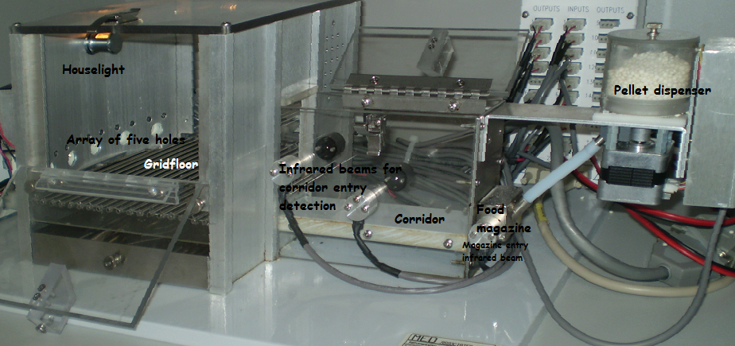
Fig. 2. Picture of the novel set-up of the operant chamber with denotations for the different parts of the box (own photograph).

Training
Prior to training and subsequent testing, the animals were handled and weighted daily for at least two weeks. One week before training started, the food-restriction schedule was implemented, with the mice receiving reduced food to reduce their body weight to about 85% of free-feeding weight gradually over this week. The amount of restricted food was later reduced by the amount of rewards the mice were eating during training and testing. During the last 3 days of the restriction schedule, the mice were also introduced to the mouse pellets used as a reward in the test. One day prior to start of the training, the animals were then placed into the boxes for about an hour to allow them to adapt to the new environment.
Training consisted of several phases. Day 1 to 3 of training involved a magazine training to associate the food tray with a reward, each session being 60 Min. long. For day 1 of this protocol, twenty of the reward pellets were available in the food tray and one crushed reward pellet was placed in each of the nose poke holes. On day 2, ten pellets were available in the food tray and one was put in each hole. Additionally, one pellet fell down into the magazine a variable time interval (up to 5 seconds) after each time the animal left the corridor. On day 3, no pellets were placed in the food tray, but still, one was available in each hole. Again, one pellet fell down a variable time interval after the animal left the corridor. The house light stayed on at all times.
The next 3 days of training constituted a nose poke-to-light training protocol without punishments. A light in one of the holes was illuminated and stayed on until the animal had poked its nose there, which was followed by the delivery of a reward. In the subsequent trials a different hole would be illuminated. For the first day of this three-day training protocol, one crushed pellet reward was placed in the holes again, to remind the animals of these possibilities to pick up a reward. These sessions lasted 60 Min. - or 120 trials completed.
On day 7, the real Go - NoGo training began. This training started with no NoGo trials occurring, a stimulus duration (SD, hole illuminated) and limited hold (LH, hole not illuminated anymore but detection still open for a nose poke) of 30 seconds and a session duration of either 60 minutes or 120 trials completed, whichever occurred first. The animal was allowed to respond to a trial during either SD or LH. Each of the trials was initiated by the mouse nose-poking in the food tray and then leaving the corridor, facing the wall with the holes, where the stimulus was then presented. This attendance to the wall was the reason of the addition of the corridor to a set-up that was used earlier by Young et al. (2009a), as this addition ensures that the animal is able to attend properly to the presented stimulus. The animal was required to respond to this stimulus by nose poking to the illuminated hole. A response to a different hole (incorrect response) or a failure to respond (omission) was followed by a timeout during which the house light was switched off for 5 seconds, while a response to the illuminated hole (correct response) was followed by a reward delivered by the pellet dispenser to the food magazine directly after the nose poke and the house light staying on the whole time. This type of training was done until the animals reliably did at least 50% of trials correct, with an accuracy of 80% and less than 20% omissions for at least 2 consecutive days. The calculation of the different parameters will be presented under the heading 'Parameters and Calculations' in this method section. The following stages consisted of decreases in SD and LH until both were 5 seconds long. The steps in between were 20, 10 and 8 s for both SD and LH.
The next stage introduced the mice to NoGo trials together with the already learned go trials in a correction trial protocol, with the NoGo trials (all holes illuminated instead of only 1 during a go trial, see Fig. 3) requiring a mouse to withhold the response for a reward. Initially this was set at 50% of trials, but as performance improved it was reduced to 20% of trials. Correction trials meant that if a certain trial, independent of whether it was a Go (requiring the animal to respond to the light to receive a reward) or a NoGo (requiring the animal to withhold a response to receive a reward) trial, was answered by an incorrect response (nose poke to another location in a go trials / nose poke to any location in a NoGo trial) or an omission (only possible in a go trial, with the animal not responding at all), this trial was repeated until the animal did a correct response. This protocol allowed a session duration of 60 minutes or 120 real (non - correction) trials. As soon as the animals reliably did at least 50% of trials correctly, with an accuracy of 80% and less than 20% omissions for at least 2 consecutive days, this phase of training was finished.
The final stages of training consisted of running the full Go and NoGo protocol, with NoGo trials occurring at about 20% of trials started, no correction trials, decreasing SD from 5s to 0.5s (stages in between being 2.5, 1.25, 1, 0.8 s) while the LH stayed at 5 s, and the protocol was terminated after 60 minutes elapsed or 120 trials were completed. Training in the test until final task parameters were reached took approximately 5 months.
Fig. 3. The two different types of trials occurring in the 5C-CPT protocol. Go trials were appearing at 80% of trials, requiring the mouse to nosepoke to the cure light and be detected by the infra-red (IR) beam. The cue light could appear in any of the 5 response locations. NoGo trials appeared at about 20% of trials, requiring the mouse to inhibit responding to the 5 illuminated holes to receive a reward. Fig. taken from Young, et al., 200a.

Parameters and Calculations
The parameters calculated in this test are based upon the matrix of response types shown in Table 1. These are a combination of measures proposed by the signal detection theory and standard 5C-SRTT parameters.
 |  | Event
 |  | Go Trial | NoGo trial
Respond | "Yes" | Hit | False Alarm
Respond | "No" | Miss | Correct Rejection
Respond | Do Nothing | Omission
Table 1. The different types of response the animal can show during the 5C-CPT and the denotation based on the SDT.

Standard 5C-SRTT measures recorded were the number of trials started, hits and misses (as detected by entry of the animal’s nose in the holes) as well as omissions, the number of perservative responses (defined as continuing nose pokes after a correct response occurred, but before the animal leaves to retrieve the pellet reward), the latencies to respond correctly and incorrectly (defined as the time from the illumination of the stimulus and its termination by a nose poke by the animal in either the correct or incorrect location) and the latency for pellet retrieval (defined as the time from a nose poke to the correct location until the detection of a nose poke in the food magazine for retrieval of the pellet). Parameters then calculated based upon these recordings were accuracy of go trials, proportions correct, incorrect and omissions, and latencies correct, incorrect and pellet retrieval in the log of milliseconds. The formulas and meanings of these variables can be found in Table 2.
Of note, the standard measure 'premature responses' (responding before an inter-trial-interval between two trials has ended) was not possible to be calculated here as the animals did initiate each trial by nose poking and then leaving the corridor. An inter-trial-interval was avoided in this new set-up as leaving the corridor, the mice directly attended to the wall with the response apertures. An interval would have interfered with this new implementation as then the animals would have time to explore the chamber again, possibly losing their attention to the location of the stimuli when they occur.
Measures recorded in the framework of the SDT and for the new protocol of the 5C-CPT were the numbers of correct rejections (as recorded when SD and LH ended without a response being detected) and false alarms (detected by a nose poke to any location during a NoGo trial) as well as the latency to a false alarm (defined as the time from the start of the NoGo trial until a false alarm response was detected in one of the response locations). Parameters calculated based upon these measures were the accuracy of NoGo trials, latency false alarms in the log in milliseconds, p(hit), p (false alarm), A', SI, B'', RI, Index Y, P(I) and (though not an original SDT parameter, see Steckler, 2001), log d. Table 2 gives an overview about the calculation and meanings of these parameters.

 | Calculation | Based upon... | Meaning
Accuracy Go trials | #hit/(#hit + #miss) | Standard 5C-SRTT | Shows how many of the Go trials that the animal responded to were correct
Accuracy NoGo trials | #correct rejections/(#correct rejections + #false alarms) | SDT | Shows how many of the NoGo trials the animal responded to were correct
Proportion Correct | #hit/(#hit + #miss + #omissions) | Standard 5C-SRTT | Shows how many of all started trials the animal did respond correctly to
Proportion Incorrect | # miss/(#miss + #hit + #omissions) | Standard 5C-SRTT | Shows how many of all started trials the animal did respond incorrectly to
Proportion Omissions | #omissions / (#omissions + #hit + #miss) | Standard 5C-SRTT | Shows how many of all started trials the animal omitted
Latency Correct log msec | Log(latency correct in sec.)*1000 | internal idea | Takes into consideration that the latency is not distributed evenly and that there are ceiling effects to be considered (an animal that decreases its latency from 2 to 1 seconds is different from an animal that decreases its latency from 20 to 19 seconds)
Latency Incorrect log msec | Log(latency incorrect in sec.)*1000 | internal idea
Latency Pellet Retrieval log msec | Log(latency pellet retrieval in sec.)*1000 | internal idea
Latency False Alarm log msec | Log(latency false alarm in sec.)*1000 | internal idea
p(Hit) = h | #hit / (#hit + #miss) | SDT | Constitutes the probability of a correct detection of the signal (stimulus to be responded to) in the Go trial
p(False Alarm) = f | #false alarms / (#false alarms + #correct rejections) | SDT | Constitutes the probability of a incorrect detection of the signal in the NoGo trial
A' | 0.5+[(h−f )+(h−f )²]/[4×h×(1−f )] | SDT | Measure of sensitivity, ranging from 0 to 1 with 0.5 reflecting chance performance; magnifies differences when accuracy is low and minimizes differences under conditions of high accuracy
B'' | [(h−h²)−( f−f ²)]/[(h−h²)+( f−f ²)] | SDT | The corresponding bias index for A'; "perceptual" bias: associated with the relative values of the choices
SI | [h−f ]/[2×(h+f )−(h+f )²] | SDT | Sensitivity index; is a third-order curvilinear function of A'; ranges from −1.0 to 1.0, with 0 reflecting chance performance
RI | [h+f−1]/[1−( f−h)²] | SDT | Responsivity index; bias index corresponding to SI; "response" bias: index of the likelihood of a response to occur
P(I) | 1/(3−2×A') | SDT | Another accuracy / sensitivity index and a third-order curvilinear function of A'; useful under conditions  where A' clusters at the high end of its range; ranges from 0.33 to 1.0, with 0.5 reflecting chance performance
Index Y | ABS(c1−c2)/(c1+c2)** | SDT | "Cognitive" bias measure; contrasts accuracy between choices; increases, if the animal only responds to the occurrence of stimulus and not its location; indicative of regression toward a simpler problem solving strategy
log d | 0.5×log[(c1/i1)×(c2/i2)]** | Choice theory (see Steckler, 2001) | Bias free measure of accuracy; ranges from −1.99 to 1.99, with 0 reflecting chance level; minimizes differences when the accuracy is low and magnifies differences when accuracy is high
Table 2. Calculations of all the variables used to assess performance of the drug-treated and transgenic animals. The SDT calculations and meanings were taken from Steckler, 2001, the more standard five-choice measures were taken from Humby, et al., 2005. ** c1 = # of correct responses in the two outer left of the five holes, i1 = # of incorrect responses in the outer two left of the five holes; c2 = # of correct responses in the two outer right of the five holes, i2 = # of incorrect responses in the two outer right of the five holes.

When the animals were fully trained and showed a stable performance at the final parameters (0.5s SD; 5s LH, 120 trials / 60 Min.), the pharmacological challenges were given to the wild type animals in 3 different Latin square designs, one per drug. The transgenic animals were assessed for their performance on three probe days, for which means were calculated on each parameter.

Statistics
The pattern of data analyses done were the same for the pharmacological challenges in wild type animals and the assessment of attentional performance on three probe days in the transgenic animals. After the different variables mentioned in 'Parameters and Calculations' were calculated, Wilcoxon Matched Pairs t-tests (for the pharmacological challenges) or Mann-Whitney U - tests (for comparing performance of the two groups of transgenic animals) were done for each of the variables separately. These compared vehicle- to drug-treated animals and control to experimental transgenic animals. The level of probability for statistically significant effects was set at 0.05. The data were analyzed using the software package Statistica 9.0 (StatSoft, Tulsa, OK, USA).

Acknowledgments
I wish to thank my supervisors, Thomas Steckler and John Talpos for their unending support on this project, for the new ideas that came up in each fruitful discussion, for their patience with me as a student, for the experiences made, for the new skills I have learned and for the improvement in my writing abilities. I also thank my mentor Laetitia Fellini to help me get started with my projects, for the help in beginning my statistical analyses and for a lot of funny moments. Also, I wish to thank Pascal van Dorsselaer, who taught me the injection techniques, and from whom I have also learned a lot. Additionally, there are a lot of other people who contributed to the success of this project. Thanks to Marc van Camp (who did the programming), Eddy “Harry” Potters (who created the equipment I needed), the whole LAM team (maintaining the animals in the weekend and providing all the necessary care aside from what I was doing), Guy Daneels (for tireless trials to finally establish that the transgenic mice we used were working and for new insights on molecular neurobiology), for the other research team of Darrel Pemberton (for interesting discussions on the project) and Jared Young (for very helpful discussions on the data from and use of the 5C-CPT). Last but not least, I wish to thank my academic supervisor, Indira Tendolkar for the uncomplicated student – supervisor relationship we maintained.

References

Abi-Dargham, A., Mawlawi, O., Lombardo, I., Gill, R., Martinez, D., Huang, Y., et al. (2002). Prefrontal dopamine D1 receptors and working memory in schizophrenia. J. Neurosci. 22, 3708 – 3719.
Abi-Dargham, A., & Moore, H. (2003). Prefrontal DA transmission at D1 receptors and the pathology of schizophrenia. Neuroscientist. 9(5), 404- 416.
Akil, M., Pierri, J., Whitehead, R., Edgar, C., Mohila, C., Sampson, A. et al. (1999). Lamina-specific alterations in the dopamine innervations of the prefrontal cortex in schizophrenic subjects. Am. J. Psychiatry 156, 1580 - 1589.
Alaerts, M., & Del-Favero, J. (2009). Searching genetic risk factors for schizophrenia and bipolar disorder: learn from the past and back to the future. Hum. Mutat. 30 (8), 1139 – 1152.
American Psychiatric Association (2000): Diagnostic and Statistical Manual of Mental Disorders, Fourth Edition, Text Revision. Washington, DC, American Psychiatric Association,
Amitai, N., & Markou, A. (2010). Disruption of Performance in the Five-Choice Serial Reaction Time Task Induced By Administration of N-Methyl-D-Aspartate Receptor Antagonists: Relevance to Cognitive Dysfunction in Schizophrenia. Biol. Psychiatry 68, 5–16.
Arias – Carrion, O., & Poeppel, E. (2007). Dopamine, learning, and reward-seeking behavior. Acta Neurobiol Exp 67, 481 – 488.
Ayhan, Y., Abazyan, B., Nomura, J., Kim, R., Ladenheim, B., Krasnova, I., et al. (2010). Differential effects of prenatal and postnatal expressions of mutant human DISC1 on neurobehavioral phenotypes in transgenic mice: evidence for neurodevelopmental origin of major psychiatric disorders. Molecular Psychiatry, 1–14
Bai, J., He, F., Novikova, S., Undie, A., Dracheva, S., Haroutunian, V., et al. (2004) Abnormalities in the dopamine system in schizophrenia may lie in altered levels of dopamine receptor-interacting proteins. Biol Psychiatry 56, 427-440.
Birks, J., Harvey, R. (2006). Donepezil for dementia due to Alzheimer's disease". Cochrane Database Syst Rev (1): CD001190.
Brandon, J., Millar, K., Korth,C., Sive, H., Singh, K., & Sawa, A. (2009). Understanding the Role of DISC1 in Psychiatric Disease and during Normal Development. The Journal of Neuroscience 29 (41), 12768-12775.
Bubeníková-Valesová, V., Horácek, J., Vrajová, M., & Höschl, C. (2008). Models of schizophrenia in humans and animals based on inhibition of NMDA receptors. Neurosci Biobehav Rev. 32(5), 1014-1023.
Buchanan, R., & Carpenter Jr, W. (1997). The neuroanatomies of schizophrenia. Schizophr Bull 23, 367–372.
Carli, M., Robbins, T., Evenden, J., & Everitt, B. (1983). Effects of lesions to ascending noradrenergic neurons on performance of a 5-choice serial reaction task in rats; implications for theories of dorsal noradrenergic bundle function based on selective attention and arousal. Behav. Brain Res. 9, 361 – 380
Carlsson, A., & Lindqvist, M. (1963). Effect of chlorpromazine or haloperidol of formation of 3Methoxytyramine and nor metanephrine in mouse brain. Acta Pharmacol Toxicol (Copenh) 1 , 20, 140-144.
Coyle, J., Tsai, G., & Goff, D. (2003). Converging evidence of NMDA receptor hypofunction in the pathophysiology of schizophrenia. Annals of the New York Academy of Sciences 1003, 318–27.
Coyle, J. (2007). Glutamate and schizophrenia: beyond the dopamine hypothesis. Cell. Mol. Neurobiol. 26, 365 – 384.
Chubb, J., Bradshaw, N., Soares, D., Porteous, D., & Millar, J.K. (2008). The DISC locus in psychiatric illness. Mol. Psychiatry 13, 36–64.
Cummings, J., & Kaufer, D. (1996). Neuropsychiatric aspects of Alzheimer’s disease: the cholinergic hypothesis revisited. Neurology 46, 876 – 883.
Davis, K., Kahn, R., Ko, G., & Davidson, M. (1991). Dopamine in schzophrenia: a review and reconceptualization. Am. J. Psychiatry 148, 1474 - 1486.
Drevets, W., Gautier, C., Price, J. (2001). Amphetamine-induced dopamine release in human ventral striatum correlates with euphoria. Biol. Psychiatry 49 (2), 81–96.
Duncan, N., Grossen, N., & Hunt, E. (1971). Apparent memory differences in inbred mice produced by differential reaction to stress. J Comp Physiol Psychol 74:383–9.
Flores, C., Wen, X., Labelle - Dumais, C., & Kolb, B. (2007). Chronic phencyclidine treatment increases dendritic spine density in prefrontal cortex and nucleus accumbens neurons. Synapse 61 (12), 978 - 984.
Harrison, P. (2004). The hippocampus in schizophrenia: a review of the neuropathological evidence and its pathophysiological implications. Psychopharmacology (Berl) 174, 151–162
Hennah, W., Thomson, P., McQuillin, A., Bass, N., Loukola, A., Anjorin, A. et al. (2009). DISC1 association, heterogeneity and interplay in schizophrenia and bipolar disorder. Mol Psychiatry 14 (9), 865–73.
Humby, T., Wilkonson, L., & Dawson, G. (2005). Assaying aspects of attention and impulse control in mice using the 5-choice serial reaction time task. Current Protocols in Neuroscience, 8.5H.1 - 8.5H.15.
Javitt, D., & Zukin, S. (1991). Recent advances in the phencyclidine model of schizophrenia. Am J Psychiatry 148, 1301-1308
Johnson, L., Guptaroy, B., Lund, D., Shamban, S., & Gnegy, M. (2005). Regulation of amphetamine-stimulated dopamine efflux by protein kinase C beta. J. Biol. Chem. 280 (12), 10914–9.
Jones, S., Kauer, J. (1999). Amphetamine depresses excitatory synaptic transmission via serotonin receptors in the ventral tegmental area. J. Neurosci. 19 (22): 9780–7.
Kahlig, K., Binda, F., & Khoshbouei, H. (2005). Amphetamine induces dopamine efflux through a dopamine transporter channel. Proc. Natl. Acad. Sci. U.S.A. 102 (9), 3495–500.
Kegeles, L., Abi-Dargham, A., Zea-Ponce, Y., Rodenhiser-Hill, J., Mann, J., Van Heertum, R., et al. (2000). Modulation of amphetamine-induced striatal dopamine release by ketamine in humans: implications for schizophrenia. Biological Psychiatry, Volume 48, Issue 7, 1 October 2000, Pages 627-640
Kim, J., Kornhuber, H., Schmid-Burgk, W., Holzmüller, B. (1980). Low cerebrospinal fluid glutamate in schizophrenic patients and a new hypothesis on schizophrenia. Neurosci Lett . 20(3), 379-82.
Klinkenberg, I., Blokland, A. (2010). The validity of scopolamine as a pharmacological model for cognitive impairment: a review of animal behavioral studies. Neurosci Biobehav Rev. 34(8), 1307-50.
Konradi, C., & Heckers, S. (2003). Molecular aspects of glutamate dysregulation: implications for schizophrenia and its treatment. Pharmacology and Therapeutics 97 (2), 153–79.
Kuczenski, R., & Segal, D. (1997). Effects of methylphenidate on extracellular dopamine, serotonin, and norepinephrine: comparison with amphetamine. J. Neurochem. 68 (5)
Lahti, A., Weiler, M., Michaelidis, T., Parwani, A., & Tamminga, C. (2001). Effects of ketamine in normal and schizophrenic volunteers. Neuropsychopharmacology 25 (4), 455–67.
Laruelle, M., Abi-Dargham, A., van Dyck, C., Gil, R., D'Souza, C., Erdos, J., et al. (1997). Single photon emission computerized tomography imaging of amphetamine-induced dopamine release in drug-free schizophrenic subjects. Proc Natl Acad Sci U S A. 93(17), 9235-40.

Leucht, S., Pitschel-Walz, G., Abraham, D., & Kissling, W. (1999). Efficacy and extrapyramidal side-effects of the new antipsychotics olanzapine, quetiapine, risperidone, and sertindole compared to conventional antipsychotics and placebo. A meta-analysis of randomized controlled trials. Schizophr Res. 4, 35(1), 51- 68.
Levy-Cooperman, N., Reches, A., Milovan, D., Pinchuk, N., Bashat, G., Shani-Hershkovitch, R., et al. (2010). Scopolamine: Modeling cognitive deficits associated with Alzheimer's disease via novel functional brain imaging and network analysis. Alzheimer's and Dementia 6 (4), S431-S432.
Lieberman, J., Stroup, T., McEvoy, J., Swartz, M., Rosenheck, R., Perkins, D., et al. (2005). Effectiveness of antipsychotic drugs in patients with chronic schizophrenia. The New England Journal of Medicine 353 (12), 1209–23. (Clinical Antipsychotic Trials of Intervention Effectiveness, CATIE- project)

Lipina, T., Niwa, M., Jaaro-Peled, H., Fletcher, P., Seeman, P., Sawa, A., et al. (2010). Enhanced dopamine function in DISC1-L100P mutant mice: implications for schizophrenia. Genes Brain Behav, Epub ahead of Print.
Lisman, J., Coyle, J., Green, R., Javitt, D., Benes, F., Heckers, S. et al. (2008). Circuit-based framework for understanding neurotransmitter and risk gene interactions in schizophrenia. Trends in Neurosciences 31 (5), 234–42.
Loos, M, Staal, J., Schoffelmeer, A., Smit, A., Spijker, S., & Pattij, T., (2010). Inhibitory control and response latency differences between C57BL/6J and DBA/2J mice in a Go/No-Go and 5-choice serial reaction time task and strain-specific responsivity to amphetamine. Behav Brain Res 214(2), 216 - 224.
Mackie, S., Millar, K., & Porteous, D. (2007). Role of DISC1 in neural development and schizophrenia. Current Opinion in Neurobiology 17, 95 – 102
Mahmoodi, G., Ahmadi, S., Pourmotabbed, A., Oryan, S., & Zarrindast, M. (2010). Inhibitory avoidance memory deficit induced by scopolamine: Interaction of cholinergic and glutamatergic systems in the ventral tegmental area. Neurobiology of Learning and Memory, 94 (1), 83-90.
Mao, Y., Ge, X., Frank, G., Madsion, J., Koehlner, A., Doud, M., et al. (2009). Disrupted in Schizophrenia 1 Regulates Neuronal Progenitor Proliferation via Modulation of GSK3β/β-Catenin Signaling. Cell 136 (6), 1017 - 1031.
Marder, S., Fenton, W., & Youens, K. (2004). Schizophrenia, IX: Cognition in schizophrenia--the MATRICS initiative. Am J Psychiatry. 161(1), 25
Marek, G. (2010). Metabotropic glutamate2/3 (mGlu2/3) receptors, schizophrenia and cognition. Eur J Pharmacol. 639 (1 - 3), 81 - 90.
Matsuzaki, S., & Tohyama, M. (2007). Molecular mechanism of schizophrenia with reference to disrupted-in-schizophrenia 1(DISC1). Neurochem. Int. 51 (2 – 4), 165 – 172.
Mattson, M. (2008). Glutamate and neurotrophic factors in neuronal plasticity and disease. Ann NY Acad Sci. 1144, 97 – 112.
Mayford, M., Bach, M., Huang, Y., Wang, L., Hawkins, R., & Kandel, E. (1996). Control of memory formation through regulated expression of a CaMKII transgene. Science 274, 1678–1683.
McCullumsmith, R., Clinton, S., & Meador-Woodruff, J.(2004). Schizophrenia as a disorder of neuroplasticity. Int Rev Neurobiol 59, 19–45.
McCreary, A., Jones, C. (2010). Antipsychotic medication: the potential role of 5-HT(1A) receptor agonism. Curr Pharm Des.16 (5), 516-21.
McEntee, W., & Crook, T. (1993). Glutamate: its role in learning, memory, and the aging brain. Psychopharmacology 111(4), 391–401.
Millar, J., James, R., Brandon, N., Thomson, P. (2004). DISC1 and DISC2: discovering and dissecting molecular mechanisms underlying psychiatric illness. Ann Med 36, 367–378.
Miller, E., & Desimone, R. (1993). Scopolamine affects short-term memory but not inferior temporal neurons. Neuroreport 4 (1), 81 - 84.
Mirsky, A., & Rosvold, H. (1960). The use of psychoactive drugs as a neuropsychological tool in studies of attention in man. In: Uhr L, Miller JG (eds) Drugs and behavior. Wiley, New York, pp 375–392.
Moore, K. (1977). The actions of amphetamine on neurotransmitters: a brief review. Biol. Psychiatry 12 (3), 451–62.
Dick, D., Riley, B., Kendler, K. (2010). Nature and nurture in neuropsychiatric genetics: where do we stand? Dialogues Clin Neurosci.12 (1), 7-23
Murphy, B., Chung, Y., Park, T, & McGorry, P. (2006). Pharmacological treatment of primary negative symptoms in schizophrenia: A systematic review. Schizophr Res. 88, 1-3, 5-25
Nuechterlein, K. (1991). Vigilance in schizophrenia and related disorders. Neuropsychology, Psychophysiology, and Information Processing. Nasrallah, H.A. (Ed.), Handbook of Schizophrenia, Vol. 5. Elsevier, Amsterdam.
Pantelis, C., Velakoulis, D., McGorry, P., Wood, S., Suckling, J., Phillips, L. (2003). Neuroanatomical abnormalities before and after onset of psychosis: a cross-sectional and longitudinal MRI comparison. Lancet 361(9354), 270-271.

Pehrson, A., & Moghaddam, B. (2010). Impact of metabotropic glutamate 2/3 receptor stimulation on activated dopamine release and locomotion. Psychopharmacology (Berl). 211(4), 443-55.
Pittenger, C., Bloch, M., Wegner, R., Teitelbaum, C., Krystal, J., Coric, V. (2006). Glutamatergic Dysfunction in Obsessive-Compulsive Disorder and the Potential Clinical Utility of Glutamate-Modulating Agents". Primary Psychiatry 13 (10): 65–77.
Pletnikov, M., Ayhan, Y., Nikolskaia, O., Xu, Y., Ovanesov, M., Huang, H., et al. (2008) Inducible expression of mutant human DISC1 in mice is associated with brain and behavioral abnormalities reminiscent of schizophrenia. Mol Psychiatry. 13(2), 173 - 186.
Risch, N. (2000). Searching for genetic determinants in the new millennium. Nature 405, 847 - 856.
Robbins, T., Roberts, A. (2007) Differential regulation of fronto-executive function by the monoamines and acetylcholine. Cereb Cortex 17 Suppl 1: i151–160.
Robbins, T., Semple, J., Kumar, R., Truman, M., Shorter, J., Ferraro, A., et al. (1997). Effects of scopolamine on
delayed-matching-to-sample and paired associates tests of visual memory and learning in human subjects: comparison with diazepam and implications for dementia. Psychopharmacology (Berl) 134:95–106.
Robbins, T. (2002). The 5-choice serial reation time task: behavioral pharmacology and functional neurochemistry. Psychopharmacology 163, 362 - 380.
Rosvold, H., Mirsky, A., Saranson, I., Bransome, E., & Beck, L. (1956): A continuous performance test of brain damage. J Consult Psychol 20, 343–350.
Salimi, K., Jarskog, L., & Lieberman, J. (2009). Antipsychotic Drugs for First-Episode Schizophrenia: A Comparative Review. CNS Drugs 23 (10), 837-855.
Seeman, P.(2006).Targeting the dopamine D2 receptor in schizophrenia. Expert. Opin. Ther. Targets 10, 515 - 531.

Sellin, A., Shad, M., Tamminga, C. (2008). Muscarinic agonists for the treatment of cognition in schizophrenia. CNS Spectr. 13 (11), 985-96.
Stahl, S. (2008). Essential Psychopharmacology. 3rd ed. New York, NY: Cambridge University Press
St Clair, D., Blackwood, D., Muir, W., Carothers, A., Walker, M., Spowart, G. et al. (1990). Association within a family of a balanced autosomal translocation with major mental illness. Lancet 336, 13–16.
Steckler, T. (2001). Using signal detection methods for analysis of operant performance in mice. Behav Brain Res 125 (1-2), 237 - 248.
Stevens, J. (1979). Schizophrenia and dopamine regulation in the mesolimbic system. Trends in Neurosciences 2, 102 - 105.
Tang, J., Chen, X., Xu, X., Wu, R., Zhao, J., Hu, Z., et al. (2006). Significant linkage and association between a functional (GT)n polymorphism in promoter of the N-methyl-_{D}-aspartate receptor subunit gene (GRIN2A) and schizophrenia. Neurosci. Lett. 409, 80 - 82
Tanner, J.., Wilson, P., & Swets, J. (1954). A decision-making theory of visual detection. Psychological Review. 61 (6), 401–409.

Toja, E., Parini, C., Bonetti, C., Hunt, P., Fortin, M., Brzaghi, F. et al. (1994). New classes of antimuscarinic agents endowed with selective antispasmodic properties. 1-Arylsulfonyl pyrrolidin-2-ones and 2-thiones, 1- arylsulfonyl piperidin-2-ones and 2-thiones and 1-arylsulfonyl hexahydro-2H-azepin-2-one. Arzneimittelforschung 44 (4), 501 - 509.
Tuominen, H.; Tiihonen, J., & Wahlbeck, K. (2005). Glutamatergic drugs for schizophrenia: a systematic review and meta-analysis. Schizophrenia Research 72 (2-3): 225–34.
Ujike, H. (2002). Stimulant-induced psychosis and schizophrenia: the role of sensitization. Curr Psychiatry Rep. 4(3), 177-84.
Young, J., Light, G., Marston, H., Sharp, R., Geyer, M. (2009a): The 5-choice continuous performance test: Evidence for a translational test of vigilance for mice. PLoS ONE 4, e4227.
Young, J., Powell, S., Risbrough, V., Marston, H., & Geyer, M. (2009b). Using the MATRICS to guide development of a preclinical cognitive test battery for research in schizophrenia. Pharmacol Ther. 122, 150–202.

Attachment: Figures
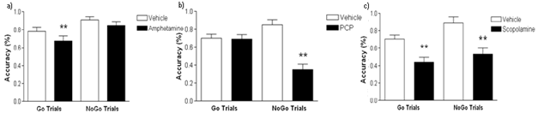
Fig. 4. a) Amphetamine-injected mice showed a decreased accuracy on the Go trials only while the NoGo trials were unaffected by the treatment. b) PCP-injected mice showed a decreased accuracy on the NoGo trials only while the Go trials were unaffected by the treatment. c) Scopolamine-injected mice showed decreases in accuracy on both, Go and NoGo trials. **p <0.01 as compared to the vehicle-injected group (Wilcoxon test). Data are expressed as means with standard errors (SEM).

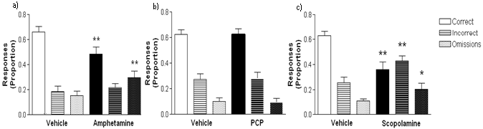Fig 5. a) Amphetamine-injected mice did less correct trials but more omissions. Incorrect responses were unchanged. b) PCP had no effect on the proportions of correct, incorrect and omissions. c) Scopolamine-injected mice showed a decrease in the proportion of correct responses as well increases in the proportions incorrect and omission trials. **p <0.01 as compared to the vehicle treated group and *p <0.05 as compared to the vehicle treated group (Wilcoxon test). Data are expressed as means with SEM.

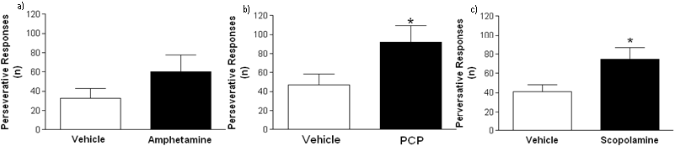
Fig 6. a) Amphetamine did not have an effect on the number of perseverative responses done. b) PCP – injected mice showed an increased number of perseverative responses. c) Scopolamine – injected mice showed an increased number of perseverative responses. *p <0.05 as compared to the vehicle – treated group (Wilcoxon test). Data are expressed as means with SEM.

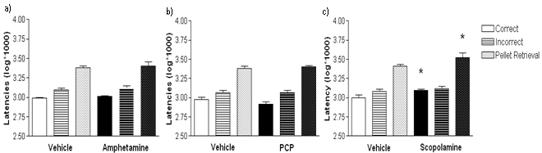
Fig 7. Illustrated is a log – transformation of the latencies for correct and incorrect responses as well as the time to retrieve the pellet. It takes into consideration that the latency is not distributed evenly and that there are ceiling effects to be considered. The response of the animal in the operant box does take a certain amount of time already, due to the length of the ways the animal needs to travel to respond and pick up rewards. Therefore, if an animal does reduce its response latency from 2 to 1 seconds, this has a bigger significance than if it reduces its response latency from 20 to 19 seconds. a) Amphetamine did not have an effect on the latencies correct, incorrect or for pellet retrieval b) PCP did not have an effect on the latencies correct, incorrect or for pellet retrieval. c) Scopolamine increased the latencies correct and pellet retrieval. The latency to an incorrect response was unaffected. *p <0.05 as compared to the vehicle – treated group (Wilcoxon test). Data are expressed as means with SEM.

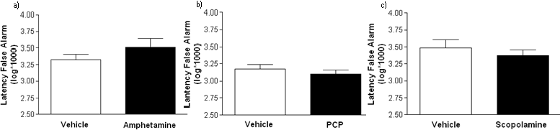
Fig 8. No significant effects were observed under the influence of amphetamine, PCP or scopolamine. Data are expressed as means with SEM.

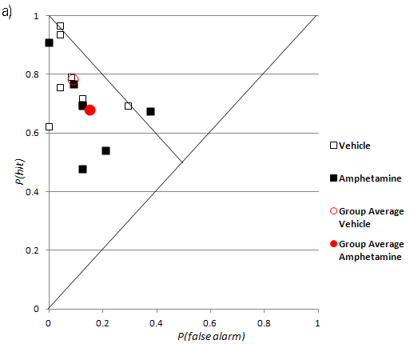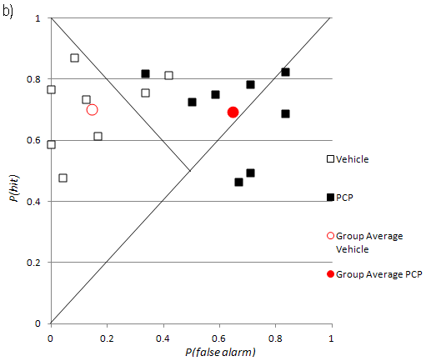
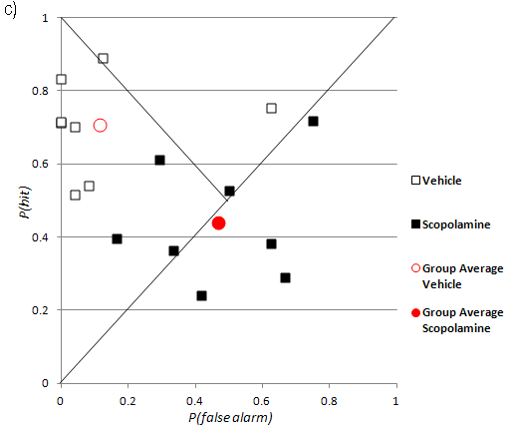
Fig. 9. Illustrated is the performance in the 5C-CPT under the influence of different compounds expressed on the 'Theoretical receiver operator characteristic' (ROC, Steckler, 2001) curve. p(Hit), the probability of correctly identifying the signal - based on the Go trials and called accuracy before - is plotted against p(False Alarm). This is the probability of misidentifying a non-signal as a target to be responded to, which is based on the NoGo trials and could be calculated as 1 - accuracy on these trials. The positive diagonal indicates chance performance; the negative diagonal indicates unbiased performance. A shift to the left from this negative diagonal by a given data point represents more conservative responding (being less likely to respond) while a shift to the right represents a more liberal response strategy (having a higher tendency to respond). a) The profile for the amphetamine-injected animals summarized the other results described. The two group means are relatively close together, differing only with respect to p(Hit) which reflects the go trials. Both group means are relatively close to unbiased responding and show a tendency towards a more conservative strategy. In summary, amphetamine results in a relatively unbiased pattern of results that reflects the effect of amphetamine on Go trials. b) The profile for the PCP-injected animals on this graph summarized the other results described. The two group means are far from each other with respect to the measure reflecting the NoGo trials, p(False Alarm), while they are at the same level for p(Hit), the measure reflecting the go part of the test. Also, while the vehicle-group mean is relatively close to unbiased responding with a tendency towards a more conservative strategy, the PCP-treated group shows strongly biased, i.e. liberal responding, reflecting their higher tendency to respond. The PCP-injected group is almost exactly clustered around the chance level line, at the high end of the go - reflection parameter p(Hit). In summary, PCP results in a pattern of results consisting of more biased responding and affected NoGo performance measures. c) The profile for the scopolamine-injected animals summarized the other results described. The two group means (red open and closed circles) are far from each other with respect to the measure reflecting the go trials, p(Hit) and the measure reflecting the NoGo trials, p(False Alarm). Both the vehicle- and the scopolamine-injected groups cluster around the negative diagonal, reflecting relatively unbiased responding. The scopolamine group, however, has a pattern of results almost perfectly aligned with chance performance on both measures (p(Hit) and p(False Alarms). In summary, scopolamine treatment results in a generally disturbed attentional performance. Data are expressed as means and individual data points.

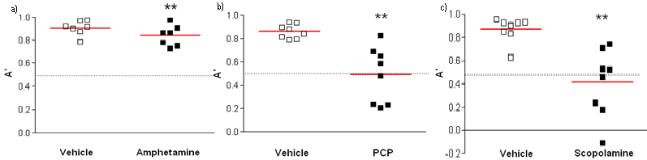
Fig. 10. a) Sensitivity A' was decreased in the amphetamine-injected animals. b) Sensitivity A' was decreased in the PCP-injected animals. c) Sensitivity A' was decreased in the scopolamine-injected animals. **p <0.01 as compared to the vehicle – treated group (Wilcoxon test). A' is a measure of sensitivity from the SDT (see p.34). Data are expressed as means and individual data points.

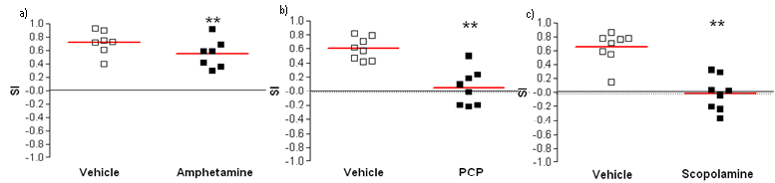
Fig 11. a) The sensitivity index SI was decreased in the amphetamine-injected animals. b) The sensitivity index SI was decreased in the PCP -injected animals. c) The sensitivity index SI was decreased in the scopolamine-injected animals. **p <0.01 as compared to the vehicle – treated group (Wilcoxon test). SI is a sensitivity index from the SDT (see p. 34). Data are expressed as means and individual data points.

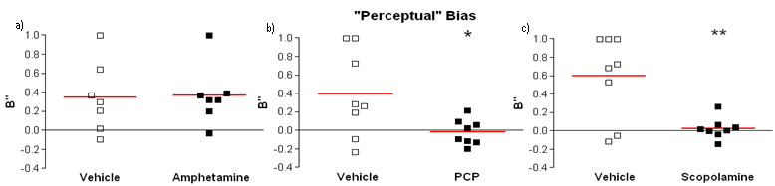
Fig 12. a) Amphetamine-injected mice did not show a perceptual bias. b) PCP- injected mice showed a perceptual bias, i.e. a drop in performance as measured by the parameter B’’. c) Scopolamine- injected mice showed a perceptual bias, i.e. a drop in performance as measured by the parameter B''. * p<0.05 as compared to the vehicle-treated group and **p<0.01 as compared to the vehicle – treated group (Wilcoxon test). B” is the perceptual bias measure from to SDT (see p. 34). Data are expressed as means and individual data points.

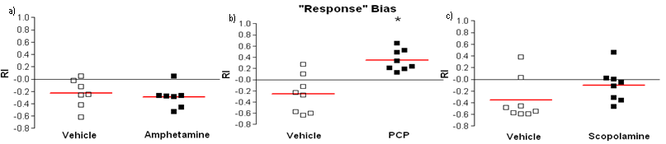
Fig. 13. a) Amphetamine-injected mice did not show a response bias. b) PCP- injected mice showed a response bias, i.e. an increase in the likelihood to respond as measured by the parameter RI. c) Scopolamine-injected mice did not show a response bias. * p<0.05 as compared to the vehicle-treated group (Wilcoxon test). RI is the response bias measure from the SDT (see p. 34). Data are expressed as means and individual data points.

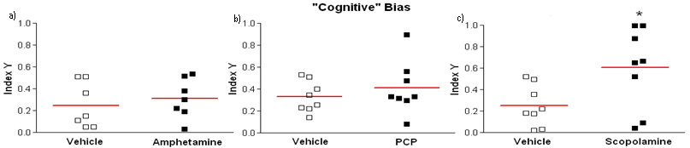
Fig. 14. a) Amphetamine-injected mice did not show a cognitive bias. b) PCP-injected mice did not show a cognitive bias. c) Scopolamine - injected mice showed a cognitive bias, i.e. an increase on the value of the parameter Index Y. * p<0.05 as compared to the vehicle-treated group (Wilcoxon test). Index Y is the cognitive bias measure from the SDT (see p.34). Data are expressed as means and individual data points.

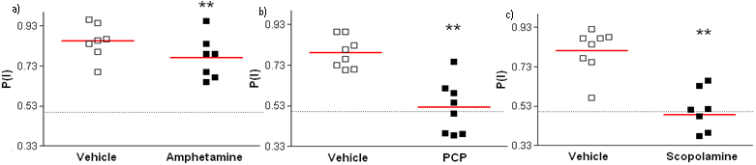
Fig. 15. a) The accuracy index P(I) was decreased in the amphetamine-injected animals. b) The accuracy index P(I) was decreased in the PCP-injected animals. c) The accuracy index P(I) was decreased in the scopolamine-injected animals. **p <0.01 as compared to the vehicle–treated group (Wilcoxon test). P(I) is a sensitivity measure from the SDT (see p. 34). Data are expressed as means and individual data points.

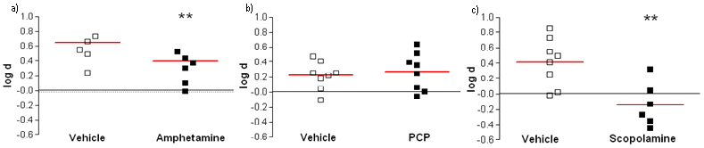
Fig. 16. log a) The bias-free measure of accuracy, log d, was decreased in the amphetamine-injected animals. b) The bias-free measure of accuracy, log d, was the unaffected in the PCP-injected animals. c) The bias-free measure of accuracy, log d, was decreased in the scopolamine-injected animals. **p <0.01 as compared to the vehicle – treated group (Wilcoxon test). log d is a bias-free measure of sensitivity from the SDT (see p. 34). Data are expressed as means and individual data points.

------------------------------------------------------------------------------------------------------------------------------------------------------------
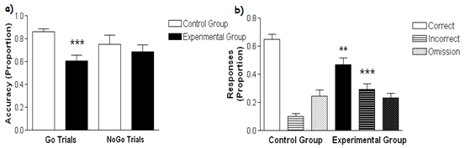
Fig. 17. a) The DISC1 - transgenic mice of the experimental group showed decreases in accuracy on Go trials only, NoGo trial performance was unaffected. b) DISC1 - transgenic mice of the experimental group did less correct trials and more incorrect trials The proportion of omissions was unaffected. ***p <0.001 as compared to the CaMKII-transgenic control group mice and **p <0.01 as compared to the CaMKII-transgenic control group mice (Mann-Whitney U-test). Data are expressed as means with SEM.

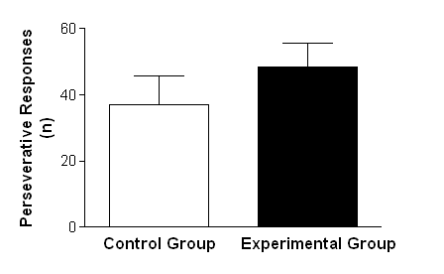
Fig. 18. The DISC1 transgene did not have an effect on the number of perseverative responses done by the animals. Data are expressed as means with SEM.

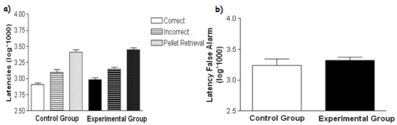
Fig. 19. Illustrated is a log – transformation of the latencies for correct and incorrect responses as well as the time to retrieve the pellet and to a False Alarm response. a) The DISC1 transgene did not have an effect on the latencies correct, incorrect or for pellet retrieval. Data are expressed as means with SEM.

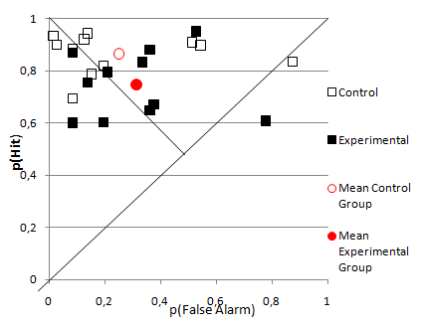
Fig. 20. Illustrated is the performance of the transgenic animals in the 5C-CPT expressed on the 'Theoretical receiver operator characteristic' (ROC, Steckler, 2001) curve. The profile for the DISC1 transgenic animals of the experimental group summarized the other results described. The two group means (red open and closed circles) are relatively close together, differing only with respect to p(Hit) which reflects the go trials. Both group means are relatively close to unbiased responding and the mean of the control group reflects a tendency towards a more liberal strategy. In summary, the DISC1 transgene results in a relatively unbiased pattern of results that reflects the effect of DISC1 on the Go trials. Data are expressed as means and individual data points.

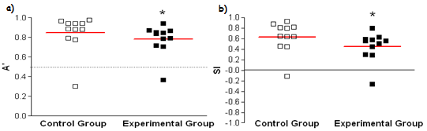
Fig. 21. a) Sensitivity A' was decreased in the DISC1 transgenic animals of the experimental group. b) The sensitivity index SI was decreased in the DISC1 transgenic animals of the experimental group. *p <0.05 as compared to the CaMKII-transgenic control group mice (Mann-Whitney U-test). A' and SI are measures of sensitivity from the SDT (see p.34). Data are expressed as means and individual data points.

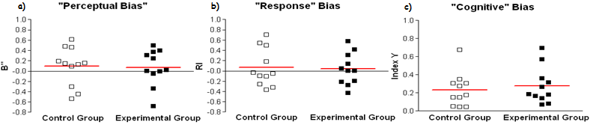
Fig. 22. a) DISC1 transgenic animals of the experimental group did not show a perceptual bias. b) DISC1 transgenic animals of the experimental group did not show a response bias. c) DISC1 transgenic animals of the experimental group did not show a cognitive bias. B”, RI and Index Y are the bias measures from the SDT (see p. 34). Data are expressed as means and individual data points.

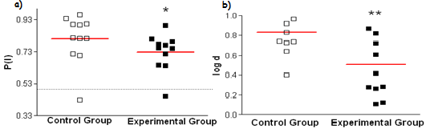
Fig. 23. a) The accuracy index P(I) was decreased in the DISC1 transgenic animals of the experimental group. b) The bias-free measure of accuracy, log d, was decreased in the DISC1 transgenic animals of the experimental group. **p <0.01 as compared to the CaMKII-transgenic control group mice (Mann-Whitney U-test). P(I) and log d are sensitivity measures from the SDT (see p. 34). Data are expressed as means and individual data points.
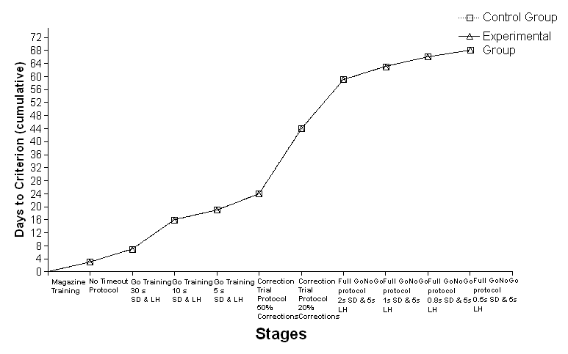
Fig. 24. Illustrating cumulative days to criterion at each stage. It can be clearly seen that the learning of the NoGo trials (as started in the Correction Trial protocol) was tremendously difficult for both groups of animals while the other criteria before and after were reached relatively fast.

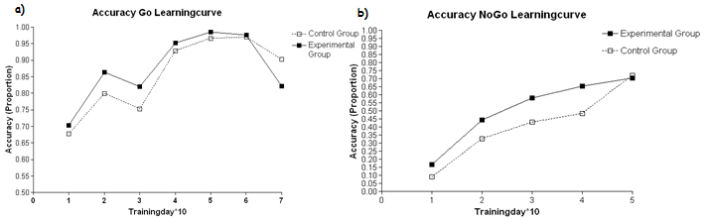
Fig. 25. Illustrating the learning curves for Go and NoGo trial accuracy over the whole training. The data are expressed as means over 10 days of training. a) The accuracy on the Go trials increased over time but without any differences between the DISC1 transgenic animals of the experimental group and the CaMKII transgenic animals of the control group. b) The accuracy on the NoGo trials increased over time but without any differences between the DISC1 transgenic animals of the experimental group and the CaMKII transgenic animals of the control group.

