Effects of aging on cerebral oxygenation during working memory performance: A functional Near-Infrared Spectroscopy study

Anouk Vermeij^{1,3}, Arenda H.E.A. van Beek¹, Jurgen A.H.R. Claassen¹, Roy P.C. Kessels^{1,2,3}
¹Department of Geriatric Medicine, Radboud University Nijmegen Medical Centre, The Netherlands
²Department of Medical Psychology, Radboud University Nijmegen Medical Centre, The Netherlands
³Donders Institute for Brain, Cognition and Behaviour, Radboud University Nijmegen, The Netherlands

Corresponding author of thesis:
Anouk Vermeij, Email: anoukvermeij@gmail.com

Word count (not including Abstract or References):
5865

Running title:
Effects of aging on cerebral oxygenation

ABSTRACT
Background.
Aging is accompanied by a decline in working memory performance in both the verbal and visuospatial domain. Evidence exists that compensatory neural activity is apparent in older adults during working memory tasks, but the underlying neurocognitive mechanisms are unclear. Functional Near-Infrared Spectroscopy (fNIRS), a noninvasive neuroimaging technique, may provide a way to elucidate the neurophysiological mechanisms of compensation. This study examined brain activation by using fNIRS in young and older adults during working memory performance.

Methods.
18 healthy young (21-32 years) and 18 older adults (64-81 years, MMSE=29.2±0.9) performed a verbal and spatial 0- and 2-back task. Oxygenated (O₂Hb) and deoxygenated hemoglobin (HHb) changes, as indices of brain activation, were registered by two fNIRS channels located over the left and right dorsolateral prefrontal cortex.

Results.
High verbal working memory load led to declined accuracy in comparison to the control condition in older adults, while the young had the same level of accuracy in both conditions. fNIRS results demonstrated an increased concentration of O₂Hb during the 2-back condition in both groups and a decrease of HHb in older adults. After the beginning of the verbal 2-back task, a significant increase in brain activation was reached earlier in older adults than in the young and the same held true for the maximum level of activation. The spatial n-back task did not induce significant concentration changes of O₂Hb and HHb in comparison to the baseline period in either of the groups, although increased working memory load led to declined behavioral performance in both older and young adults.

Discussion.
Older adults showed a stronger recruitment of prefrontal areas during verbal working memory performance in comparison to young adults, suggesting an attempt to compensate for age-related decline. Also, our study indicates that age effects on the time course of hemodynamic processes must be taken into account in the interpretation of neuroimaging studies that rely on blood oxygen levels, such as fMRI.

Key Words.
functional Near-Infrared Spectroscopy; Aging; Cortical oxygenation; Working memory; Dorsolateral prefrontal cortex

Abbreviations used.
BOLD, blood-oxygen-level dependent; DLPFC, dorsolateral prefrontal cortex; fNIRS, functional Near-Infrared Spectroscopy; fMRI, functional Magnetic Resonance Imaging; HHb, deoxygenated hemoglobin; O₂Hb, oxygenated hemoglobin; PET, Positron Emission Tomography; tHb, total hemoglobin

INTRODUCTION

Cognitive aging has been described in behavioral terms including decline in information processing speed (Salthouse, 1996), inhibition (Hasher, Stoltzfus, Zacks & Rypma, 1991), cognitive control (Braver & Barch, 2002), and memory (Grady et al., 1995). At the cerebral level, several structural changes have been reported that accompany aging, such as volume reductions of various brain regions (Raz et al., 2005), white matter alterations (Salat et al. 2005) and changes in the dopaminergic system (Cropley, Fujita, Innis & Nathan, 2006). Although cognitive and cerebral aging are clearly linked to each other, the relationships between the two phenomena are largely unknown.
Working memory has been shown to be sensitive to age-related decline, both in the verbal and visuospatial domain (Salthouse, 1991; Baddeley, 1992; Park et al., 2002). While age-related limitations in working memory capacity presumably arise from declined neural efficiency and structural changes, normal aging is also hypothesized to be associated with an alteration in working memory processing networks (Grady & Craik, 2002). In comparison to young adults, older adults show patterns of reduced activity (e.g. Mitchell, Johnson, Raye, & D’Esposito, 2000) and increased activity (e.g. Reuter-Lorenz et al., 2000) in brain areas that participate in working memory. A frequently reported observation is additional activation of prefrontal regions during working memory performance (Cabeza et al., 2004). The underlying neurocognitive mechanisms of this additional activation are unclear, but might be due to dedifferentiation of neurocognitive functions, meaning that neural mechanisms become less specialized during aging, which then leads to the recruitment of similar resources by different neurocognitive functions (Baltes & Lindenberger, 1997). Alternatively, additional recruitment of brain regions might represent compensatory mechanisms meant to counteract age-related neurocognitive decline (Reuter-Lorenz & Cappell, 2008).
Functional Near-Infrared Spectroscopy (fNIRS), a noninvasive neuroimaging technique, may provide a way to elucidate the neurocognitive mechanisms of increased prefrontal activation in older adults. The principles of fNIRS have been extensively described in different review articles (Villringer & Chance, 1997; Hoshi, 2003a; Obrig & Villringer, 2003). In short, near-infrared light penetrates biological tissue such as the skull and brain tissue rather easily. In the cortex the near-infrared light is absorbed by the chromophores oxygenated hemoglobin (O₂Hb) and deoxygenated hemoglobin (HHb), which have different absorption spectra. Assuming constant scattering and a fixed light emitter and detector distance, it is possible, by using the modified Lambert-Beer Law, to calculate concentration changes of O₂Hb and HHb in the penetrated brain tissue based on changes in the detected light intensity.
fNIRS can be considered as a complementary method to functional Magnetic Resonance Imaging (fMRI), the most widely used neuroimaging technique. fMRI measures neuronal activity indirectly through the blood-oxygen-level dependent (BOLD) signal. The BOLD signal essentially relies on the hemodynamic component of neurovascular coupling as it represents changes in HHb concentration in the microvasculature surrounding of the activated brain region. Neurovascular coupling refers to the relationship between local neural activity and subsequent changes in hemodynamic properties of the surrounding vasculature, including cerebral blood flow, cerebral blood volume and cerebral metabolic rate for oxygen. The mechanisms that underlie neurovascular coupling are not fully understood and evidence exists that these mechanisms alter with aging (D’Esposito, Deouell & Gazzaley, 2003). Aging leads to a degeneration of the vascular system, probably beginning as early as the fourth decade of life. Regional cerebral blood flow, for example, decreases with age and vessel stiffness is enhanced. These phenomena are accompanied by a reduction in the cerebral metabolic rate for oxygen (Farkas & Luiten, 2001). fNIRS is particularly sensitive to the microvasculature (Liu et al., 1995a,b) and enables monitoring, with high temporal resolution, of changes in O₂Hb, HHb and total hemoglobin (tHb) concentration during neuronal activation induced by cognitive operations. Accordingly, fNIRS may to be a valuable tool to unravel the neurophysiological and neurocognitive mechanisms of age-related decline.
There have been few studies involving the use of fNIRS in the field of cognitive aging research. Mehagnoul-Schipper et al. (2002) determined motor-task-related changes in hemoglobin concentrations over the left motor cortex in young and older adults. Increases in O₂Hb and decreases in HHb were present in both groups during finger-tapping, although the changes were less pronounced in the older adults. A slight increase in tHb was found only in the young adults. Schroeter, Schmiedel and von Cramon (2004) noted no influence of age on hemoglobin concentration changes in the occipital cortex during visual stimulation. However, spontaneous low-frequency oscillations of O₂Hb and HHb declined strongly with age during both rest and visual checkerboard stimulation.
Other studies used paradigms that induce prefrontal activation. Hock et al. (1995) found increases in O₂Hb and tHb, and a decrease in HHb, both in young and older adults who performed a calculation task. The increase in O₂Hb and tHb was much less pronounced in the older adults, however. Schroeter, Zysset, Kruggel and von Cramon (2003) reported that in comparison to young adults, the Stroop interference effect led to recruitment of a less extensive lateral prefrontal network in older adults. The mean changes of the hemodynamic responses again were reduced in the older adults. In contrast to the results of Mehagnoul-Schipper et al. (2002), no age-related differences in the motor cortex during finger movement were found in this study. Herrmann, Walter, Ehlis and Fallgatter (2006) showed that performance of a verbal fluency task led to activation of the left and right dorsolateral prefrontal cortex (DLPFC). The increases in O₂Hb and more localized decreases in HHb were stronger in the young adults. Although Kameyama, Fukuda, Uehara and Mikuni (2004) only reported O₂Hb changes during verbal fluency tasks, the older adults nevertheless exhibited again less prefrontal activation. Kwee and Nakada (2003) reported diminished activation of the DLPFC as a function of age during performance of three subtests of the WAIS, which represent several cognitive constructs.
Taken together, these fNIRS studies suggest an age-related decline in prefrontal activity during cognitive testing. Despite this agreement in findings, these studies vary substantially from a methodological perspective. The mean age of the older participants varied across studies; it ranged from 40-50 years (Hock et al, 1995; Kameyama et al. 2004) to 70+ (Mehagnoul-Schipper et al., 2002). Several studies (e.g. Schroeter et al., 2003) included relatively small sample sizes (N < 15 per group). Also, some researchers did not report on all outcome parameters that may be relevant for adequate interpretation of the results. For example, Kameyama et al. (2004) only reported O₂Hb concentration changes. Furthermore, a large variability of data analysis methods is evident. For example, the mean duration of the analyzed task period varied across participants in the study of Hock et al. (1995). For each participant, the period from the start of the task up to maximum alteration of O₂Hb concentration was selected for analysis. In other studies, the duration of the analyzed task period was fixed across all participants. These examples emphasize some methodological points of interest and stress the need for more fNIRS research in the field of cognitive aging.
fNIRS studies on the effects of aging on cerebral oxygenation during working memory performance are lacking. Working memory, a system for the temporary storage and manipulation of information, is an integral part of higher order cognition (Baddeley, 1992). Hence, age-related limitations in working memory capacity mediate age-related variance on higher order cognitive tasks, including the previously mentioned calculation, verbal fluency and Stroop tasks that were used during fNIRS research. It is therefore crucial to gain insight into the mechanisms that underlie age-related decline in working memory performance.

The purpose of the present study is to determine whether changes in O₂Hb, HHb and tHb concentration in the dorsolateral prefrontal cortex during working memory performance are age-dependent. A group of young and older adults will perform a verbal as well as a spatial variant of the n-back paradigm. In fMRI research, the n-back paradigm has reliably and validly been employed in establishing cerebral activity patterns in the prefrontal cortex in relation to increasing working memory load (Jansma, Ramsey, Coppola & Kahn, 2000; Owen, McMillan, Laird & Bullmore, 2005). Based on previous fNIRS studies on cognitive aging, we would expect declined prefrontal activity in the older adults. However, several fMRI studies have reported increased prefrontal activation in older adults during n-back task performance under varying levels of working memory load (Mattay et al., 2006; Nagel et al., 2009; Nyberg, Dahlin, Stigsdotter Neely & Bäckman, 2009). Therefore, we hypothesize that in comparison to young adults, older adults show increased prefrontal activity during performance of a verbal and spatial n-back task.

METHODS

Participants
Thirty-six healthy Dutch speaking volunteers participated in the study (18 young adults, 11 female, mean age = 25.6 ± 3.1 years, range 21-32; 18 older adults, 11 female, mean age = 70.4 ± 5.2 years, range 64-81). The young adults were recruited from the social networks of the authors. The older adults were recruited from local bridge, chess and senior clubs. They did not report memory problems, were living independently at home and were high functioning (Mini Mental State Examination (Folstein, Folstein, & McHugh, 1995) mean score = 29.2 ± 0.9, range 27-30). The educational level of the participants was assessed by the Verhage coding system (Verhage, 1964), which consist of seven categories (1= less than primary school, 7 = university degree). The educational level differed between the groups (Mann Whitney U = 66.00, p = .001); the mean education level of the young was high (M = 6.7 ± 0.7, range 5-7) and that of the older adults was above average (M = 5.6 ± 1.0, range 4-7). All participants had an IQ > 85 as estimated by the Dutch version of the National Adult Reading Test (Schmand, Lindeboom, & Harskamp, 1992). They were all right-handed and had normal or corrected to normal vision. None of the participants had a history of neurological/psychiatric disease or used psychopharmacological drugs. Seven older adults were on antihypertensive medication. All participants refrained from alcohol, caffeine and nicotine from at least 3 hours before the experimental session. The study was approved by the local medical ethics committee and all participants gave written informed consent.

Experimental paradigm
Participants performed a verbal and a spatial variant of the n-back working memory task with different levels of working memory load (n-back = 0 and 2). The order of the two variants was counterbalanced among the participants. In Figure 1, a schematic overview of the experimental conditions is given. Stimuli were presented in black on a grey background using E-prime 2.0 software (Psychology Software Tools, PA, USA), which also registered behavioral performance. Participants responded to each presented stimulus by pressing one of two buttons on the PST Serial Response Box (http://www.pstnet.com/srbox/srb.htm).
Prior to each of the four conditions, participants were allowed to practice for one minute and they received feedback about their performance. The conditions were preceded by a baseline period of one minute, during which a black fixation cross was displayed at the center of the 15 inch screen. Each condition consisted of 60 trials of which 17 were target trials. Participants indicated each trial whether the stimulus was a target by pressing the button under the right index finger, or a non-target by pressing the button under the right middle finger. During the verbal task, on each trial a letter that was randomly selected from a set of 20 consonants was displayed at the center of the screen. In the 0-back condition, the letter “X” was defined as target. In the 2-back condition, the target was any letter that was identical to the letter presented two trials before and the letter “X” was not shown. During the spatial task, on each trial a square was presented at one of 14 pre-specified locations on the display. In the 0-back condition, a square at a one of the four outer corners of the screen was defined as target. In the 2-back condition, the target was any square that appeared at the same location as the square presented two trials before, while squares no longer appeared in the corners. In order to prevent verbalization of the locations by the participant, no grid or clock configuration of the squares was chosen (see Figure 1).

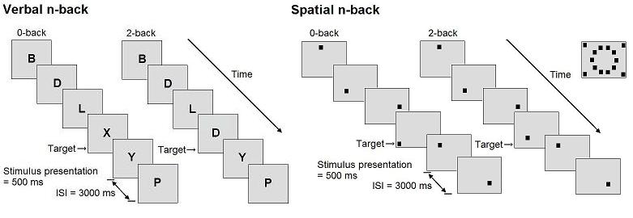
Figure 1. Schematic overview of the verbal n-back (left) and spatial n-back task (right). Stimulus presentation was 500 ms, interstimulus interval (ISI) 3000 ms. During the ISI, a fixation cross was displayed. Participants were allowed to respond until the next stimulus appeared. At the right upper corner of the figure, all possible positions of the square during the spatial 0- and 2-back task are shown.

fNIRS acquisition
Concentration changes of O₂Hb and HHb (µmol/L) were measured by a continuous-wave NIRS device (Oxymon, Artinis Medical Systems™, The Netherlands) at three wavelengths (775, 845, 904 nm). Total Hb (tHb) was determined as the sum of O₂Hb and HHb. Data were sampled at 125 Hz. Two pairs of optodes were placed over the left and right dorsolateral prefrontal cortex. This positioning corresponds to respectively the midpoint between the Fp1 and F3 positions and the midpoint between the Fp2 and F4 positions, according to the international 10-20 electrode system. The optodes were tightly fixed in a customized headband (Spencer technologies, Seattle, Wa). The emitter-detector spacing was 50 mm to assure minimized contamination from the extra-cerebral circulation and maximized signal intensity. The differential pathlength factor (DPF), which accounts for the increased distance travelled by light due to scattering, is age-dependent (Duncan et al., 1996). For the young adults, DPF was calculated by the formula 4.99 + 0.067×Age^{^0.814}. At present however, no data are available on the actual variation of DPF in adults aged above 50 years. Therefore, the DPF was set to 6.61, corresponding to age 50, in the older adults (Duncan et al. 1996, Claassen, Colier, & Jansen, 2006).

Data processing
fNIRS data were analyzed using commercially available software (Oxysoft, Artinis Medical Systems, The Netherlands). A moving average window of 1 second was applied to the O₂Hb and HHb signals to filter out the noise of the heart beat frequency. The first three trials (all non-targets) of all conditions were excluded from behavioral and fNIRS data analyses. Data from the verbal and spatial task were preprocessed and analyzed according to the same procedure. The 2-back task period was divided in six time segments of 30 seconds. Mean values of O₂Hb, HHb and tHb were calculated for each segment. These values were corrected for activation caused by the corresponding control task, as well as for signal drift. Drift was calculated by subtracting the mean value of the first 30 seconds of the 0-back task period from the mean value of the last 30 seconds of this period. Subsequently, a linear drift correction was applied to the time segments of the 2-back task. In addition, mean values of O₂Hb, HHb and tHb were calculated over the last 20 seconds of the pre-task baseline period of the 2-back task. Paired t-tests indicated that there were no laterality effects on O₂Hb, HHb and tHb concentration changes (p > .05). Accordingly, data from the left and right fNIRS channel were averaged for each participant.

Statistical analysis
Statistical analysis was performed using SPSS software version 15.0 (SPSS Inc., Chicago, IL, USA). Behavioral performance on the working memory tasks was assessed by number of hits, misses, correct rejections, and false alarms. Shapiro-Wilk tests indicated that none of the behavioral parameters were normally distributed. Consequently, the non-parametric index for sensitivity A' was calculated, which is a performance variable derived from signal detection theory (Grier, 1971). Reaction time and accuracy (A') of the young and older adults were compared by Mann-Whitney-U tests. In both groups, the effects of working memory load were established by performing Wilcoxon signed-rank tests.
Shapiro-Wilk tests were carried out to establish whether the fNIRS data were normally distributed. This assumption of normality was met by the fNIRS data acquired during the verbal working memory task. For each of the hemodynamic measures, O₂Hb, HHb and tHb, a 2 (group: young, old) × 7 (time: baseline, time segments 1, 2, 3, 4, 5, 6) repeated measures ANOVA was performed. Due to violations of the sphericity assumption, Greenhouse-Geisser corrections were applied. Significant main and interaction effects were further analyzed by means of planned contrasts.
The fNIRS data obtained during spatial working memory testing, were not normally distributed. Changes in O₂Hb, HHb and tHb concentration were evaluated by Friedman’s ANOVA with factor time (baseline, time segments 1, 2, 3, 4, 5, 6). Post hoc testing was performed using Bonferroni corrected Wilcoxon signed-rank tests.

RESULTS

Verbal task: behavioral performance
The upper half of Table 1 shows the behavioral results of the young and older adults during the verbal n-back task. High working memory load led to declined accuracy in comparison to the control condition in older adults (z = -3.129, p = .002), while the young had the same level of accuracy in both conditions (z = -1.437, p = .151). With greater load, reaction times on targets and non-targets prolonged significantly in both groups (p < .001).

Table 1. Accuracy and reaction times (Mean ± SD) for the two conditions of the verbal (upper half) and spatial (lower half) n-back task. For group comparisons (young vs. older) Mann-Whitney-U test values are given.

 |  | Young adults |  |  | Older adults |  |  | U-statistic
Verbal n-back
A' (accuracy) | 0-back  2-back | 0.99  0.99 | ±  ± | 0.01  0.01 | 0.99  0.94 | ±  ± | 0.01  0.05 | 146.0  69.0*
RT target (ms) | 0-back  2-back | 498.46  655.11 | ±  ± | 77.94  139.75 | 651.42  872.25 | ±  ± | 127.87  150.07 | 41.0**  56.0**
RT non-target (ms) | 0-back  2-back | 495.45  755.02 | ±  ± | 82.74  187.39 | 604.65  848.38 | ±  ± | 88.23  169.53 | 56.0**  114.0
Spatial n-back
A′ (accuracy) | 0-back  2-back | 0.99  0.97 | ±  ± | 0.01  0.02 | 0.99  0.93 | ±  ± | 0.02  0.06 | 142.0  76.0*
RT target (ms) | 0-back  2-back | 513.65  717.52 | ±  ± | 77.70  208.75 | 661.25  1047.72 | ±  ± | 113.86  333.06 | 44.0**  66.0*
RT non-target (ms) | 0-back  2-back | 498.45  818.55 | ±  ± | 69.19  230.43 | 633.51  941.08 | ±  ± | 87.59  254.88 | 35.0**  119.0
**p ≤ .001, *p < .01

Verbal task: fNIRS results

O₂Hb
In Figure 2, the concentration changes of O₂Hb, HHb and tHb during the verbal 2-back task are displayed. The values in the upper panels of the figure are not corrected for activity and drift during the verbal 0-back condition. For the corrected values we found a significant effect of time on O₂Hb concentration changes ( F(2.79, 94.91) = 13.18, p < .001). There was no effect of group ( F(1, 34) = 1.60, p = .215). The significant interaction of group and time ( F(2.79, 94.91) = 4.25, p = .009) revealed that O₂Hb was increased during all time segments in comparison to baseline in the older adults ( F(1.92, 33.41) = 10.75), p < .001), while in the young adults O₂Hb was only increased during time segments 5 and 6 ( F(2.98, 50.64) = 7.35, p < .001). In the older adults, a significant quadratic trend was apparent ( F(1, 17) = 16.55, p < .001). Maximum increase of O₂Hb was reached during time segment 3
(time segment 3 vs. 2 F(1, 17) = 10.60, p = .005). Based on visual inspection of the figure, a decrease of O₂Hb was suspected during the last two time segments in comparison to time segments 3 and 4, but this decrement did not reach significance. The maximum level of increase was maintained during the rest of the task period. In the young, concentration changes of O₂Hb followed a linear trend ( F(1, 17) = 12.53, p = .003). The O₂Hb values of time segments 5 and 6 did not differ (p > .05).

HHb
We found a main effect of time on HHb concentration changes ( F(1.74, 59.12) = 6.98, p = .003), but no main effect of group ( F(1, 34) = 2.350, p = .135). There was no significant interaction between group and time ( F(1.74, 59.12) = 1.95, p = .156). However, further analysis of both groups revealed that in the young adults the concentration of HHb did not change at all during the task ( F(1.85, 31.44) = 1.75, p = .192), while in the older adults HHb was decreased during the whole task period ( F(1.56, 26.44) = 6.47, p = .009). A significant quadratic trend was evident in this group ( F(1, 17) = 14.94, p = .001). Based on visual inspection of the figure, an increase of HHb was suspected during the last two time segments in comparison to time segments 3 and 4, but this relative increase did not reach significance. During the third time segment, HHb decrease reached a minimum and this level was maintained during the rest of the task period (time segment 3 vs. 2 F(1, 17) = 10.81, p = .004).

tHb
The effect of time on concentration changes of tHb was significant ( F(2.02, 68.76) = 5,36, p = .007). No significant effect of group was found ( F(1, 34) = 0.36, p = .553). The interaction between group and time showed a trend ( F(2.02, 68.76) = 2.54, p = .086). Additional analyses demonstrated a significant effect of time in the young ( F(2.64, 44.87) = 6.44, p = .002), but not in the older adults ( F(1.28, 21.82) = 1.93, p = .178). In the young, there was a drop in tHb concentration during the first time segment of the task (F (1, 17) = 7.63, p = .013). The increase of tHb during time segments 5 and 6 showed a trend ( F (1, 17) = 3.29, p = .087 and F (1, 17) = 3.65, p = .073 respectively). The tHb values of these time segments did not differ (p > .05).

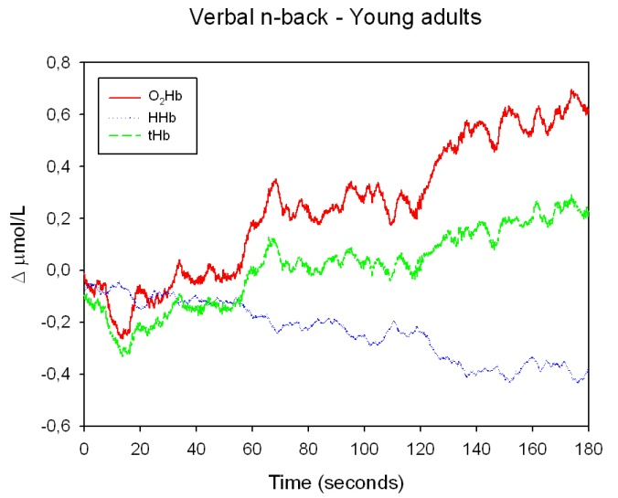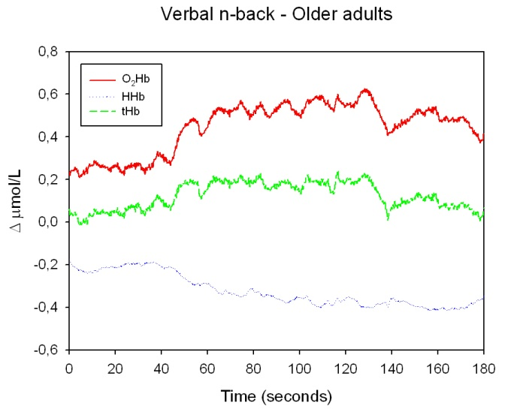
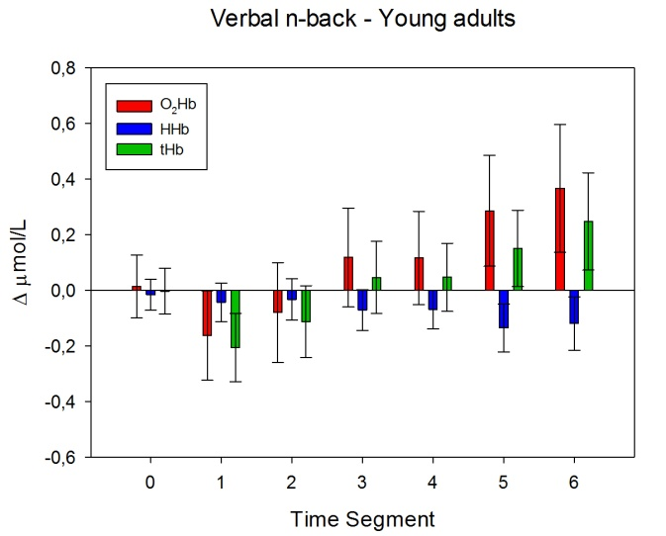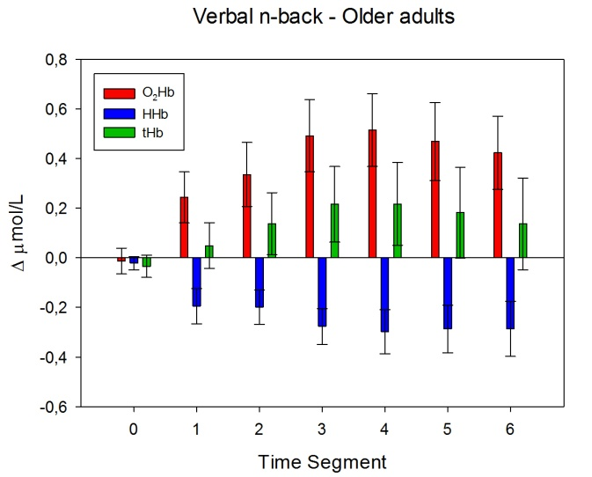
Figure 2. Upper panel. Filtered grand average waveforms of O₂Hb, HHb an tHb changes during the verbal n-back task. Since the first three trials were excluded from analysis, T = 0 seconds corresponds to the start of the fourth trial. The values are not corrected for activity and drift during the verbal 0-back condition. Lower panel. Mean (± SEM) corrected values over baseline (time segment 0) and the 30-second time segments of the task period.

Spatial task: behavioral performance
Behavioral performance of the young and older adults on the spatial n-back task is shown in the lower half of Table 1. High working memory load led in comparison to the control condition to declined accuracy in both young (z = -2.760, p = .002) and older adults
(z = -3.680, p < .001). While the groups did not differ in accuracy during the 0-back condition, the drop in accuracy between the 0- and 2-back condition was stronger in older adults. High working memory load resulted in significantly prolonged reaction times on targets and non-targets in both groups (p < .001).

Spatial task: fNIRS results

O₂Hb
Figure 3 shows the concentration changes of O₂Hb, HHb and tHb during the spatial 2-back task. We found a significant effect of time on O₂Hb concentration changes in both the young (χ²(6) = 18.60, p = .005) and the older adults group (χ²(6) = 14.98, p = .020). Post hoc tests indicated however, that there were no significant changes in comparison to baseline.

HHb
Analysis demonstrated no significant effect of time on HHb concentration changes in the young (χ²(6) = 6.00, p = .423) and older adults (χ²(6) = 10.31, p = .112).

tHb
There was a significant effect of time on tHb concentration changes in the young (χ²(6) = 16.52, p = .011) and older adults group (χ²(6) = 14.76, p = .022). However, further analysis revealed that there were no were no significant concentration changes of tHb in comparison to baseline.

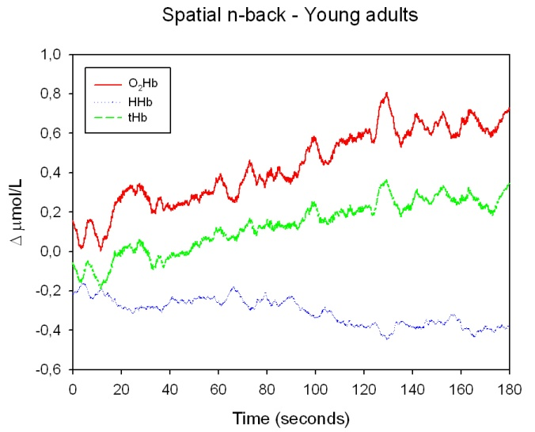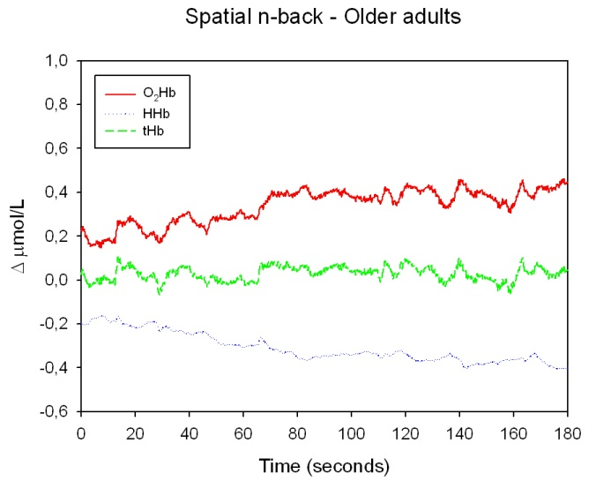
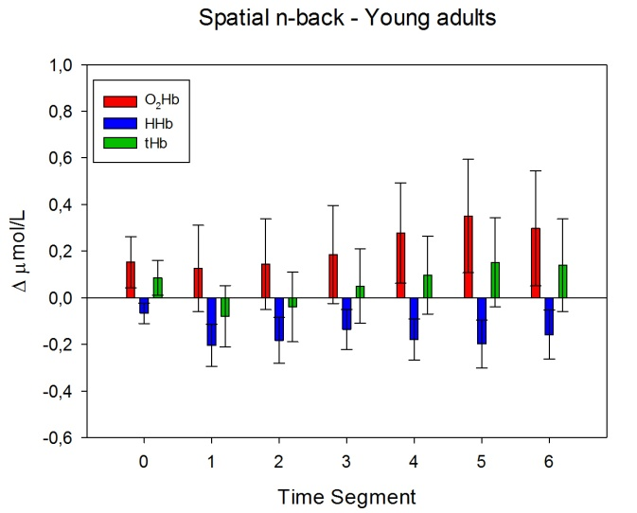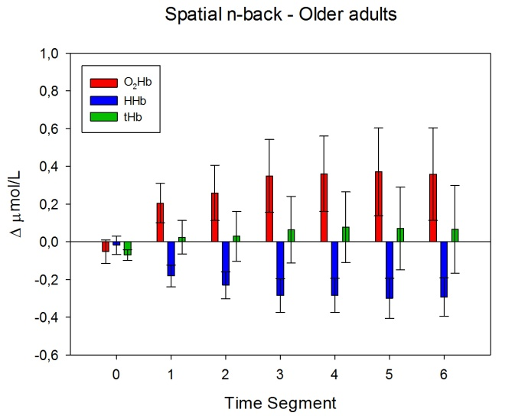
Figure 3. Upper panel. Filtered grand average waveforms of O₂Hb, HHb an tHb changes during the spatial n-back task. Since the first three trials were excluded from analysis, T = 0 seconds corresponds to the start of the fourth trial. The values are not corrected for activity and drift during the spatial 0-back condition. Lower panel. Mean (± SEM) corrected values over baseline (time segment 0) and the 30-second time segments of the task period.

DISCUSSION

The present study investigated the effects of aging on concentration changes of O₂Hb, HHb and tHb in the dorsolateral prefrontal cortex during working memory performance. Older adults exhibited stronger recruitment of the DLPFC during verbal working memory performance in comparison to the young adults. After the beginning of the verbal 2-back task, a significant increase in brain activation was reached earlier in older adults than in the young and the same held true for the maximum level of activation. An increased concentration of O₂Hb was evident in both groups, while a decrease in HHb only appeared in the older adults. The time courses of O₂Hb and HHb changes in the older adults were in sync with each other. Cerebral blood volume, as measured by tHb, remained constant during the task period, although it showed an increasing trend in the young.
In contrast to earlier fNIRS research in the field of cognitive aging (Hock et al., 1995; Schroeter et al., 2003; Mehagnoul-Schipper et al., 2002; Herrmann et al., 2006; Kameyama et al., 2004; Kwee et al., 2003) we found increased prefrontal activity in older adults in comparison to young adults during cognitive performance. The results of the young adults were in agreement with other fNIRS studies on verbal n-back performance. Hoshi et al. (2003b) determined concentration changes of O₂Hb between verbal 1-, 2-, or 3-back tasks and the 0-back task and reported that the degree of increases in O₂Hb showed a positive correlation with task difficulty. Herrmann et al. (2007) found an increased concentration of O₂Hb and decreased concentration of HHb during verbal 1- and 2-back performance compared to baseline. Further, stronger activity was associated with higher working memory load. Remarkably, these two studies found primarily activation in the ventrolateral prefrontal cortex. However, no measurements of activity in this brain area were carried out in the present study.
fNIRS studies on the effects of aging on prefrontal activation during verbal working memory performance are lacking. fMRI studies on this topic reported larger prefrontal activity in older adults relative to young adults during a verbal 1-back task. Higher working memory load (2- and 3-back) resulted in reduced prefrontal activity in older adults in comparison to young adults (Mattay et al., 2006; Nyberg et al., 2009). In contrast, our study showed increased prefrontal activation in the older adults during verbal 2-back performance. These findings on the relation between working memory load and prefrontal activation in older adults are inconsistent. Our behavioral results showed that high working memory load resulted in declined accuracy in comparison to the control condition in older adults, while the young had the same level of accuracy in both conditions. However, accuracy scores were on average still very high in both groups during 2-back performance. This might suggest that in the present study, working memory capacity was not exceeded in either of the groups. Callicott et al. (1999) investigated the relationship between working memory load and activation of the DLPFC in young adults. They found an inverted U-shape relationship; activity in the DLPFC increased with working memory load, but as soon as the working memory capacity of the individual participants was exceeded, activity in the DLPFC decreased.
Our study supports the notion that older adults show increased prefrontal activity as long as their working memory capacity is not exceeded. The ability to keep the DLPFC adequately engaged with increasing working memory demands seems to be beneficial in both young and older adults. Changes in patterns of functional brain activation, including additional prefrontal activation, may accompany aging, due to compensational reorganization of neural circuits or dedifferentiation. Alternatively, older adults might engage the same neural units as the young, but to a larger degree. Additional prefrontal activation, together with lowered performance, might therefore be considered as a consequence of declined neural efficiency (Zarahn, Rakitin, Abela, Flynn & Stern, 2007). In the present study, only activity in the DLPFC was monitored. Therefore, patterns of functional brain activity could not be analyzed. Nevertheless, our study contributes to this debate about the underlying mechanisms of increased functional prefrontal activity in older adults during working memory performance. Age-related limitations in working memory capacity might arise from a failure to activate one or more of the critical brain regions during working memory challenge. We propose that older adults attempt to meet working memory demands by additional recruitment of the DLPFC, which may compensate their limited resources.
Our findings fit well into the recently formulated the scaffolding theory of aging and cognition (Park & Reuter-Lorenz, 2009). This theory provides an integrative framework for understanding the relationships of structural and functional age-related changes in combination with behavioral performance. This model posits that increased functional activity is due to compensatory scaffolding; the recruitment of additional circuitry with age that shores up declining structures whose function has become noisy, inefficient, or both. Scaffolding is not unique to the aging brain, but aging simply results in more frequent cognitive challenges.
Another important outcome of our study was the differential time course of prefrontal activation for young and older adults. After the start of the verbal 2-back task, a significant increase in brain activation was immediately evident during the first time segment in the older adults. This activation reached its maximum and plateau level during the third time segment. In the young, significant activation was not apparent until the fifth time segment. Butti et al. (2009) investigated concentration changes of O₂Hb and HHb in the prefrontal cortex of young healthy adults, while they performed a continuous performance task for ten minutes. The fNIRS parameters did not show a fast level change. Concentration of O₂Hb increased and that of HHb decreased until maximum activation was reached in approximately 4-5 minutes after the start of the task. Subsequently, values slowly returned to baseline during the remaining task period. After the task, concentration of O₂Hb increased rapidly, peaked within 2 minutes and returned to baseline after another couple of minutes. fNIRS studies of León-Carrión et al. (2006; 2007) showed that exposure to stimuli can cause lasting prefrontal activation long after stimuli cessation and may even induce more robust prefrontal activation after than during the task period.
These findings have several implications. First, fNIRS studies, and neuroimaging studies in general, must take the duration of task and rest periods into account. Moreover, lasting post-task effects may have consequences for data-analysis. In several fNIRS studies, the mean of a pre- and post-task baseline was calculated to exclude slow drift during the task period by means of a linear fitting procedure. An overshoot of O₂Hb during the post-task period might lead to an overestimation of drift, resulting in an underestimation of the genuine effects. In our study, we also found an substantial overshoot of O₂Hb after task cessation (data not reported). Therefore, we argue for another drift correction procedure, which is described in the methods sections. Most importantly, our study indicates that age has an effect on the time course of O₂Hb and HHb changes. Clearly, both young and older adults did not maintain a constant level of activation over the whole task period. Moreover, after the start of the task, concentration levels of O₂Hb and HHb changed more rapidly in the older adults. Also, maximum level of activation was reached earlier in older adults than in young adults. Taken together, our study indicates that age effects on the time course of hemodynamic processes must be taken into account in the interpretation of neuroimaging studies that rely on blood oxygen levels.
Surprisingly, the spatial n-back task did not induce significant concentration changes of O₂Hb, HHb and tHb in comparison to the baseline period in either of the groups. High spatial working memory load led to declined behavioral performance relative to the control condition in both groups. Accordingly, changes in prefrontal activity were expected irrespective of age. The configuration of our paradigm prevented verbalization of the locations of the squares. Possibly, the participants were not able to use mnemonic strategies and chunk the spatial information, which might have affected DLPFC activity. The study of Bor, Duncan, Wiseman and Owen (2003) showed that the implementation of chunking strategies led to stronger recruitment of the DLPFC during a spatial working memory task. To date, only one other fNIRS study has employed a non-verbal n-back task. Schreppel et al. (2008) found increased prefrontal activity in healthy young adults during working memory performance. However, in their study, participants had to remember objects instead of locations. Despite the lack of fNIRS studies on spatial working memory, fMRI and PET research have provided extended evidence for activity in the DLPFC during spatial working memory performance in healthy young and older adults (Carlson et al., 1998; Reuter-Lorenz et al. 2000). We have not been able to replicate these findings.
Future fNIRS studies on cognitive aging should consider the relation between performance level and prefrontal activation patterns, for example, by dividing groups in low and high performers, or by correlating accuracy with prefrontal signal change. Because accuracy scores were on average very high in the present study, we were not able to differentiate between low and high performers. Recently, the relationship between performance level and prefrontal activation during working memory tasks has been considered in two fMRI studies (Nyberg et al., 2009; Nagel et al., 2009). In both the young and older adults, differences in prefrontal activation patterns were found between high and low performers. It is suggested that in comparison to low performers, high performers show increased prefrontal activity under high working memory demands. Possibly, this might be true for both young and older adults. In addition, we argue for including task conditions that might be beyond the working memory capacity of the participants. We hypothesize that the older adults in our study might have shown declined prefrontal activity during a verbal 3-back condition, due to limitations in compensatory activation.
Furthermore, to gain insight into the underlying mechanisms of additional prefrontal activation, it would also be interesting to study older adults who fail to show successful compensation, such as patients with Alzheimer’s disease or Mild Cognitive Impairment. To date, only a few fNIRS studies investigated healthy older adults as well as Alzheimer/ Mild Cognitive Impairment patients during performance of a verbal fluency task (Hock et al., 1997; Arai et al., 2006; Herrmann, Langer, Jacob, Ehlis & Fallgatter, 2008). In comparison to healthy older adults, patients with Mild Cognitive Impairment showed decreased prefrontal activity during performance of a verbal fluency task. Alzheimer patients exhibited an even stronger decline in prefrontal activity. It is however, also necessary to obtain fNIRS data from these patients during working memory performance, because memory deficits are prominent symptoms of Alzheimer’s disease and Mild Cognitive Impairment. Future research has to show whether a changed prefrontal activation pattern during working memory performance might be suitable as predictor for early-stage dementia. fNIRS might be a valuable tool for early diagnosis and intervention in pathological cognitive aging.
To summarize, older adults showed a stronger recruitment of prefrontal areas during verbal working memory performance in comparison to young adults, suggesting an attempt to compensate for age-related decline. Also, our study indicates that age effects on the time course of hemodynamic processes must be taken into account in the interpretation of neuroimaging studies that rely on blood oxygen levels, such as fMRI.

Acknowledgements
I would like to thank Arenda van Beek, Jurgen Claassen and Roy Kessels for their excellent supervision and enthusiasm. Furthermore, I would like to thank my colleagues for the great atmosphere at the department.

REFERENCES
Arai, H., Takano, M., Miyakawa, K., Ota, T., Takahashi, T., Asaka, H., & Kawaguchi, T.
(2006). A quantitative near-infrared spectroscopy study: a decrease in cerebral hemoglobin
oxygenation in Alzheimer’s disease and mild cognitive impairment. Brain and Cognition,
61, 189-194.
Baddeley, A.D. (1992). Working memory. Science, 255, 556-559.
Baltes, P.B., & Lindenberger, U. (1997). Emergence of a powerful connection between
sensory and cognitive functions across the adult life span: a new window to the study of
cognitive aging? Psychology and Aging, 12, 12-21.
Bor, D., Duncan, J., Wiseman, R.J., & Owen, A.M. (2003). Encoding strategies dissociate
prefrontal activity from working memory demand. Neuron, 37, 361-367.
Braver, T.S., & Barch, D.M. (2002). A theory of cognitive control, aging cognition, and
neuromodulation. Neuroscience and Biobehavioral Reviews, 26, 809-817.
Butti, M., Contini, D., Molteni, E., Caffini, M., Spinelli, L., Baselli, G., Bianchi, A.M.,
Cerutti, S. Cubeddu, R., & Torricelli, A. (2009). Effect of prolonged stimulation on cerebral
hemodynamic: a time-resolved fNIRS study. Medical Physics, 36, 4103-4114.
Cabeza, R., Daselaar, S.M., Dolcos, F., Prince, S.E., Budde, M., & Nyberg, L. (2004). Task-
independent and task-specific age effects on brain activity during working memory, visual
attention and episodic retrieval. Cerebral Cortex, 14, 364-375.
Callicott, J.H., Mattay, V.S., Bertolino, A., Finn, K., Coppola, R., Frank, J.A., Goldberg, T.E.,
& Weinberger, D.R. (1999). Physiological characteristics of capacity constraints in working
memory as revealed by functional MRI. Cerebral Cortex, 9, 20-26.
Carlson, S., Martinkauppi, S., Rämä, P., Salli, E., Korvenoja, A., & Aronen, H.J. (1998).
Distribution of cortical activation during visuospatial n-back tasks as revealed by functional
magnetic resonance imaging. Cerebral Cortex, 8, 743-752.
Claassen, J.A.H.R., Colier, W.N.J.M., & Jansen, R.W.M.M. (2006). Reproducibility of
cerebral blood volume measurements by near infrared spectroscopy in 16 healthy elderly
subjects. Physiological Measurement, 27, 255-264.
Cropley, V.L., Fujita, M., Innis, R.B., & Nathan, P.J. (2006). Molecular imaging of the
dopaminergic system and its association with human cognitive function. Biological
Psychiatry, 59, 898-907.
D’Esposito, M., Deouell, L.Y., & Gazzaley, A. (2003). Alterations in the BOLD fMRI signal
with ageing and disease: a challenge for neuroimaging. Nature Reviews Neuroscience, 4,
863-872.
Duncan A., Meek J.H., Clemence M., Elwell C.E., Fallon P., Tyszczuk L., Cope M., &
Delpy D.T. (1996). Measurement of cranial optical path length as a function of age using
phase resolved near infrared spectroscopy. Pediatric Research, 39, 889-894.
Farkas, E. & Luiten, P.G.M. (2001). Cerebral microvasular pathology in aging and
Alzheimer’s disease. Progress in Neurobiology, 64, 575-611.
Folstein, M.F., Folstein, S.E., & McHugh, P.R. (1975). “Mini-mental state” : A practical
method for grading the cognitive state of patients for the clinician. Journal of Psychiatric
Research, 12, 189-198.
Grady, C.L., & Craik, F.I.M. (2000). Changes in memory processing with age. Current
Opinion in Neurobiology, 10, 224-231.
Grady, C.L., McIntosh, A.R., Horwitz, B., Maisog, J.M., Ungerleider, L.G., Mentis, M.J.,
Pietrini, P., Shapiro, M.B., & Haxby, J.V. (1995). Age-related reductions in human
recognition memory due to impaired encoding. Science, 269, 218-221.
Grier, J.B. (1971). Nonparametric indexes for sensitivity and bias: computing formulas.
Psychological Bulletin, 75, 424-429.
Hasher, L., Stoltzfus, E.R., Zacks, R.T., & Rypma, B. (1991). Age and Inhibition. Journal of
Experimental Psychology: Learning, Memory and Cognition, 17, 163-169.
Herrmann, M.J., Langer, J.B.M., Jacob, C., Ehlis, A.-C., & Fallgatter, A.J. (2008). Reduced
prefrontal oxygenation in Alzheimer disease during verbal fluency tasks. American Journal
of Geriatric Psychiatry, 16, 125-135.
Herrmann, M.J., Walter, A., Ehlis, A.-C., & Fallgatter, A.J. (2006). Cerebral oxygenation
changes in the prefrontal cortex: effects of age and gender. Neurobiology of Aging, 27, 888-
894.
Herrmann, M.J., Walter, A., Schreppel, T., Ehlis, A.-C., Pauli, P., Lesch, K.-P., & Fallgatter,
A.J. (2007). D4 receptor gene variation modulates activation of prefrontal cortex during
working memory. European Journal of Neuroscience, 26, 2713-2718.
Hock, C., Müller-Spahn, F., Schuh-Hofer, S., Hofmann, M., Dirnagl, U., & Villringer, A.
(1995). Age dependency of changes in cerebral hemoglobin oxygenation during brain
activation: a near-infrared spectroscopy study. Journal of Cerebral Blood Flow &
Metabolism, 15, 1103-1108.
Hock, C., Villringer, K., Müller-Spahn, F., Wenzel, R., Heekeren, H., Schuh-Hofer, S.,
Hofmann, M., Minoshima, S., Schwaiger, M., Dirnagl, U. & Villringer, A. (1997). Decrease
in parietal cerebral hemoglobin oxygenation during performance of a verbal fluency task in
patients with Alzheimer’s disease monitored by means of near-infrared spectroscopy
(NIRS) -correlation with simultaneous rCBF-PET measurements. Brain Research, 755, 293-
303.
Hoshi, Y. (2003a). Functional near-infrared optical imaging: utility and limitations in human
brain mapping. Psychophysiology, 40, 511-520.
Hoshi, Y., Tsou, B.H., Billock, V.A., Tanosaki, M., Iguchi, Y., Shimada, M., Shinba, T.,
Yamada, Y., & Oda, I. (2003b). Spatiotemporal characteristics of hemodynamic changes in
the human lateral prefrontal cortex during working memory tasks. NeuroImage, 20, 1493-
1504.
Jansma, J.M., Ramsey, N.F., Coppola, R., & Kahn, R.S. (2000). Specific versus nonspecific
brain activity in an parametric n-back task. NeuroImage, 12, 688-697.
Kameyama, M., Fukuda, M., Uehara, T., & Mikuni, M. (2004). Sex and age dependencies of
cerebral blood volume changes during cognitive activation: a multichannel near-infrared
spectroscopy study. NeuroImage, 22, 1715-1721.
León-Carrión, J., Damas, J., Izzetoglu, K., Pourrezai, K., Martín-Rodríguez, J.F., Barosso y
Martin, J.M., & Domínguez-Morales, M.R. (2006). Differential time course and
intensity of PFC activation for men and women in response to emotional stimuli: a
functional near-infrared spectroscopy (fNIRS) study. Neuroscience Letters, 403, 90-95.
León-Carrión, J., Martín-Rodríguez, J.F., Damas-López, J., Pourrezai, K., Izzetoglu, K.,
Barosso y Martin, J.M., & Domínguez-Morales, M.R. (2007). A lasting post-stimulus
activation on dorsolateral prefrontal cortex is produced when processing valence and
arousal in visual affective stimuli. Neuroscience Letters, 422, 147-152.
Liu, H., Boas, D.A., Zhang, Y., Yodh, A.G., & Chance, B. (1995a). Determination of optical
properties and blood oxygenation in tissue using continuous NIR light. Physics in Medicine
and Biology, 40, 1983-1993.
Liu, H., Chance, B., Hielscher, A.H., Jacques, S.L., & Tittel F.K. (1995b). Influence of blood
vessels on the measurement of hemoglobin oxygenation as determined by time resolved
reflectance spectroscopy. Medical Physics, 22, 1209-1217.
Mattay, V.S., Fera, F., Tessitore, A., Hariri, A.R., Berman, K.F., Das, S., Meyer-Lindenberg,
A., Goldberg, T.E., Callicott, J.H., & Weinberger, D.R. (2006). Neurophysiological
correlates of age-related changes in working memory capacity. Neuroscience Letters, 392,
32-37.
Mehagnoul-Schipper, D.J., van der Kallen, B.F.W., Colier, W.N.J.M., van der Sluijs, M.C.,
van Erning, L.J.Th.O., Thijssen, H.O.M., Oeseburg, B., Hoefnagels, W.H.L., & Jansen,
R.W.M.M. (2002). Simultaneous measurements of cerebral oxygenation changes during
brain activation by near-infrared spectroscopy and functional magnetic resonance imaging
in healthy young and elderly subjects. Human Brain Mapping, 16, 14-23.
Mitchell, K.J., Johnson, M.K., Raye, C.L., & D’Esposito, M. (2000). fMRI evidence of age-
related hippocampal dysfunction in feature binding in working memory. Cognitive Brain
Research, 10, 197-206.
Nagel, I.E., Preuschhof, C., Li, S.-C., Nyberg, L., Bäckman, L., Lindenberger, U., &
Heekeren, H.R. (2009). Performance level modulates adult age differences in brain
activation during spatial working memory. Proceedings of the National Academy of
Sciences of the United States of America, 106, 22552-22557.
Nyberg, L., Dahlin, E., Stigsdotter Neely, A., & Bäckman, L. (2009). Neural correlates of
variable working memory load across adult age and skill: dissociative patterns within the
fronto-parietal network. Scandinavian Journal of Psychology, 50, 41-46.
Obrig, H., & Villringer, A. (2003). Beyond the visible – imaging the human brain with light.
Journal of Cerebral Blood Flow & Metabolism, 23, 1-18.
Owen, A.M., McMillan, K.M., Laird, A.R., & Bullmore, E. (2005). N-back working memory
paradigm: a meta-analysis of normative functional neuroimaging studies. Human Brain
Mapping, 25, 46-59.
Park, D.C., Lautenschlager, G., Hedden, T., Davidson, N.S., Smith, A.D., & Smith, P.K.
(2002). Models of visuospatial and verbal memory across the adult life span. Psychology
and Aging, 17, 299-320.
Park, D.C., & Reuter-Lorenz, P. (2009). The adaptive brain: aging and neurocognitive
scaffolding. Annual Review of Psychology, 60, 173-196.
Raz, N., Lindenberger, U., Rodrigue, K.M., Kennedy, K.M., Head, D., Williamson, A., Dahle,
C., Gerstorf, D., & Acker, J.D. (2005). Regional brain changes in aging healthy adults:
general trends, individual differences and modifiers. Cerebral Cortex, 15, 1676–1689.
Reuter-Lorenz, P.A., & Cappell, K.A. (2008). Neurocognitive aging and the compensation
hypothesis. Current Directions in Psychological Science, 17, 177-182.
Reuter-Lorenz, P.A., Jonides, J., Smith, E.E., Hartley, A., Miller, A., Marshuetz, C., &
Koeppe, R.A. (2000). Age differences in the frontal lateralization of verbal and spatial
working memory revealed by PET. Journal of Cognitive Neuroscience, 12, 174-187.
Schreppel, T., Egetemeir, J., Schecklmann, M., Plichta, M.M., Paubli, P., Ellgring, H.,
Fallgatter, A.J., & Herrmann, M.J. (2008). Activation of the prefrontal cortex in working
memory and interference resolution processes assessed with near-infrared spectroscopy.
Neuropsychobiology, 57, 188-193.
Schroeter, M.L., Schmiedel, O., & von Cramon, D.Y. (2004). Spontaneous low-frequency
oscillations decline in the aging brain. Journal of Cerebral Blood Flow & Metabolism, 24,
1183-1191.
Schroeter, M.L., Zysset, S., Kruggel, F., & von Cramon, D.Y. (2003). Age dependency of the
hemodynamic response as measured by functional near-infrared spectroscopy. NeuroImage,
19, 555-564.
Salat, D.H., Tuch, D.S., Greve, D.N., van der Kouwe, A.J.W., Hevelone, N.D., Zaleta, A.K.,
Rosen, B.R., Fischl, B., Corkin, S., Rosas, H.D., & Dale, A.M. (2005). Age-related
alterations in white matter microstructure measured by diffusion tensor imaging.
Neurobiology of Aging, 26, 1215-1227.
Salthouse, T.A., & Babcock, R.L. (1991). Decomposing adults age differences in working
memory. Developmental Psychology, 27, 763-776.
Salthouse, T.A. (1996). The processing-speed theory of adult age differences in cognition.
Psychological Review, 103, 403-428.
Schmand, B., Lindeboom, J., Harskamp, F. van (1992). De Nederlandse leestest voor
volwassen. Lisse: Swets & Zeitlinger.
Verhage, F. (1964). Intelligentie en leeftijd bij volwassenen en bejaarden. Assen: Van
Gorcum.
Villringer, A., & Chance, B. (1997). Non-invasive optical spectroscopy and imaging of
human brain function. Trends in Neurosciences, 20, 435-442.
Zarahn, E., Rakitin, B., Abela, D., Flynn, J., & Stern, Y. (2007). Age-related changes in brain
activation during a delayed item recognition task. Neurobiology of Aging, 28, 784-798.

