Unraveling carbon dynamics in Sphagnum farming
The Department of Aquatic Ecology and Environmental Biology invites internships to apply for Unraveling carbon dynamics in Sphagnum farming starting February 2023 (or earlier).
Biomass produced on rewetted peatlands is an important strategy for the sustainable use of peatlands. Sphagnum paludiculture farming is a forerunner in combining effective climate action with biomass production for growing food. The OptiMOOS project presents unique opportunities where field-scale experiments situated in the peatland Hankhauser Moor (in Germany). In the project, we are investigating ways to optimize Sphagnum farming and we quantify the effects of water chemistry, water level fluctuations, and topsoil management on productivity and carbon cycling.
In this part of the project, the climate mitigation potential of this novel land-use option is assessed by greenhouse gas flux measurements. The measures are taking place in the field-scale experiment related to topsoil removal management, a strategy that is already known to reduce methane emissions. The related tasks are helping to prepare and perform fieldwork, sample processing and laboratory analysis, data integration, and data analysis.
- Contact persons:
Gabrielle Quadra: gabrielle.quadra@ru.nl
Sannimari Käärmelahti: s.kaarmelahti@science.ru.nl
Christian Fritz: christian.fritz@ru.nl

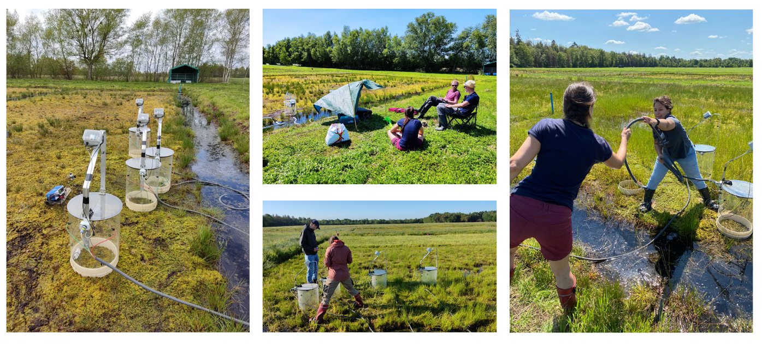
Greenhouse gas flux measurements with automatic chambers at the Sphagnum farming site. Credits to the researchers (for illustration purposes only).

