The representation and processing of identical cognates by late bilinguals: RT and N400 effects

David Peeters¹
Ton Dijkstra², Jonathan Grainger³

¹ Radboud University Nijmegen, The Netherlands
²Donders Centre for Brain, Cognition and Behaviour, Nijmegen, The Netherlands
³Aix-Marseille University and CNRS, France

Across the languages of a bilingual, words can have the same orthographic form and a similar meaning. How such words, called identical cognates, are processed and represented in the bilingual brain is not well understood. We collected reaction time data and event-related potentials in response to identical cognates and control words while late French-English bilinguals performed a lexical decision task in their L2, English. The behavioral data showed facilitatory effects of cognate status and English frequency. Further analysis on the identical cognates revealed effects of both English and French frequency. Cognates with a low English frequency showed a larger facilitation effect than cognates with a high English frequency. The electrophysiological data showed N400 effects of cognate status and both English and French frequency of the identical cognates. All results are discussed in terms of the processing of identical cognates and the way they are represented in the bilingual brain.

Key words: bilingual word recognition, cognate representation, word frequency, N400 effects

Corresponding author: David Peeters, dgtpeeters@gmail.com
Introduction
When reading in a second language, it is sometimes hard to relate a foreign word form to its meaning. However, words that have a similar form and meaning across languages, so-called cognates, generally facilitate foreign reading. For instance, a native speaker of English reading a French book will understand the words FILM, TAXI and RESTAURANT easily because they exist in both French and English. The processing of such words, which are called identical cognates, and their representation in the bilingual brain are not well understood. The current study investigates the processing and representation of identical cognates by contrasting three theoretical views.
Cognates have been used in a large number of studies investigating whether access to the bilingual lexicon is blocked by language, i.e., whether only words in the target language or in the context-relevant language are considered for recognition during reading. If this is the case (a situation called ‘language selective lexical access’, see e.g., Scarborough, Gerard, & Cortese, 1984; Soares & Grosjean, 1984), the processing of cognates should not differ from that of matched control words. In contrast, when cognates are processed more quickly (or on the other hand, more slowly) than matched control words, the context irrelevant reading of the cognate must have been activated as well (a situation called ‘language nonselective access’, for an overview see Dijkstra & Van Heuven, 2002). For instance, if a Dutch-English bilingual is faster to process the L2 English word MELON than a matched L2 control word, this implies that the L1 Dutch translation equivalent MELOEN has been activated as well. Indeed, it has repeatedly been found that cognates are generally processed more quickly than matched control words. This so-called cognate facilitation effect has been observed in behavioral studies at the word level (Caramazza & Brones, 1979; Cristoffanini, Kirsner, & Milech, 1986; Davis, Sánchez-Casas, García-Albea, Guasch, Molero, & Ferré, 2010; De Groot & Nas, 1991; Dijkstra, Grainger, & Van Heuven, 1999; Dijkstra, Van Jaarsveld, & Ten Brinke, 1998; Dijkstra, Miwa, Brummelhuis, Sappelli, & Baayen, 2010; Font, 2001; Lemhöfer & Dijkstra, 2004; Lemhöfer, Dijkstra, & Michel, 2004; Sánchez-Casas, Davis, & García-Albea, 1992; Van Hell & Dijkstra, 2002; Voga & Grainger, 2007) and more recently also for words in sentence context (Duyck, Van Assche, Drieghe, & Hartsuiker, 2007; Libben & Titone, 2009; Schwartz & Kroll, 2006; Van Assche, Drieghe, Duyck, Welvaert, & Hartsuiker, 2010; Van Assche, Duyck, Hartsuiker, & Diependaele, 2009; Van Hell & De Groot, 2008).
The cognate facilitation effect has also been found for speakers of more than two languages. Lemhöfer, Dijkstra, and Michel (2004) had Dutch-English-German trilinguals perform a lexical decision task on cognates and control words in their L3 German. Dutch-German cognates were processed more quickly than German control words. In addition, Dutch-English-German cognates were processed even more quickly. The authors interpreted these findings as evidence that access to the lexicon is not blocked by the context relevant language (in this case the L3 German). Apparently, word forms from other languages are also activated when they are sufficiently similar to the input letter string. This study, like many others using cognates, thus concluded in favor of language non-selective lexical access in word recognition by multilinguals.
The cognate facilitation effect has not only been reported in behavioral studies, but also in recent ERP studies. Midgley, Holcomb, and Grainger (2011) recorded the electroencephalogram (EEG) of English-French bilinguals while cognates and matched control words were presented in an English (L1) and a French (L2) language block. Participants performed a semantic categorization task on animal names. By asking for overt responses only when items were animal names, no behavioral response needed to be given for the critical items (of non-animal categories). In both language blocks, ERPs were found to be sensitive to cognate status. The N400 component, which is argued to reflect how difficult it is to process a word and grasp its meaning (Lau, Phillips, & Poeppel, 2008; Midgley et al., 2011), was more negative in both language blocks for control words compared to cognates. This led the authors to conclude that the mapping from form to meaning is facilitated for cognates, and, like Lemhöfer et al. (2004), that access to the bilingual lexicon is language non-selective.
If cognate facilitation occurs because cognates share their form across languages, then a greater form overlap could lead to larger facilitation. Dijkstra et al. (2010) let Dutch-English bilinguals perform an L2 English lexical decision task in which both identical cognates (e.g., FRUIT with an identical form and meaning in Dutch and English) and near-identical cognates (e.g., MELON, translated as MELOEN in Dutch) were presented. They showed that, indeed, the cognate facilitation effect becomes larger with an increase in orthographic similarity between the two readings of the cognate. Dijkstra et al. (2010) explained the cognate facilitation effect by pointing at co-activation of lexical candidates. When Dutch-English bilinguals read a cognate, both the Dutch and the English orthographic word form were activated, apparently as a function of their cross-lingual orthographic overlap. Both activated word forms then activated the shared meaning of the cognate. This resulted in facilitation of processing compared to control words, which had their meaning activated by only one orthographic representation.
One interesting finding in the Dijkstra et al. study is that identical cognates showed a discontinuously large facilitation effect compared to near-identical cognates. This discontinuity calls into question whether identical cognates are represented in the same way in the bilingual lexicon as near-identical cognates. It is unclear whether identical cognates, like near-identical cognates, are at some level represented twice in the bilingual brain.
The representation(s) of identical cognates
Although the cognate facilitation effect is reported in many studies and taken to be evidence in favor of language non-selective lexical access, there is no consensus about cognate representation. More specifically, there are conflicting views about the bilingual representation of identical cognates. In this section, we describe three theoretical positions with respect to the representation of identical cognates that will be tested later in our combined RT/ERP study.
A first theoretical position (Midgley et al., 2011; Voga & Grainger, 2007) is that identical cognates have a shared orthographic and a shared semantic representation in the bilingual brain. We will henceforth call this the one-representation view. Identical cognates have exactly the same orthographic form in the two languages of a bilingual and therefore require only one orthographic representation. In addition, identical cognate also have a shared meaning. This first position accounts for the cognate facilitation effect by pointing at cumulative frequency effects: Cognates are hypothesized to be processed faster than control words, because the frequency of the cognate’s readings in the two languages is additive. For instance, a French-English bilingual will process the identical cognate FILM faster than a French or English control word, because she encounters the word FILM not in one but in two languages. According to this position, the frequency with which one encounters the word in L2 can be added to the L1 frequency. As a consequence of the higher frequency of usage, cognates are processed more quickly than matched control words that occur only in one language.
A second theoretical position (see Dijkstra et al., 1998; Dijkstra et al., 1999; Dijkstra & Van Heuven, 2002; Van Hell & Dijkstra, 2002) is to argue that cognate facilitation is not just a cumulative frequency effect, because cognates might have some kind of connected representation in the lexicon. In contrast with the first view, these authors hold that identical cognates have, at some level (e.g., morphology), two form-related representations and a (partially) shared semantic representation. When a cognate is read, both its representations are activated, but depending on the context (e.g., the experimental task or stimulus list), one of both representations will be more important. This view explains cognate facilitation by pointing at semantic facilitation: Both form-related representations activate a shared semantic representation, which leads to a stronger semantic activation relative to control words that have only one form-representation activate its meaning. Next, this semantic activation might then send feedback to lower levels. This account has not specified in detail at what level identical cognates would be represented twice. We propose two representations at the morphological level, in between a shared orthographic form and a shared semantic representation (see Figure 1). Although prima facie it might not seem optimally efficient to have two form-related representations for the same word, when we keep in mind that identical cognates can have different plural markers, gender and/or relative frequencies across languages and are generally learnt in a different context (L1 at home, L2 at school/abroad), this might nonetheless be the way such identical words are represented. The language-specific plural markers, gender, and relative frequencies could then be related to a language-specific morpheme for both readings of the identical cognates. We will refer to this position as the two-representations view.
According to a third theoretical position (henceforth the one-morpheme view), held by Kirsner and colleagues (Christoffanini, Kirsner, & Milech, 1986; Kirsner, Lalor, & Hird, 1993; Lalor & Kirsner, 2000) and by Sánchez-Casas and colleagues (Davis et al., 2010; Sánchez-Casas, Davis, & García-Albea, 1992; Sánchez-Casas & García-Albea, 2005) cognates, just like morphologically related words in a single language, share a single morphemic representation between languages. Recently, Davis et al. (2010) outlined this proposal stating that the lexicon could be structured on the basis of morphological properties, such that words that have the same etymological root would share a representation at the morphological level. Such morphological representations would be independent of language. The shared morphemic representation for cognates, which could be located between the form level and the lemma level, then underlies the cognate advantage because cognates have the same root. In line with the first view, also this theoretical position explains cognate facilitation by pointing at cumulative frequency (Davis et al., 2010). However, whereas the first view places the cumulative frequency advantage at the level of the (shared) orthographic representation, the third position places it at the level of the shared morphological representation. Identical cognates are thus processed more quickly than control words because their morpheme is activated more frequently than the morpheme of control words that are activated by words from one language only. Figure 1 gives a graphical overview of the three theoretical positions on identical cognates.
We will now turn to the description of the current study that aims at empirically contrasting those three views in a combined RT and ERP experiment.

--------------------------------
Insert Figure 1 about here
--------------------------------

The present study
In our study, we will test how identical cognates are processed by late French-English bilinguals by comparing RTs and ERPs to identical cognates and control words. Four groups of cognates were created by orthogonally manipulating the relative word frequency (high vs. low) of the French and English reading of a cognate. Cognates could be high frequent in English and French (HEHF), high frequent in English and low frequent in French (HELF), low frequent in English and high frequent in French (LEHF) or low frequent in both languages (LELF). A comparable design has successfully been used in a behavioral study (Dijkstra et al., 1998) and in an electrophysiological investigation (Kerkhofs, Dijkstra, Chwilla, & De Bruin, 2006) into the bilingual recognition of interlingual homographs, and in a study into the effect of syllable frequency in L2 bilingual speech production (Alario, Goslin, Michel, & Laganaro, 2010).
The present study is the first to manipulate word frequency of both readings of a cognate. The result patterns can be compared to those in a large number of previous studies, which have generally only taken into account the frequency of the cognate reading in the language that was relevant for the task that was performed by the participants. However, although identical cognates have the same form and meaning across languages, their frequency of occurrence in different languages can be completely different (Schepens, Dijkstra, & Grootjen, in press). For instance, the English-French word ASSASSIN is relatively high frequent in French but relatively low frequent in English, possibly because in English its synonym MURDERER is used more often. It is unclear how such a discrepancy influences cognate processing.
Our study did not only record RTs but also ERPs while French-English bilinguals read words. Whereas RTs (e.g., in a lexical decision task) are single data points after participants read a string of letters, decided whether it was a word and implemented a movement, ERPs are more sensitive and provide a reflection of the several processes which take place during word reading (Holcomb & Grainger, 2006) before the onset of the button press. In particular the N400 can be expected to be informative in the present experiment. This negative component around 400 ms after the onset of a word is sensitive, among other variables, to word frequency (Kerkhofs et al., 2006; Münte, Wieringa, Weyerts, Szentuki, Matzke, & Johannes, 2001; Van Petten & Kutas, 1990) and to cognate status (Midgley et al., 2011). A recent study in the domain of bilingual language production has also shown that the N400 is sensitive to both word frequency and cognate status (Strijkers, Costa, & Thierry, 2010). Before predicting the electrophysiological brain activity for the different conditions in our experiment, we will first formulate predictions for the behavioral data.
The one-representation view and the one-morpheme view as outlined above make a clear prediction: The cumulative frequency of the two readings of a cognate determines its processing speed. The former view positions cumulative frequency at the orthographic level whereas the latter places it at the shared morphological representation for cognates. In the case of unbalanced bilinguals, frequency of exposure to the L1 reading of the cognate will generally be higher than frequency of exposure to the L2 reading. For instance, late unbalanced French-English bilinguals will have encountered the identical cognate FILM more often in a French than in an English context. Consequently, the cognate items with a high frequency in the L1 of the participants (French) should benefit from the higher cumulative exposure compared to the items with a low frequency in the L1 of the participant. Because those bilinguals encounter identical cognates less often in their L2 compared to their L1, the frequency of the L2 reading would have a secondary effect. In other words, this account predicts an increase in RTs for test conditions going from HEHF – LEHF - HELF – LELF. Note that, if our participants would have been fully balanced bilinguals, this account would predict no difference in processing speed between the LEHF and HELF cognates. However, in our study the high frequent French reading of the LEHF cognates will have been encountered more often than the high frequent English reading of the HELF cognates, which explains the hierarchy in RTs that can be derived from both the one representation view and the morphological view.
The two-representations view predicts that, when a French-English bilingual reads an identical cognate in English, both the French and the English form-related representation are activated and they both activate (partially) shared semantics. In the case of an English lexical decision task, the RT will depend most on the English (target) reading of the cognate, whereas the French reading will have a secondary effect, because it will also become activated due to the identical form. In other words, the English frequency of the identical cognates is more important than the French frequency when identical cognates are encountered in an English context (such as our English lexical decision task). Therefore, this account predicts an increase in RTs for conditions going from HEHF – HELF – LEHF – LELF. We will now turn to our predictions for the electrophysiological data.
The one-representation view and the one-morpheme view predict a similar hierarchy in the amplitude of the N400. Because those views claim French frequency of the cognates to be the most important factor, similar N400 effects can be expected for the LE-cognates (LEHF and LELF) compared to the LE control words as for the HE-cognates (HEHF and HELF) compared to the HE control words. In other words, the amplitude of the N400 would become less negative for HEHF and HELF cognates compared to HE control words as it would for LEHF and LELF cognates compared to LE control words, because in both cases the French reading of the cognate would be most important in cognate processing. In addition, we can expect a more negative going wave of the N400 for the HE controls compared to the HE cognates and for the LE controls compared to the LE cognates, which would both replicate overall cognate facilitation effects as found by Midgley et al. (2011).
The two-representation view does not predict large differences for the amplitude of the N400 when comparing HE control words with HEHF and HELF cognates, because in all these cases the high English frequency will lead to fast recognition and the French frequency will only have a secondary effect. The same holds when comparing the LE control words with the LELF cognates. However, when comparing the LE control words with the LEHF cognates, large facilitation can be expected because the high frequent French reading of the cognate might be activated at least as quickly as the low frequent English reading. Both readings would then activate the semantic representation, which would lead to clear facilitation in the N400 time-window. Also the two-representation view would expect overall cognate effects as reflected in a more negative going wave of the N400 for the HE controls compared to the HE cognates, and for the LE controls compared to the LE cognates. For reasons outlined above, the effect would be larger in the comparison of the LE conditions, because of the relatively large cognate facilitation effect for the LEHF cognates.
Experiment
The experiment consisted of an English lexical decision task during which both RTs and ERPs were simultaneously recorded for the same French-English participants. Because both behavioral and electrophysiological data were collected for the same participants, one integrated method section is presented.
Method
Participants
Nineteen participants (14 female; 20-27 years of age, mean age = 22.3) took part in the combined RT and ERP study. They were all right-handed as assessed by a French version of the Edinburgh Inventory for hand dominance (Oldfield, 1971), had normal or corrected-to-normal vision and no history of neurological insult or language disability. They were all native speakers of French (L1) and English was their second language (L2). All participants were advanced students of English (i.e., at least in their 3rd year) at Aix-Marseille University, France. On average they started learning English at the age of 10 (SD = 1.8; range = 7-14). Participants filled in a questionnaire to assess their auto-evaluation of French and English language skills (the same one as used in Midgley, Holcomb, Van Heuven, & Grainger, 2008). On a 7-point Likert scale, they rated their competences to read, speak, and comprehend their L1 French and their L2 English (1 = unable to 7 = expert), as well as the frequency with which they read in the two languages (1 = rarely to 7 = very often). The overall average of self-reported language skills in French was 6.9 and in English 5.5. The frequency of reading was reported 6.9 for French and 5.6 for English. Participants indicated to use French on average 75% of their day and English 25%. See Table 1 for more specific self-assessed competences.

--------------------------------
Insert Table 1 about here
--------------------------------

Stimuli
Both RTs and ERPs were measured to 480 trials that consisted of 120 English-French identical cognates, 120 English control words, and 240 English-like nonwords. All words were selected from the CELEX database (Baayen, Piepenbrock, & Van Rijn, 1993) and were correct English nouns. Lexical characteristics of the English reading of cognates and control words came from CELEX. Characteristics of the French reading of the cognate stimuli were derived from LEXIQUE 3.55 (New, Palier, Ferrand, & Matos, 2001). All word stimuli had noun as their most frequent syntactic category. When syntactically ambiguous, frequency measures were based on summed frequencies across all categories involved. All stimuli were between 3 and 9 letters of length. Table 2 gives an overview of stimulus characteristics in the various conditions of the experiment.
The 120 cognates were identical in orthography between English and French and they had a similar meaning in both languages. They all had a CELEX and LEXIQUE written lemma frequency of at least one per million and consisted of four categories. Thirty cognates were high frequent nouns in both English and French according to the CELEX (for the English reading) and LEXIQUE (for the French reading) lexical databases (HEHF; e.g., MESSAGE). Thirty cognates were high frequent in English and low frequent in French (HELF; e.g., MIXTURE). Thirty cognates were low frequent in English and high frequent in French (LEHF; e.g., ASSASSIN). Thirty cognates were low frequent in both English and French (LELF; e.g., ALTITUDE).
The 120 English control words, which did not exist in French and had a CELEX written lemma frequency of at least one per million, consisted of two categories. Sixty control words were high frequent English noncognate nouns (HE; e.g., MISTAKE). Sixty control words were low frequent English noncognate nouns (LE; e.g., BAKERY).
The 240 English-like nonword stimuli were derived from unused English nouns which were taken from CELEX. Nonwords were constructed by Wuggy (Keuleers & Brysbaert, 2010) by changing one to four letters of these existing English nouns, in line with English orthotactics.
The total set of 480 stimuli were included in different randomized lists, which consisted of four blocks of 120 trials and were unique for each individual participant. Not more than three words or nonwords were presented in sequence. In addition, no more than two cognates from the same category were presented in sequence.

--------------------------------
Insert Table 2 about here
--------------------------------

Stimuli were manipulated at the Category level with respect to four measures: written log frequency of the lemma, written log frequency of the word form, written frequency of the lemma and written frequency of the word form. T-tests showed that the groups of words that were assigned to a high frequency group (i.e., HE, the high frequency English reading of HEHF and HELF, as well as the high frequency French reading of HEHF and LEHF) did not differ significantly among one another on those four measures. The same held among the groups that were assigned low frequency (i.e., LE, the low frequency English reading of LEHF and LELF, as well as the low frequency French reading of HELF and LELF). All high frequency groups differed significantly from the low frequency groups on the four measures. The four groups of cognates, the two groups of control words, and the nonwords did neither differ significantly in word length as measured by the number of letters, nor on the number of orthographic neighbors (for all t tests: p<.05, Bonferroni correction applied).
Procedure
After completing informed consent, participants were seated in a comfortable chair at a distance of about one meter in front of a 22-inch CRT monitor in a sound attenuated, dimly illuminated room. All letter strings were presented in white letters on a black background in Courier New font (size 18). Before the start of the experiment, written instructions in English were presented on the screen. Participants were instructed that English strings of letters would appear on the screen, one after the other. They were asked to read every letter string carefully and to indicate by pressing a button with the left or right index finger whether the presented word was an English word (right finger) or not (left finger). They were asked to make their decisions as quickly and as correctly as possible. Also, they were asked to blink only when a blinking symbol was presented on the screen.
Each trial started with the presentation of a fixation point that remained on the screen for 200 ms. After the fixation point, there was a blank of another 200 ms, after which the stimulus appeared. The stimulus remained on the screen for 1300 ms, followed by a blinking symbol for 2500 ms. After this symbol, there was a blank again for 300 ms and then the next trial started. The response deadline was set to 1500 ms. Responses given after this deadline were considered as errors.
The experiment was presented in four blocks of 120 stimuli. Between the blocks participants could have a pause for as long as they wanted. The experiment lasted about 50 minutes, cap-fitting excluded. Twelve test-items with the same characteristics as the stimuli preceded the main experiment as a practice set.
Electrophysiological recording
The electroencephalogram (EEG) was recorded continuously from 64 active Ag-AgCI electrodes held in place on the scalp by an elastic cap (Electro-Cap Inc.) and placed according to the 10-10 International system (American Clinical Neurophysiology Society, 2006). Two additional electrodes, placed at both sides of POz, were used for online referencing (see Schutter, Leitner, Kenemans, & Van Honk, 2006; www.biosemi.com). In addition to the 66 scalp sites, four external electrodes were attached, one below the left eye (to monitor for vertical eye movement/blinks), one on the lateral canthus to the right of the right eye (to monitor for horizontal eye movements/saccades), one over the left mastoid bone and one over the right mastoid bone. All electrode impedances were kept below 5 KΩ. The continuous EEG was digitized at 256 Hz and filtered offline (high-pass at 1 Hz and low-pass at 20 Hz). All electrode sites were re-referenced offline to the average of the right and left mastoids. Epochs from 100 ms pre-stimulus onset to 700 ms post-stimulus onset were selected using EEGLAB software (Delorme & Makeig, 2004).
Results
Behavioral analyses
Of the total raw dataset, 10.84 % were errors (wrong responses and responses given after the RT deadline) and therefore removed. In addition, RTs outside the range of 2.5 standard deviations above the participant’s mean were considered outliers and were not taken into the analyses (2.0% of all data). In the RT analysis, errors and outliers were replaced by the participant’s mean RT for each condition of the remaining data. Analyses of variance were performed on the mean RTs and mean error rate per experimental condition (repeated measures) in the participant analyses (F₁) and on the mean RT and mean error rate per item in the item analyses (F₂). All factors are within-participant factors in the participant analyses and between-item variables in the item analyses.
Table 3 shows the mean RT and the mean error rate for each category (4 groups of cognates and 2 groups of control words).

------------------------------
Insert Table 3 about here
------------------------------

Overall, mean RTs to words were 705 ms and to nonwords 812 ms. Identical cognates (M = 694 ms) were responded to faster than control words (M = 726 ms), which amounts to an overall cognate facilitation effect of 32 ms.
To compare identical cognates with their control words, analyses of variance were performed involving cognate status (cognate vs. control) and English frequency (high vs. low) as independent variables on the mean RTs of the correct responses. These analyses showed a significant main effect of cognate status, F₁ (1, 18) = 13.57, p = .002; F₂ (1, 236) = 20.70, p = .001, implying that the overall cognate facilitation effect was significant. The analysis further showed a significant main effect of English frequency, F₁ (1, 18) = 179.55, p = .001; F₂ (1, 236) = 113.20, p = 001. Overall, high frequency English items (cognates and controls) were responded to significantly faster than low frequency English items (M = 669 ms vs. M = 752 ms). There was also a significant interaction between the two main factors, F₁ (1, 18) = 8.54, p = .009; F₂ (1, 236) = 5.26, p = .023, which reflects that the cognate facilitation effect is larger for low frequency English cognates than for high frequency English cognates when both groups are compared with their matched control words.
To assess the effect of the manipulation of the French frequency, analyses were performed on the RTs of the four groups of cognates only. These analyses, with English frequency (high vs. low) and French frequency (high vs. low) as factors, showed a significant main effect for English frequency, F₁ (1, 18) = 90.91, p = .001; F₂ (1, 116) = 37.13, p = 001, and a significant main effect for French frequency in the by-participant analysis, F₁ (1, 18) = 4.65, p = .045; F₂ (1, 116) = 3.23, p = .075. Thus, cognates with a high English frequency reading (M = 659 ms) were responded to significantly faster than cognates with a low English frequency reading (M = 729 ms). Cognates with a high French frequency reading (M = 687 ms) were responded to significantly faster than cognates with a low French frequency reading (M = 701 ms). There was no significant interaction effect between the two main factors (F₁ and F₂ < 1).
Error analyses were performed on all responses participants gave in the lexical decision task. Overall, the mean error percentage to words was 10.02% and to nonwords 11.67%. Slightly more errors were made on control words (11.01%) compared to cognates (9.04%).
To compare cognates with their control words, analyses of variance were performed involving cognate status (cognate vs. control) and English frequency (high vs. low) as independent variables on the mean error rates. These analyses showed a significant main effect of English frequency, F₁ (1, 18) = 69.64, p = .001; F₂ (1, 236) = 119.53, p = .001. The analysis did not show a significant main effect of cognate status, F₁ (1, 18) = 1.24, p = .28; F₂ (1, 236) = 1.74, p = .19. Overall, high frequency English items (cognates and controls) yielded significantly fewer errors than low frequency English items (1.84% vs. 18.20%). Cognates did not yield significantly fewer errors compared to their control words.
Additional analyses were performed on the mean error rates for the four groups of cognates only. These analyses, with English frequency (high vs. low) and French frequency (high vs. low) as factors, showed a significant main effect for English frequency, F₁ (1, 18) = 39.12, p = .001; F₂ (1, 116) = 72.37, p = .001, and a significant main effect for French frequency, F₁ (1, 18) = 20.73, p = .001; F₂ (1, 116) = 7.70, p = .006. Thus, cognates with a high English frequency reading yielded significantly fewer errors than cognates with a low English frequency reading (0.96% vs. 17.11%). Cognates with a high French frequency reading yielded significantly more errors than cognates with a low French frequency reading (11.67% vs. 6.40%). There was a significant interaction effect between the two main factors, F₁ (1, 18) = 23.39, p = .001; F₂ (1, 18) = 8.22, p = .005. This can be explained by the finding that an increase in English frequency of the cognates led to fewer errors whereas an increase in French frequency of the cognates led to more errors. Apparently, when cognates have a high French frequency in an English context, participants were more inclined to make errors (i.e., to judge the word as not being English). This interaction effect is carried by the low frequency English items (see Table 3).
ERP analyses
ERPs were calculated by averaging the EEG time-locked to a point 100 ms prestimulus onset and lasting until 700 ms after the onset of the stimulus. The 100 ms prestimulus period was used as a baseline. Trials defined as errors or outliers in the behavioral analyses and trials containing ocular or muscular artifacts, were not taken into the averaging process. Of the total remaining dataset after removal of errors and outliers, 4.6% of the trials were removed due to artifacts.
Separate ERPs were computed for every category in the experiment (i.e., four groups of cognates and two control categories). We applied an approach to data analysis in which the head is divided into seven parasagittal columns along the anterior-posterior axis of the head (see Figure 2). The activity picked up by the electrodes in each of three pairs of lateral columns and one midline column was analyzed in separate repeated measures ANOVAs. In three of these analyses (column 1: c1, column 2: c2, column 3: c3) a hemisphere factor was included (left vs. right). The fourth analysis included all midline electrode sites (Midline). A fifth analysis was performed in which the head was divided in an anterior and a posterior part (Ant-Post). The electrodes present on the horizontal midline (T7, C5, C3, C1, Cz, C2, C4 and C6) were not included in this latter analysis. This approach to data analysis has successfully been used before (see Holcomb & Grainger, 2006; Massol, Grainger, Dufau, & Holcomb, 2010) and provides an extensive overview of brain activity from both small clusters (e.g., c1) and large regions (front vs. back, left vs. right).
The mean amplitudes of the ERP waveforms for each condition per subject were entered into a repeated measures ANOVA. By-participants analyses were performed for each of six predefined time-windows (300-350, 350-400, 400-450, 450-500, 500-550 and 550-600 ms) to capture possible N400 effects. We will first present analyses that tested for ERP correlates of the cognate facilitation effect. In those analyses English frequency and cognate status were the independent variables. Secondly, we will present analyses on the four groups of cognates only that tested for effects of the frequency of the English and French reading of the identical cognates. In the latter analyses English frequency and French frequency were the independent variables.
Finally, the two control conditions (HE and LE) were compared to show the validity of the control items. In this final analysis the main factor was English Frequency (high vs. low). The Geisser and Greenhouse (1959) correction was applied to all analyses with more than one degree of freedom in the numerator (corrected p-values are reported). Unless stated differently, only significant results are reported.

--------------------------------
Insert Figure 2 about here
--------------------------------

ERP cognate facilitation effects. We first tested for ERP correlates of the cognate facilitation effect including the two groups of control words (HE and LE) and the two groups of cognates regardless of their French frequency (HE-cognates and LE-cognates) in an analysis with cognate status (cognate vs. control) and English frequency (high vs. low) as main factors. A significant main effect of cognate status was found in the 450-500 ms time-window, c1, F(1,18) = 16.66, p = .001; c2, F(1,18) = 16.67, p = .001; c3, F(1,18) = 9.10, p = .007; midline, F(1,18) = 12.98, p = .002; Ant-Post, F(1,18) = 12.79, p = .002, as well as in the 500-550 ms time-window, c1, F(1,18) = 6.97, p = .017; c2, F(1,18) = 14.26, p = .001; c3, F(1,18) = 7.57, p = .013; midline, F(1,18) = 13.18, p = .002; Ant-Post, F(1,18) = 11.05, p = .004. Also, a significant main effect of English frequency was found in the 500-550 ms time-window, c1, F(1,18) = 8.67, p = .009; c2, F(1,18) = 7.10, p = .016; midline, F(1,18) = 6.98, p = .017; Ant-Post, F(1,18) = 5.29, p = .034, as well as in the 550-600 ms time-window, c1, F(1,18) = 39.59, p = .001; c2, F(1,18) = 34.05, p = .001; c3, F(1,18) = 13.33, p = .002; midline, F(1,18) = 29.82, p = .001; Ant-Post, F(1,18) = 23.59, p = .001. There was a trend towards an interaction effect between cognate status and English frequency in the 500-550 ms time-window, c1, F(1,18) = 3.18, p = .091; c2, F(1,18) = 3.27, p = .088, as well as in the 550-600 ms time-window, c1, F(1,18) = 3.44, p = .080; c2, F(1,18) = 3.99, p = .061. Table 4 gives a schematic overview of the cognate facilitation effect and the main effect of English frequency.
The main effect of cognate status reflects that cognates yielded a significantly more negative going wave compared to control words. Figure 3 shows the voltage maps of the difference waves of the cognates versus the control words. Figure 4 shows the scalp waves for the cognate facilitation effect. The main effect of English frequency reflects that the words with a low English frequency yielded a significantly more negative going wave than the words with a high English frequency. Figure 5 shows the voltage maps of the difference waves of the high frequent English versus the low frequent English words.. Figure 6 shows the corresponding scalp waves. The trend towards an interaction between the two factors reflects that the cognate facilitation effect might be larger for the low frequent English cognates compared to the LE control words than for the high frequency English cognates compared to the HE control words, as it was the case in the behavioral data. We performed follow-up analyses to test for this possibility.

--------------------------------
Insert Table 4 about here
--------------------------------
--------------------------------
Insert Figures 3-6 about here
--------------------------------

In a first follow-up analysis we compared the HE cognates (irrespective of their French frequency) with the HE control words. A significant main effect of cognate status was found in the 450-500 ms time-window, c1, F(1,18) = 11.95, p = .003; c2, F(1,18) = 6.94, p = .017; Midline, F(1,18) = 8.55, p = .009; Ant-Post, F(1,18) = 5.41, p = .032. The HE control words yielded a significantly more negative going wave compared to the HE cognates.
Second, we compared the LE cognates (irrespective of their French frequency) with the LE control words. A significant main effect of cognate status was found in the 450-500 ms time-window, c1, F(1,18) = 6.80, p = .018; c2, F(1,18) = 7.83, p = .012; c3, F(1,18) = 4.71, p = .044; midline, F(1,18) = 4.69, p = .044; Ant-Post, F(1,18) = 6.07, p = .024, as well as in the 500-550 ms time-window, c1: F(1,18) = 13.31, p = .002; c2, F(1,18) = 15.81, p = .001; c3, F(1,18) = 6.64, p = .019; midline, F(1,18) = 8.93, p = .008; Ant-Post, F(1,18) = 10.06, p = .005. The LE control words yielded a significantly more negative going wave compared to the LE cognates.

--------------------------------
Insert Table 5 about here
--------------------------------

In sum, both for high frequency and low frequency English stimuli a cognate facilitation effect was found. The effect was present longer for the low frequency than for the high frequency stimuli. Table 5 gives a schematic overview of the cognate facilitation effects. Figure 7 shows the voltage maps of the cognate facilitation effects, which show that the effect was more wide-spread over the scalp for the low frequency than for the high frequency stimuli.

--------------------------------
Insert Figure 7 about here
--------------------------------

ERP cognate frequency effects. Secondly, we performed analyses on the four groups of cognates only, to test whether the English and the French frequency contributed equally to the cognate processing.
An analysis on the four groups of cognates with English frequency and French frequency as independent variables yielded a significant main effect of French frequency only, in the 450-500 ms time-window, c1, F(1,18) = 8.26, p =.010; c2, F(1, 18) = 10.44, p = .005; c3, F(1, 18) = 9.91, p = .006; midline, F(1, 18) = 8.22; p = .010; Ant-Post, F(1, 18) = 10.83, p = .005. This effect reflects that cognates with a low French frequency yielded a more negative going wave than cognates with a high French frequency. Figure 8 shows the scalp waves and Figure 9 the voltage maps of this comparison.

--------------------------------
Insert Figure 8 about here
--------------------------------
--------------------------------
Insert Figure 9 about here
--------------------------------

Discussion
We recorded RTs and ERPs in an L2 (English) lexical decision task that was performed by late French-English bilinguals. Identical cognates were orthogonally manipulated on their English and French frequency and compared to matched English control words. The RT data showed overall facilitatory effects of cognate status and English frequency. Further analysis of the RTs on the identical cognates revealed that an increase in English and/or French frequency led to a faster recognition. The cognate facilitation effect was larger for cognates with a low English frequency than for cognates with a high English frequency. The error analyses showed fewer errors for cognates compared to control words and fewer errors for words with a high English frequency compared to words with a low English frequency. One interesting finding was that the LEHF cognates yielded a relatively high percentage of errors.
The electrophysiological data showed a cognate facilitation effect in the N400 time-window for both cognates with a low frequency in English and cognates with a high frequency in English when compared to matched control words. The cognate facilitation effect for cognates with a low English frequency was present longer and it was more wide-spread over the scalp compared to the cognates with a high English frequency. Both cognate facilitation effects were carried by the cognate items that had a high frequent French reading (the LEHF and HEHF cognates respectively), as shown by the main effect of French frequency in the comparison of the cognates only.
Our behavioral data are in line with a wealth of previous studies showing that cognates are processed more quickly than control words (e.g., Caramazza & Brones, 1979; Cristoffanini et al., 1986; Davis et al., 2010; De Groot & Nas, 1991; Dijkstra et al., 1998; Dijkstra et al., 1999; Dijkstra et al., 2010; Font, 2001; Lemhöfer & Dijkstra, 2004; Lemhöfer et al., 2004; Sánchez-Casas et al., 1992; Van Hell & Dijkstra, 2002; Voga & Grainger, 2007). Our electrophysiological data, in showing cognate facilitation in the N400 time-window, replicate a recent finding by Midgley et al. (2011). However, our study is the first to show, both behaviorally and electrophysiologically, that not only the frequency of the target reading of the cognate (in this case English) but also the frequency of the non-target reading (in this case French) is of importance for processing. Furthermore, our data show that cognate effects are larger for identical cognates with a low frequent target reading compared to a high frequent target reading. In other words, an identical cognate with a low English frequency can benefit relatively more from its French reading than a cognate with a high English frequency. This supports a claim made by Gollan, Montoya, Cera, & Sandoval, (2008) that an increase in the use of a word leads to a smaller frequency effect.
In the remainder, we will discuss our findings in terms of the three theoretical positions on identical cognates discerned in the introduction.
The representation and processing of identical cognates
The first theoretical account that we put forward underlined the shared orthographic representation that identical cognates have. It explains cognate facilitation by pointing at cumulative frequency: Bilinguals encounter cognates more often than other words that exist in only one language, have therefore stronger links between their orthographic and semantic representation and are as such processed more quickly than control words. This one-representation view would predict that the French frequency of the cognates is more important than its English frequency in the case of late French-English bilinguals reading cognates, because those encountered the identical cognates relatively more often in their L1 compared to their L2. Our behavioral data reject the cumulative frequency account and as such the one-representation view, because the HELF cognates were processed more quickly than the LEHF cognates. This indicates that participants relied more on the frequency cognates had in the target language (English) than on the frequency cognates had in their native language (French), whereas the one-representation view would predict the opposite. In addition, this view would predict relatively similar N400-effects for HE-cognates compared to HE control words as for LE cognates compared to LE control words. However, our data show that N400 cognate facilitation effects last longer and are more wide-spread over the scalp in the comparison of the LE conditions compared to the comparison of the HE conditions.
The two-representations view underlines that identical cognates, although having an identical form, are represented twice in the bilingual lexicon. In an English language context, participants then use the representations related to the target language (English) to base their decisions on. Indeed, this view predicted that in our experiment the English frequency of identical cognates would be more important than their French frequency. This account predicted the hierarchy we found in our RT data. It also predicted small N400 effects for the HE cognates compared to the LE cognates and relatively large cognate facilitation effects for the LEHF cognates compared to the LE control words. Apparently in the LEHF cognates, the French reading of the cognates became activated quickly enough to have an influence on the N400. This interpretation is in line with the discontinuously high error rates for the LEHF cognates compared to the other groups of cognates. Apparently in this case the French reading of the cognates must have been activated quickly enough to make the participants believe that the cognate was only a French and not an English word.
The one-morpheme view, like the one-representation view, underlined the shared representation identical cognates would have, introducing a shared morphological representation. Because this shared morphological representation would get activated by cognates in both languages of the bilingual, and noncognates activate their morphological representation in only one language, cognates would be processed more quickly than matched control words. However, in line with the one-representation view, also this account focuses on cumulative frequency and therefore cannot account for our data.
There is another reason why the notion of cumulative frequency is not as straightforward as it seems. Gollan and colleagues (e.g., Gollan & Silverberg, 2001; Gollan et al., 2008) argue that the total time a bilingual speaks must be distributed in some proportion over two languages. Consequently, although French-English bilinguals might use and encounter an identical cognate, such as the word FILM, in two languages and thus apparently more often than a matched noncognate word, the number of times they would encounter the word in L1 would decrease with an increased use of their L2. This reasoning casts considerable doubt on the assumption of added frequencies for identical cognates as based on the frequency in lexical databases.
Our data are in line with previous studies rejecting the one-morpheme view. For instance, Voga and Grainger (2007) argued that, if cognates share one morphemic representation across languages, no RT-difference is expected for the same target word in cognate priming and in priming by a morphologically related noncognate matched prime. However, their masked priming experiment resulted in a significantly larger advantage from cognate primes compared to the morphological primes, which argues against the morphological view of cognate processing that would predict a null effect. More recently, Dijkstra et al. (2010) also found evidence against the one-morpheme view, showing that RTs in an L2 lexical decision task decrease when cognates increase in orthographic similarity. The one-morpheme view would not predict such a difference in processing for identical and non-identical cognates, because both cognate types would have one shared morphological representation between the two readings and would benefit in a similar way from it.
All in all, our data indicate that at some representational level there must be two representations for identical cognates. We assumed the two-representations view to make this distinction at the morphological level: Identical cognates have a language-specific morphological representation in each of their languages. In an English language context, the English morphological representation is most important.
Why would identical cognates, although identical in orthographic form and meaning, have developed two representations? One reason could be that identical cognates in different languages can have different plural forms (e.g., the identical cognate FILM which has the plural form FILMS in English but FILME in German). The information about the plural form in a specific language would be related to the cognate morpheme in that language only, facilitating the use of the correct plural suffix in the language one is using. Similarly, identical cognates can also have different gender across languages and belong to different syntactic categories.
Another reason why identical cognates would have two representations is that, in the case of late bilinguals, identical cognates are generally acquired in different contexts. This explanation is in line with a recent claim made by Baayen (2010) that contextual learning during past experience can explain proficient reading. Baayen, in line with McDonald and Shillcock (2001), argues that the context in which a word is learnt influences the speed of lexical processing. Because late bilinguals generally learn their native language in a different context than their second language (at home vs. at school/abroad), and as such learn the two readings of identical cognates in different contexts, two representations may have been developed for those orthographically and semantically identical words. In addition, also the usage context of the two readings of identical cognates might differ, whereas late bilinguals will generally only use their L2 in particular contexts (e.g., in a classroom).
To conclude, our study was the first to systematically manipulate the frequency of both readings of cognates. It has led to several conclusions concerning the processing and representation of identical cognates. First, it has shown both behaviorally and electrophysiologically that both readings of cognates are important in cognate processing. Previous studies investigating cognates mainly focused on the contextually relevant reading.
Second, our data showed that cognate facilitation is larger for cognates with a low compared to cognates with a high frequency in the target-language. Especially cognates with a low frequent target reading and a high frequent non-target reading led to large facilitation effects.
Finally, we have argued that a two-representations view accounts best for our data. In line with this account, we proposed two language-specific morphemic representations to explain the differential effects of both cognate readings. These two representations can be characterized by their own language-specific frequency and can be linked to their own language-specific plural markers, gender, and syntactic category. The different context in which identical cognates are learnt by late bilinguals (at home for L1 vs. at school/abroad for L2) might be another reason why identical cognates would be represented twice in the bilingual brain.

Author Note
We thank Maria Ktori and Stéphane Dufau for help in setting up the experiment and Olivier Sasburg for constructive comments during selection of the stimuli.

References
Alario, F.-X., Goslin, J., Michel, V., & Laganaro, M. (2010). The functional origin of the
foreign accent: evidence from the syllable-frequency effect in bilingual speakers. Psychological Science, 21, 15-20.
Americal Clinical Neurophysiology Society. (2006). Guideline 5: Guidelines for standard
electrode position nomenclature. Journal of Clinical Neurophysiology, 23, 107-110.
Baayen, R. H. (2010). Demythologizing the word frequency effect: A discriminative
learning perspective. The Mental Lexicon, 5, 436-461.
Baayen, R. H., Piepenbrock, R., & Van Rijn, H. (1993). The CELEX lexical database [CD-
ROM]. University of Pennsylvania Linguistic Data Consortium.
Caramazza, A., & Brones, I. (1979). Lexical access in bilinguals. Bulletin of the Psychonomic
Society, 13, 212-214.
Cristoffanini, P., Kirsner, K., & Milech, D. (1986). Bilingual lexical representation: The
status of spanish-english cognates. The Quarterly Journal of Experimental Psychology Section A, 38, 367-393.
Davis, C., Sánchez-Casas, R., García-Albea, J. E., Guasch, M., Molero, M., & Ferré, P.
(2010). Masked translation priming: Varying language experience and word type with Spanish-English bilinguals. Bilingualism: Language and Cognition, 13, 137-155.
De Groot, A. M., & Nas, G. L. (1991). Lexical representation of cognates and noncognates in
compound bilinguals. Journal of Memory and Language, 30, 90-123.
Delorme, A., & Makeig, S. (2004). EEGLAB: An open source toolbox for analysis of single-
trial EEG dynamics including independent component analysis. Journal of Neuroscience Methods, 134, 9-21.
Dijkstra, T., Van Heuven, W. J. B., & Grainger, J. (1999). Recognition of cognates and
interlingual homographs: The neglected role of phonology. Journal of Memory and Language, 41, 496-518.
Dijkstra, A., & Van Heuven, W. J. B. (2002). The architecture of the bilingual word
recognition system: From identification to decision. Bilingualism: Language and Cognition, 5, 175-197.
Dijkstra, T., Miwa, K., Brummelhuis, B., Sappelli, M., & Baayen, H. (2010). How cross-
language similarity and task demands affect cognate recognition. Journal of Memory and Language, 62, 284-301.
Dijkstra, T., Van Jaarsveld, H., & Ten Brinke, S. (1998). Interlingual homograph recognition:
Effects of task demands and language intermixing. Bilingualism: Language and Cognition, 1, 51-66.
Duyck, W., Van Assche, A., Drieghe, D., & Hartsuiker, R. J. (2007). Visual word recognition
by bilinguals in a sentence context: Evidence for nonselective lexical access. Journal of Experimental Psychology: Learning, Memory, and Cognition, 33, 663-679.
Font, N. (2001). Rôle de la langue dans l’accès au lexique chez les bilingues: Influence de la
proximité orthographique et sémantique interlangue sur la reconnaissance visuelle des mots. Unpublished doctoral dissertation, Université Paul Valéry, Montpellier, France.
Geisser, S., & Greenhouse, S. (1959). On methods in the analysis of profile data.
Psychometrika, 24, 95-112.
Gollan, T. H., Montoya, R. I., Cera, C. M., & Sandoval, T. C. (2008). More use almost always
means a smaller frequency effect: Aging, bilingualism, and the weaker links hypothesis. Journal of Memory and Language, 58, 787-814.
Gollan, T. H., & Silverberg, N. B. (2001). Tip-of-the-tongue states in Hebrew-English
bilinguals. Bilingualism: Language and Cognition, 4, 63-83.
Holcomb, P. J., & Grainger, J. (2006). On the time-course of visual word recognition: An
ERP investigation using masked repetition priming. Journal of Cognitive Neuroscience, 18, 1631-1643.
Kerkhofs, R., Dijkstra, T., Chwilla, D. J., & De Bruin, E. R. A. (2006). Testing a model for
bilingual semantic priming with interlingual homographs: RT and N400 effects. Brain Research, 1068, 170-183.
Keuleers, E., & Brysbaert, M. (2010). Wuggy: A multilingual pseudoword generator.
Behavior Research Methods, 42, 627-633.
Kirsner, K., Lalor, E., & Hird, K. (1993). The bilingual lexicon: Exercise, meaning and
morphology. In R. Schreuder & B. Weltens (Eds.), The bilingual lexicon (pp. 215-248). Amsterdam: John Benjamins.
Lalor, E., & Kirsner, K. (2000). Cross-lingual transfer effects between English and Italian
cognates and noncognates. International Journal of Bilingualism, 4, 385-398.
Lau, E. F., Phillips, C., & Poeppel, D. (2008). A cortical network for semantics:
(de)constructing the N400. Nature Reviews Neuroscience, 9, 920-933.
Lemhöfer, K., & Dijkstra, T. (2004). Recognizing cognates and interlingual homographs:
Effects of code similarity in language-specific and generalized lexical decision. Memory & Cognition, 32, 533-550.
Lemhöfer, K., Dijkstra, A., & Michel, M. (2004). Three languages, one ECHO: Cognate
effects in trilingual word recognition. Language and Cognitive Processes, 19, 585-611.
Libben, M. R., & Titone, D. A. (2009). Bilingual lexical access in context: Evidence from
eye movements during reading. Journal of Experimental Psychology: Learning, Memory, and Cognition, 35, 381-390.
Massol, S., Grainger, J., Dufau, S., Holcomb, P. (2010). Masked priming from orthographic
neighbors: An ERP investigation. Journal of Experimental Psychology: Human, Perception and Performance, 36, 162-174.
Midgley, K., Holcomb, P. J., & Grainger, J. (2011). Effects of cognate status on word
comprehension in second language learners: an ERP investigation. Journal of
Cognitive Neuroscience, 23, 1634-1647.
Midgley, K. J., Holcomb, P. J., Van Heuven W. J. B., & Grainger, J. (2008). An
electrophysiological investigation of cross-language effects of orthographic neighborhood. Brain Research, 1246, 123-135.
Münte, T. F., Wieringa, B. M., Weyerts, H., Szentuki, A., Matzke, M., & Johannes, S. (2001).
Differences in brain potentials to open and closed class words: Class and frequency effects. Neuropsychologia, 39, 91-102.
New, B., Palier, C., Ferrand, L., & Matos, R. (2001). Une base de données lexicales du
français contemporain sur Internet : Lexique. L’Année psychologique, 101, 447-462.
Oldfield, R.C. (1971). The assessment and analysis of handedness: The Edinburgh inventory.
Neuropsychologia, 9, 1, 97-113.
Sánchez-Casas, R., Davis, C. W., & García-Albea, J. E. (1992). Bilingual lexical
processing: Exploring the cognate/noncognate distinction. European Journal of Cognitive Psychology, 4, 311-322.
Sánchez-Casas, R., & García-Albea, J. E. (2005). The representation of cognate and
noncognate words in bilingual memory: Can cognate status be characterized as a special kind of morphological relation? In J. F. Kroll & A. M. B. De Groot (Eds.), Handbook of Bilingualism: Psycholinguistic approaches (pp. 226-250). Oxford: Oxford University Press.
Scarborough, D. L., Gerard, L., & Cortese, C. (1984). Independence of lexical access in
bilingual word recognition. Journal of Verbal Learning and Verbal Behavior, 23, 84-99.
Schepens, J., Dijkstra, T., & Grootjen, F. (in press). Distributions of cognates in Europe as
based on Levenshtein distance. Bilingualism: Language and Cognition.
Schutter, D. J. L. G., Leitner, C., Kenemans, J. L., & Van Honk, J. (2006).
Electrophysiological correlates of cortico-subcortical interaction: A cross-frequency spectral EEG analysis. Clinical Neurophysiology, 117, 381-387.
Schwartz, A. I., & Kroll, J. F. (2006). Bilingual lexical activation in sentence context. Journal
of Memory and Language, 55, 197-212.
Soares, C., & Grosjean, F. (1984). Bilinguals in a monolingual and a bilingual speech mode:
The effects on lexical access. Memory & Cognition, 12, 380-386.
Strijkers, K., Costa, A., & Thierry, G. (2010). Tracking lexical access in speech production:
Electrophysiological correlates of word frequency and cognate effects. Cerebral Cortex, 20, 912-928.
Van Hell, J. G., & Dijkstra, A. (2002). Foreign language knowledge can influence language
performance in exclusively native contexts. Psychonomic Bulletin & Review, 9, 780-789.
Van Assche, E., Drieghe, D., Duyck, W., Welvaert, M., & Hartsuiker, R. J. (2010). The
influence of semantic constraints on bilingual word recognition during sentence reading. Journal of Memory and Language, 64, 88-107.
Van Assche, E., Duyck, W., Hartsuiker, R. J., & Diependaele, K. (2009). Does bilingualism
change native-language reading? Cognate effects in a sentence context. Psychological Science, 20, 923-927.
Van Hell, J. G., & De Groot, A. M. B. (2008). Sentence context modulates visual word
recognition and translation in bilinguals. Acta Psychologica, 128, 431-451.
Van Petten, C., & Kutas, M. (1990). Interactions between sentence context and word
frequency in event-related brain potentials. Memory & Cognition, 18, 380-393.
Voga, M., & Grainger, J., (2007). Cognate status and cross-script translation priming.
Memory & Cognition, 35, 938-952.

Figure Captions
Figure 1. Graphical overview of the three theoretical positions on the representation and processing of identical cognates; a) the one-representation view b) the two-representations view c) the morphological view.
Figure 2. Electrode montage and four regions used for the analysis of the electrophysiological data.
Figure 3. Voltage maps of the difference waves of cognates (irrespective of their French and English frequency) compared to the control words (irrespective of their English frequency), for 50 ms time-windows.
Figure 4. Scalp waves of cognates compared to control words for nine electrode sites.
Figure 5. Voltage maps of the difference waves of high frequent English stimuli (irrespective of their cognate status) compared to low frequent English stimuli (irrespective of their cognate status), for 50 ms time-windows.
Figure 6. Scalp waves of high frequent English words compared to low frequent English words.
Figure 7. Voltage maps of the difference waves of cognates (irrespective of their French frequency) compared to their matched control words, for 50 ms time-windows. Panel a: The cognates with a high English frequency (HEHF and HELF) compared to their matched control words; panel b: The cognates with a low English frequency (LEHF and LELF) compared to their matched control words.
Figure 8. Voltage maps of the difference waves of high frequent French cognates (irrespective of their English frequency) compared to low frequent French cognates (irrespective of their English frequency), for 50 ms time-windows.
Figure 9. Scalp waves of high frequent French cognates compared to low frequent French cognates.

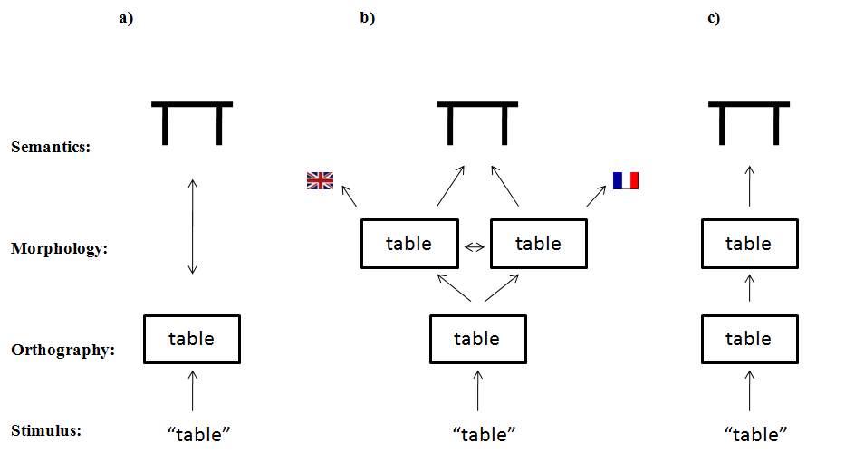

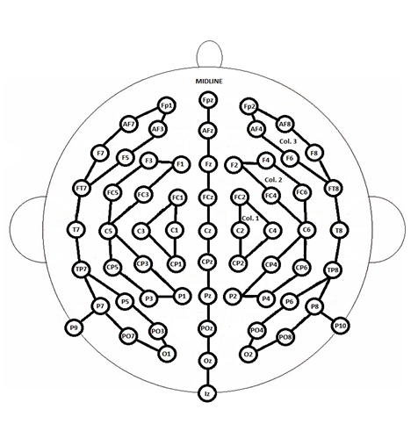

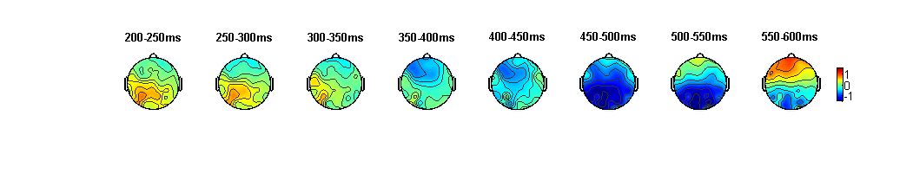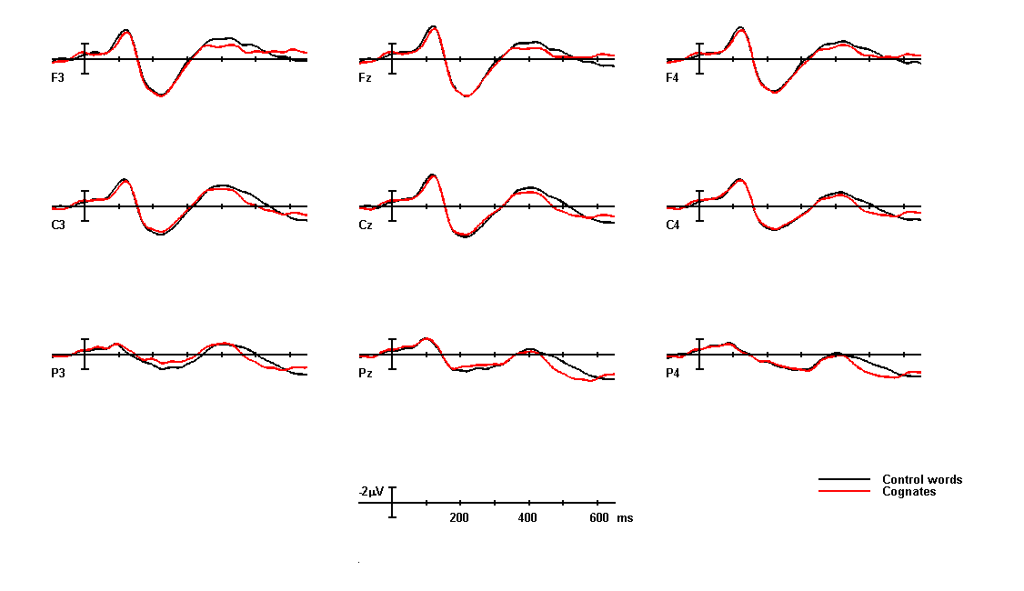
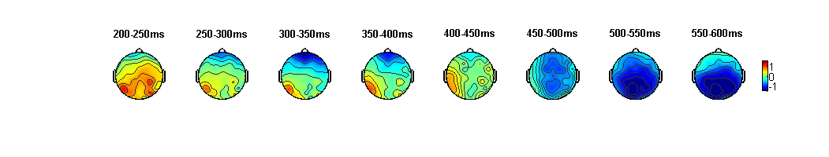
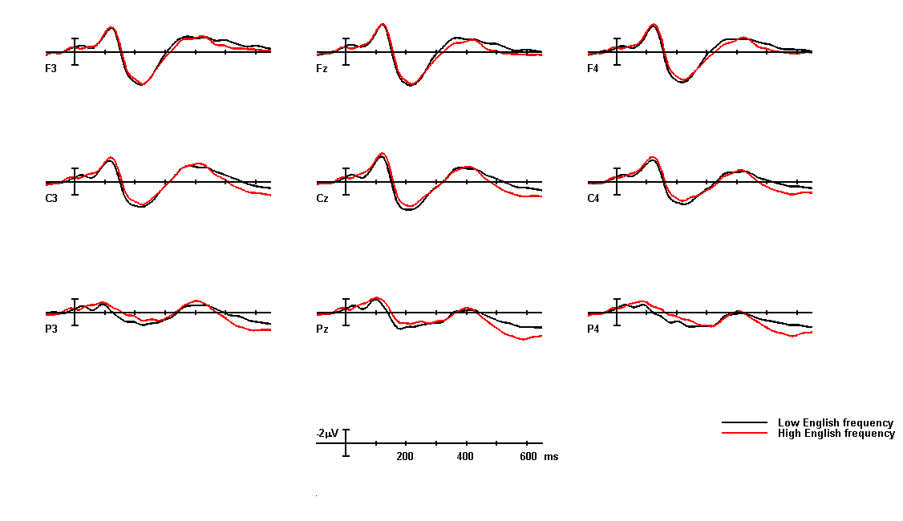
a)
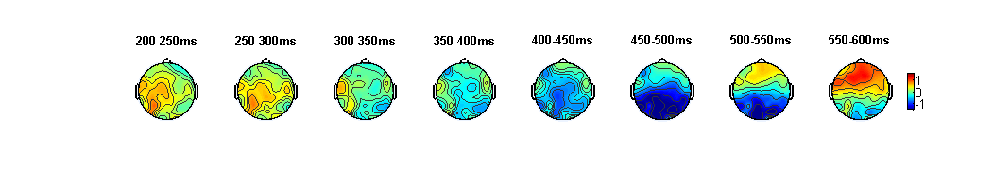

b)
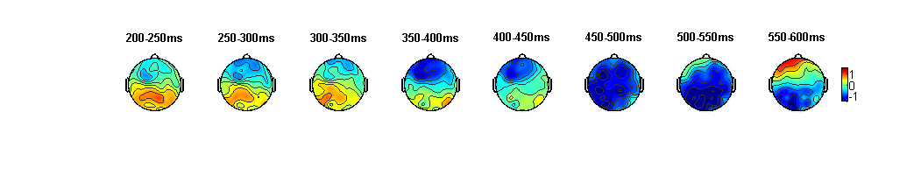

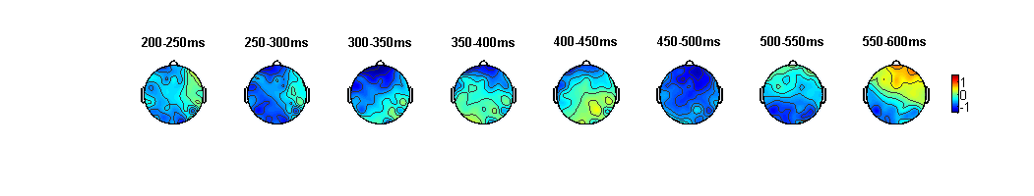
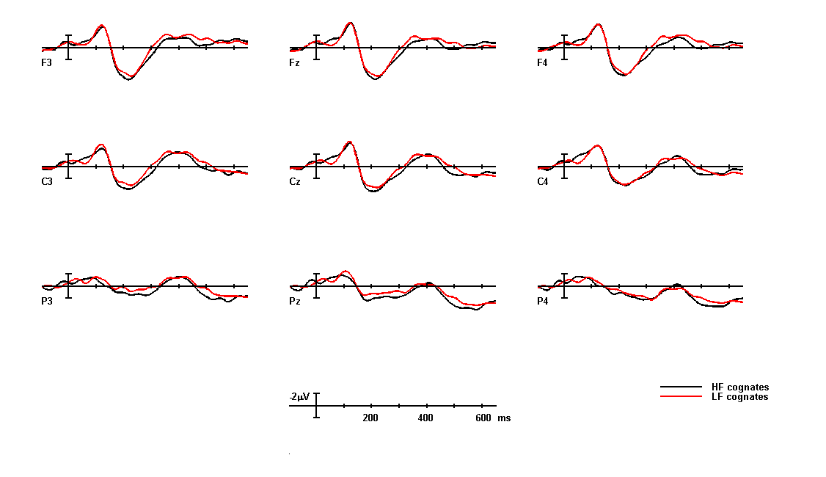
Table 1.
Self assessed ratings (on a 7-point Likert scale) on L1 (French) and L2 (English) proficiency as well as the self-reported reading frequency in both languages. Standard deviations are indicated between parentheses.

Reading Speaking Reading Frequency General comprehension
L1 French 6.89 (0.32) 6.79 (0.71) 6.84 (0.37) 7 (0)
L2 English 5.66 (0.82) 5.47 (0.96) 5.32 (1.11) 5.55 (1.04)

Table 2.
Mean English (Log EN) and French (Log FR) log frequencies, and mean English (MF EN) and French (MF FR) frequencies of the lemma corresponding to the stimuli (cognates and noncognates), and mean number of letters (Nletters) for four groups of cognates (HEHF, HELF, LEHF and LELF) and two groups of control words (HE and LE).

Category N Log EN Log FR MF EN MF FR Nletters
HEHF 30 1.68 1.70 53.47 52.49 6.40
HELF 30 1.65 0.79 51.90 7.74 6.63
HE 60 1.68 50.68 6.05

LEHF 30 0.79 1.61 7.40 50.83 6.43
LELF 30 0.71 0.74 5.97 6.11 6.07
LE 60 0.75 5.91 6.05

Table 3.
Mean RTs (in ms) per condition in the experiment (HE, LE, HEHF, HELF, LEHF, LELF) and mean Error rates per condition (in percentages). Standard deviations are indicated between parentheses.

Category Mean RT Mean Error rate
HEHF 653 (77) 0.88 (1.51)
HELF 666 (74) 1.05 (1.59)
HE 678 (73) 2.72 (2.56)

LEHF 722 (86) 22.46 (15.31)
LELF 737 (72) 11.75 (9.19)
LE 775 (74) 19.30 (12.76)

Table 4.
The cognate facilitation effect and the main effect of English frequency, for all five columns in the analyses (c1, c2, c3, midline, and AntPost) and per 50 ms time-window.
300-350 350-400 400-450 450-500 500-550 550-600
Cognate effect
c1 ns ns ns *** * ns
c2 ns ns ns *** *** ns
c3 ns ns ns ** * ns
Mid ns ns ns ** ** ns
AntPost ns ns ns ** ** ns
English frequency effect
c1 ns ns ns ns ** ***
c2 ns ns ns ns * ***
c3 ns ns ns ns ns **
Mid ns ns ns ns * ***
AntPost ns ns ns ns * ***
*p < .05, **p < .01, ***p < .001

Table 5.
The cognate facilitation effect for the HE-cognates (HEHF and HELF) compared to the HE-control words and the LE-cognates (LEHF and LELF) compared to the LE-control words, for all five columns in the analyses (c1, c2, c3, midline, and AntPost) and per 50 ms time-window.
300-350 350-400 400-450 450-500 500-550 550-600
HE(HF/LF)
c1 ns ns ns ** ns ns
c2 ns ns ns * ns ns
c3 ns ns ns ns ns ns
Mid ns ns ns ** ns ns
AntPost ns ns ns * ns ns
LE(HF/LF)
c1 ns ns ns * ** ns
c2 ns ns ns * *** ns
c3 ns ns ns * * ns
Mid ns ns ns * ** ns
AntPost ns ns ns * ** ns
*p < .05, **p < .01, ***p < .001

