
(All prices are estimates, based on approximate figures)

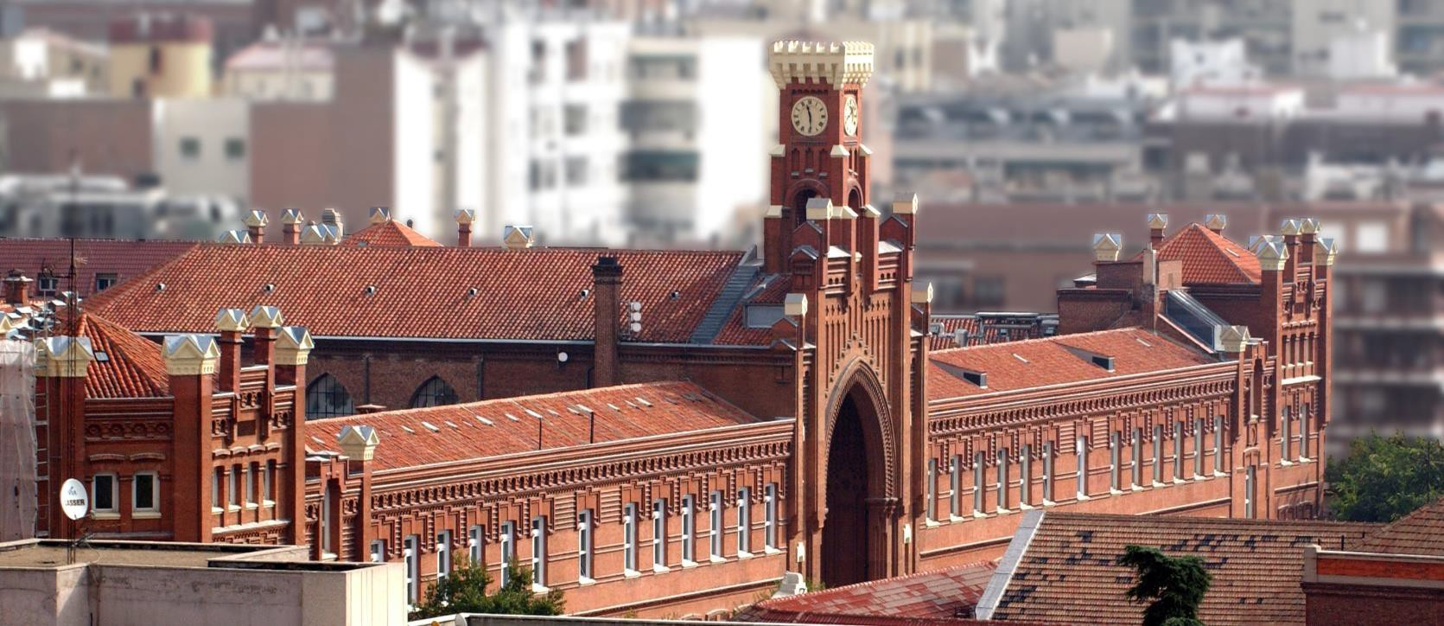
Alberto Aguilera 23

LODGING MONTHLY Rent for an apartment for one person (“Argüelles” area) 1400 €
Rent for a room in a flat shared by other students 700-900 € Family (home-stay) with full board (breakfast-lunch-dinner) 950 €
Family (home-stay) with half-board (breakfast and dinner) 800 € University Hall of Residence (Lodging)) 800-1200€

MEALS DAILY Breakfast 3 € Lunch (Daily Menu special) 10-13 €

LAUNDRY MONTHLY
20 €

PUBLIC TRANSPORT DAILY MONTHLY
“Metro” (Underground) Ticket (Metro/Bus) 1,50-2 €

Ticket supplement airport 3 € Ticket for 10 trips (Metro/Bus) 12,20 €
Monthly ticket (in the Madrid central area, valid 54,60 €
for Metro/Bus/Train)
Monthly Ticket (Madrid metropolitan area and 63,70 € Metro/Bus/Train)
Monthly Ticket (Madrid metropolitan area and 20,00 € Metro/Bus/Train (up to 26)

THE SHOPPING LIST(Approximate prices)
1 liter of milk | 0.90 € | 1 kg. of boiled ham (York style) | 11,95 €
1 pack of 4 yogurts | 1,10 € | 460 grs. of sliced bread | 1,89 €
1 kg. of fish (hake, cod, sole) | 11,00 € | “Baguette” style bread | 0,85 €
1 kg. of Sugar | 1,00 € | Cookies María Dorada | 2,50 €
3 kgs. of potatoes | 1,60 € | 1 liter of Olive oil | 4,00 €
1 kg. of chicken (whole) | 3,50 € | 1 liter of Juice | 1,30 €
12 eggs | 2,00 € | 2 liters of Coca-Cola | 1,80 €
Lettuce | 0,70 € | 12 rolls of toilet paper | 3,82 €
500 grs. of spaghetti | 1,70 € | 1 pack of 12 sanitary napkins | 2,45 €
1 kg. of bananas | 2,15 € | 750 ml of shampoo | 2,30 €
1 kg. of oranges or apples | 1,60 € | 1 liter of Bath gel | 2,20 €
1 kg. of veal steaks | 12,00 € | 600 ml. of dishwasher | 2,20 €
1 kg. of chicken breasts | 8,00 € | Tube of toothpaste | 2,60 €
250 grs. of butter-margarine | 2,40 € | Washing powder (500 grs.) | 11,00 €
1 kg. of rice | 1,50 € | Newspaper | 1,50 €

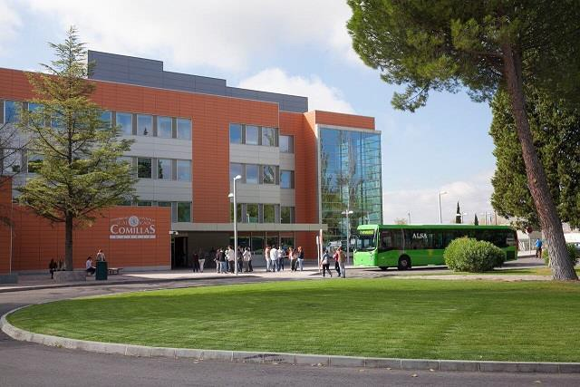

Cantoblanco Campus

