Quantifying the magnetocaloric effect
from first-principles

Diana Iuşan¹, Johan Hellsvik², Erna K. Delczeg-Czirjak¹, and Olle Eriksson¹

¹ Division of Materials Theory, Department of Physics and Astronomy, Uppsala University

² Nordita and the Department of Physics, KTH

The magnetocaloric effect may be described in terms of the adiabatic temperature and entropy change during the cooling cycle: ΔT and ΔS. In order to predict theoretically new magnetocaloric materials, or improve upon the existing ones, we need to be able to quantify ΔT and ΔS. In this talk, I will present a way for estimating these quantities from first-principles. Our approach consists in a two-step procedure: The first step is the calculation of the electronic structure and magnetic properties within density functional theory and the mapping of the magnetic interactions onto a magnetic Hamiltonian. This is later used in Monte Carlo simulations at finite temperatures and/or magnetic fields, from which ΔT and ΔS is calculated. The recipe will be exemplified for the Gd, FeRh, Fe₂AlB₂, Fe₂P, and La(Fe,Si)₁₃ systems.
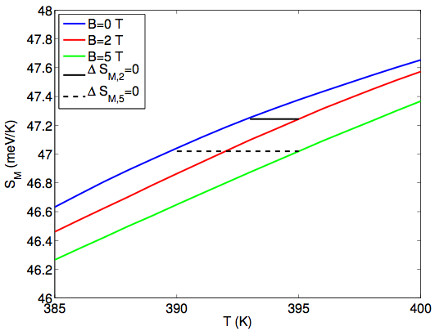

Short figure caption.

The calculated magnetic entropy for Fe₂AlB₂. The black full (dashed) line indicate the adiabatic cooling when reducing the external magnetic field from H = 2T (5T) for a system initially at room temperature.

References
[1] A.M. Tishin and Y.I. Spichkin, The Magnetocaloric Effect and its Applications, Institute of Physics Publishing, Bristol, United Kingdom, 2003
[2] Z. Gercsi et al., Physical Review B 88, 024417 (2013)
[3] E. K. Delczeg-Czirjak et al., Physical Review B 85, 224435 (2012)
[4] E. K. Delczeg-Czirjak et al., Physical Review B 86, 045126 (2012)
[5] E. K. Delczeg-Czirjak et al., Physical Review B 90, 214436 (2014)
[6] O. Eriksson, A. Bergman, L. Bergqvist, and J. Hellsvik, Atomistic Spin Dynamics (Oxford University Press, 2017)

