Step 1: In the Osiris environment, go to Osiris stay abroad
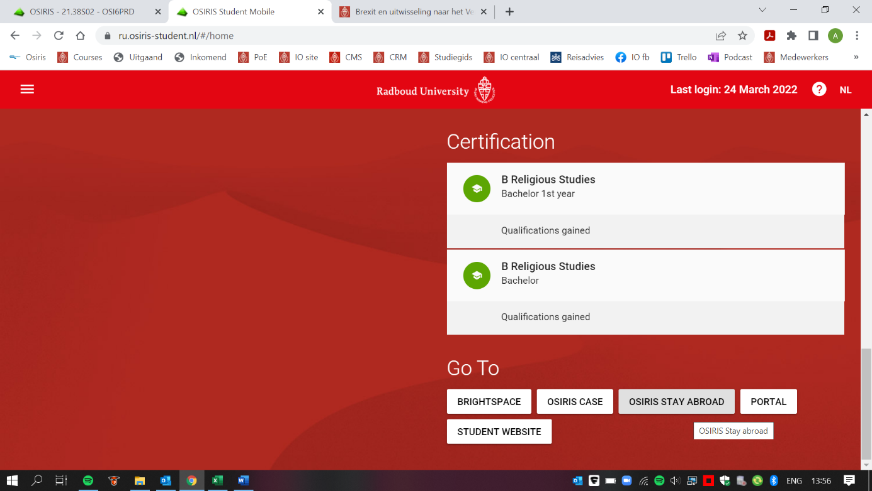

Step 2: Click on new request
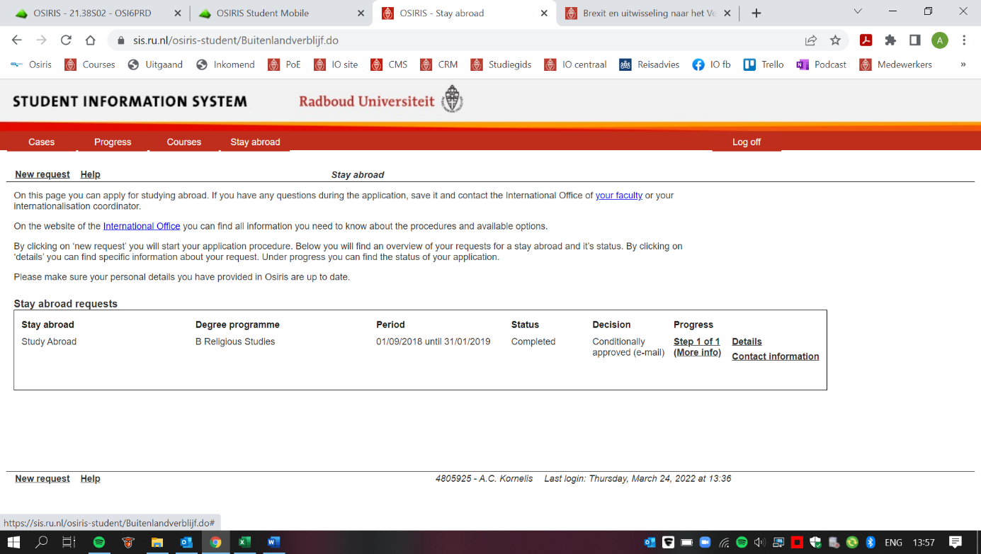

Step 3: Chose the short stay abroad option
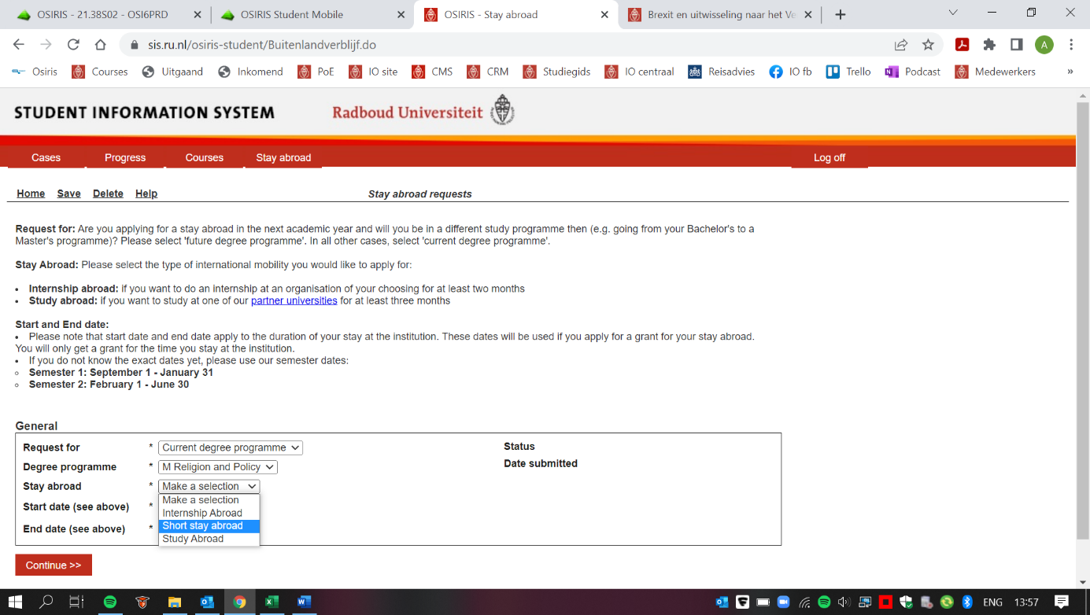

Step 4: Fill in your intended destination
