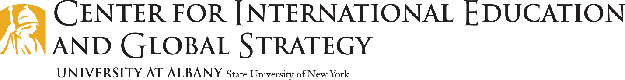
University at Albany: International Exchange & Visiting Students
General Factsheet for Partners
Primary Contacts:
Renee DeCelle, Director of Education Abroad
Address: Center for International Education & Global Strategy G40, University at Albany, 1400 Washington Ave. Albany, NY 12222
Phone: 518-591-8172 Fax: 518-591-8171 Email: rdecelle@albany.edu
Jacqueline Ledermann, Assistant Director and Exchange Manager
Phone: 518-591-8172 Email: jledermann@albany.edu
Academic Information and Application Process for Visiting and Exchange Students:
- Undergraduate and graduate students are welcome. Non-degree, post-baccalaureate students who wish to take undergraduate academic courses are also welcome to apply.
- Cumulative GPA Requirement: 2.5
- Most undergraduate fields of study are open to visiting and exchange students EXCEPT within the School of Business which is restricted and requires a course pre-approval process that Jacqueline facilitates.
- Academic calendar: https://www.albany.edu/registrar/academic_calendar.php
- Minimum Course Load for international students: 12 credits minimum/19 maximum
- Online link to application for visiting and exchange students: https://abroad.albany.edu/international-visiting-exchange-students/

Required application includes: 2 academic recommendations, personal statement, academic transcript (in English), proof of funding, and nomination from home university
Application Deadlines: Academic Year and Fall Semester, March 1 (flexible) and Spring Semester, October 1 (flexible)
Minimum TOEFL: 70 or IELTS: 6.0 band score
- On campus housing is guaranteed for all visiting and exchange students.
- Our office can assist students with off campus housing by directing them to community resources but we do not offer placement of students in off campus housing.
- Arrival Information and Mandatory Orientation: www.albany.edu/issss
- Pick up available for students arriving to Albany International Airport, Albany bus station and the Albany-Rensselaer train station.
Tuition, Fees and Estimates of Cost available online on individual program pages:
https://abroad.albany.edu/international-visiting-exchange-students/
Mandatory International Student Health Insurance: http://www.albany.edu/isss/insurance.php

