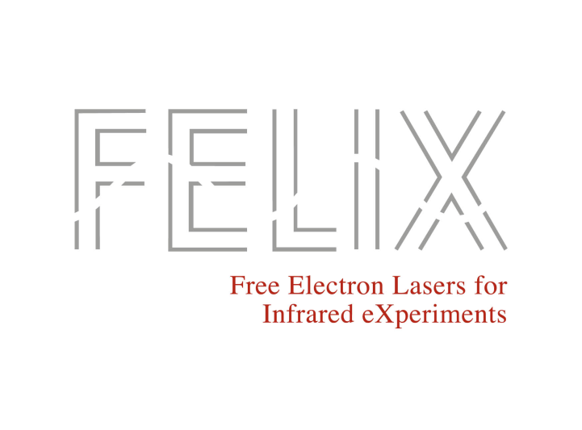

**FELIX Rapid Access Beam Time Request**

**Project title**

**Proposers**

1. **Scientific background and aim of the proposed experiment   
   (approx. 300 words)**
2. **Justification of rapid access (approx. 100 words)**

**3. Experiment information**

**a) Required FELIX beamline, end station and number of shifts**

|  |  |
| --- | --- |
| FELIX beamline |  |
| FELIX end station |  |
| Number of shifts requested |  |

Please briefly justify the selection of beamline/technique and the requested number of shifts   
(max 100 words)

**b) samples & safety related issues**

- list the samples to be studied (size, composition, quality)  
- list all possible safety aspects (e.g., dangerous, toxic or radioactive substances…) under consideration of safety issues related to the nature of biological samples

**c) required laboratory and equipment and technical information**

1. **Results expected and their impact**

Describe the information you expect to obtain from the experiment and what would be the scientific relevance of the results.

**5. References**